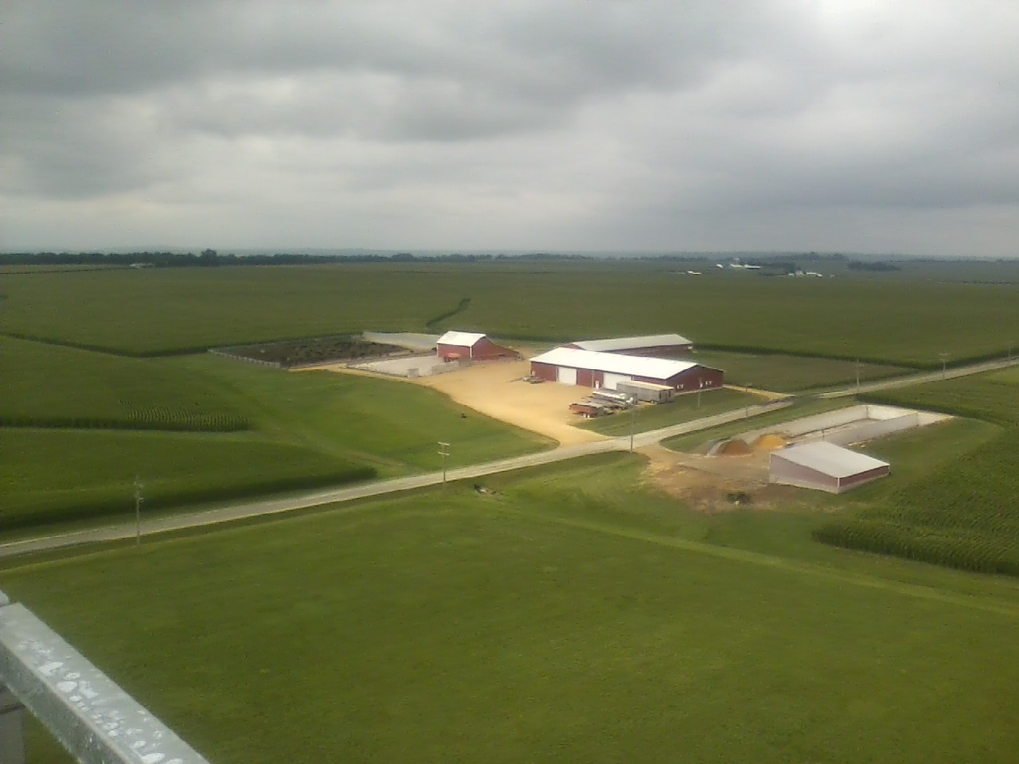
August 2 - 6, 2023
Ogle
County
Fair

Fields Of Opportunity
Fun For
Friends & Family

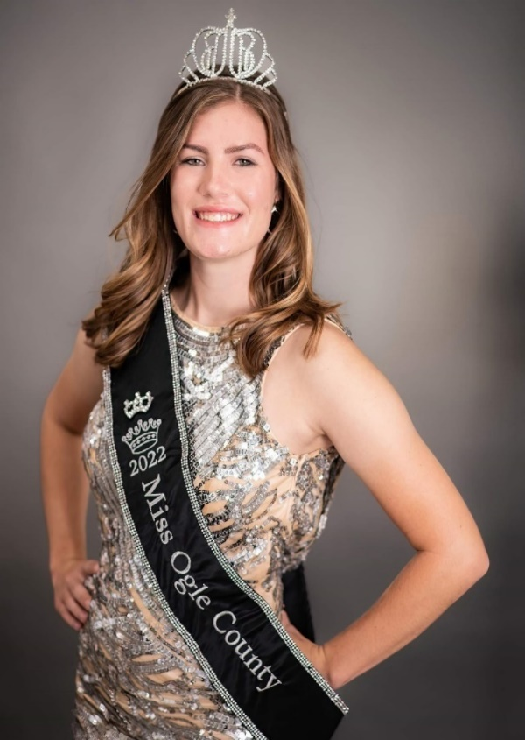
The 2023 Queen Contest
Renee Gehrke

2022-2023
Ogle County Fair Queen
Begins at 5:30 pm Wednesday August 2, 2023
Ogle Co Fairgrounds Stage near Lions Shelter

Consisting of the Following:
Little Miss and Little Mr. (ages 5-8)
Young Miss (ages 9-12)
Junior Miss (ages 13-15)
Queen Miss Ogle Co. Pageant (ages 16-21)

- All contestants should have read and signed the proper forms located on the Queen Pageant web site for Ogle County Fair.
- After knowing your category, payment may be made selecting the proper category listed below.
- Reminder that the Miss Category must find a sponsor as well.
- All category pricing will increase by $10.00 if not registered by 6-8-23.

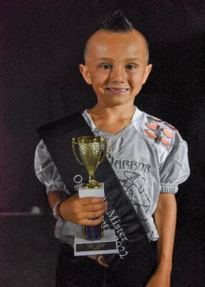
For contest rules and entry forms see web site: www.oglecountyfair.com
2022 Little Mister
Brycen Legue
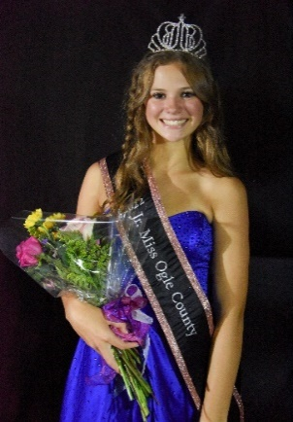
Registration due by July 10, 2023.
2022 Junior Miss
Kaelin Shaffer
Contact the Pageant Director Michelle Jozefowicz at OCFQueen@gmail.com if you have questions.

Department Z50 Queen Pageant Section 001
Class 1701 | Queen Miss | $30.00
Class 1702 | Junior Miss | $35.00
Class 1703 | Young Miss | $30.00
Class 1704 | Little Miss | $25.00
C;ass 1705 | Little Mister | $25.00
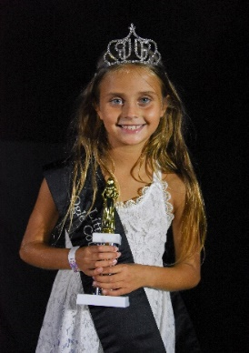
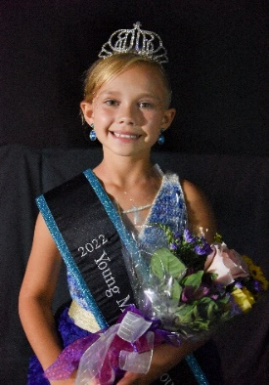
2022 Little Miss
Aniyah Mac Master
2022 Young Miss
Onyx Doan
JUNIOR and OPEN SHOW TABLE OF CONTENTS

Full Schedule of events and ticket prices
can be found at the end of this digital version.

Fair Queen Information |  | Inside cover |  | Free Entertainment & Events |  |  | 6-7
In Memory Of |  | 2 |  | Grandstand Events |  |  | 8
Ogle Co Officials & Fair Board |  | 3 |  | Attendee/Visitors Rules |  |  | 9
Message From Board |  | 4 |  | Premiums |  |  | 10
Barn Competition |  | 4 |  | Exhibitor Rules |  |  | 11
Benefit Horse Show |  | 5 |  | Animal Show Rules |  |  | 12
Junior Livestock |  |  |  | Open Show – Exhibit Building
Animal Health Rules |  | 13 |  | Open Show General Information |  |  | 67
Dept H01 | Beef | 19 |  | Dept K28 | Fruits & Vegetables |  | 68
Dept H03 | Dairy | 22 |  | Dept L29 | Floriculture |  | 70
Dept H05 – H07 | Goats – Dairy, Meat, & Pygmy | 24 |  | Dept M30 | Beekeeping |  | 72
 |  |  |  | Dept M31 | Clothing |  | 73
Dept H08 | Horses | 30 |  | Dept M32 | Craft |  | 74
Dept H09 | Poultry | 32 |  | Dept M33 | Photography |  | 76
Dept H10 | Quality Meats | 36 |  | Dept M34 | Quilting |  | 78
Dept H11 | Rabbits | 38 |  | Dept M35 | Painting & Drawing |  | 79
Dept H12 | Sheep | 41 |  | Dept O36 | Foods |  | 80
Dept H13 | Swine | 43
 |  |  |  | Special Events
Junior Exhibit Building |  |  |  | Dept Q41 & Q43 |  | Wed. Stock & Tractor Pull | 82
Jr. Show General Information |  | 48
Dept P14 | Clothing | 50 |  | Dept Q41 & Q43 |  | Thur. Truck & Tractor Pull | 83
Dept P15 | Foods | 51
Dept P16 | Beekeeping | 52 |  | Dept Z40 |  | Big Hat Rodeo | 84
Dept P17 | Visual Arts | 53 |  | Dept X00 |  | Demolition Derby | 86
Dept P19 | Natural Resources & Environment | 55 |  | Dept Q41 |  | Tri-County Pullers | 87
Dept P20 | Horticulture | 56
Dept P21 | Crops & Soils | 59 |  | Other
Dept P22 | Electricity | 59 |  | Driving Directions & Map |  |  | 89
Dept P23 | Mechanical Science | 60 |  | Camping Request Form |  |  | 90
Dept P24 | Woodworking | 61 |  | Fair Grounds Map |  |  | Back cover
Dept P25 | Life Skills/Computer Science | 62
Dept P26 | Photography | 63
Dept P27 | Animal Science | 65

In Memory of

In memory to those individuals that have greatly contributed to the growth, the children, and the great traditions that have built this fair. Please feel free to submit names to us throughout the year as we are incredibly grateful to all that have helped us become what we are.

Thank You,
The Ogle County Fair Board

Ron Baker
Steve G. Benesh
Robert Bulthaus
Don Bybee
Daryl Cave
Ralph Davis
Chuck Diehl
Danny Lee Diehl
Lisa Eden
Loretta Eden
Merlyn Eichman
Diane M. Engelbrecht
Daryl (Gig) Fulton
Ben Griener
Marion Gwathmey
Harry Hinkle
Harlan Holm
Robert Hopkins
Tom and Joanna Juriga
Ralph Larson
Jackson P. Light
Mike McNett
Robert Myers
Tracy D. (Burkhart) Palan
Carl Nelson
John Pendergast
Polo – Judging Team 1933
Wayne I. Printz
David Van Raden
Douglas Ray Rude
Mary Ann Rude
Larry Schier
Victor Scott
Anna May Snodgrass
Merle Snodgrass
Sherwood Stauffer
Dorthy Swalve
Ted Thomas
Fritz & Millie Wills
Gladys & Leonard Wills
Gloria Winterton

Ogle County Fair
1440 N. Limekiln Road
Oregon, IL 61061
815-732-6962

FAIR OFFICIALS

Dennis Alderks, Chana, Fair Livestock Superintendent
Jon Sheely, Oregon, Assistant. Livestock Superintendent
Dr. Taryn Pfeiffer, Ogle County Fair Veterinarian

OGLE COUNTY FAIR ASSOCIATION BOARD OF DIRECTORS 2022

Tom Simpson – President, Entertainment, Commercial & Food Vendors
Nathan Magnuson - Vice President, Buildings Operations/Maintenance, Commercial & Food Vendors
Brenda Holm - Secretary, Office Manager, Advertising, Fairbook
Rosanne Hurst – Treasurer, Sponsorships
Denny Alderks - Superintendent of Livestock, Grounds Operations/Maintenance
Jon Sheely - Assistant Superintendent of Livestock, Parking
Chris Carter – Director, Jr/Open Exhibits, Tickets & Sales
Rita Dauphin – Director, Food
Bambi Hinkle – Director, Main Gates
Justin Simpson – Director, Website & Social Media, Camping
Lyle Hopkins – Director, Grandstand Gate
Eric Speakes – Director, Special Events/Point of Contact
Dave Engelbrecht - Past President, Registration & Ribbons

GENERAL FAIR NOTES:

Other information
- Handicap parking available near main gate entrance.
- There are camp area rentals available during the fair.
- The Fair Grounds maybe rented for special events.
- There is winter storage rental for car, campers, trailers, and boats.
- Contact the Fair office for more information at 815-732-6962.

Disclaimer For All Days
Fair attendees assume all risk and danger incidental to the event for which this ticket/wristband provides admission, including, but not limited to, the danger posed by a foreign object entering any seating or viewing area, and the holder agrees that the Ogle County Fair Association and its agents, vendors, or independent contractors are not liable for any injuries.

Message from the Board:

Contributors, Exhibitors, Parents, and Superintendents

The Ogle County Fair Association would like to welcome you to the Ogle County Fair this year and hope that you will tell others about the Ogle County Fair. We would also like to thank the contributors to the fair this year, without you there would be no fair in Ogle County this year. A special thanks to all the volunteers, that put in lots of hours and hard work to put the fair together.

If you have suggestions or comments or would like to volunteer in the future, please send us a note or feel free to discuss them with a Fair Board member or a Fair Superintendent. Comments may be mailed to Ogle Co Fair, PO Box 142, Oregon, IL, 61061; dropped off in the fair office; or you can email them to President Tom Simpson at kentuckyboy64@gmail.com. The Ogle County Fair Board appreciates your comments.

Thank You Again and Good Luck,
Ogle County Fair Association Board

This Fairbook can also be found on the fair’s web site: www.oglecountyfair.com

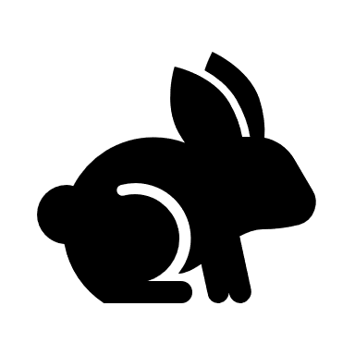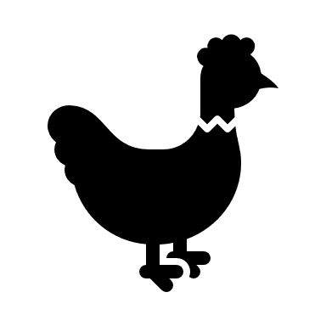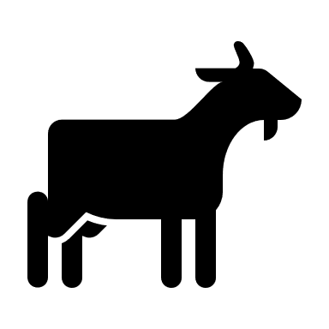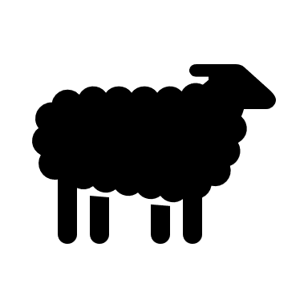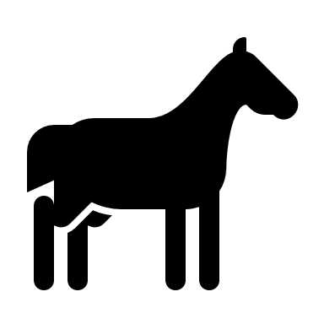
Barn Competition
In 2021, the Ogle County Farm Bureau Young Leaders began the "Battle of the Barns" program to assist our local food banks and provide friendly competition between the livestock exhibitors at the annual Ogle County Fair. We are excited to put this program on once again this year. The competition is like last year, as barns will compete against each other to see which barn can raise the most amount of canned food items during the fair week. Once again, this year we will be accepting only CANNED food items. We will also accept monetary donations from barns for our annual harvest for all donation to local food banks. We will pro-rate monetary donations on our point system for the completion. The barn that earns the most points for their donations at the end of the fair week will receive a monetary donation on behalf of OCFB Young Leaders to be used toward remodel or renovation projects of their livestock barn at the fairgrounds. We look forward to the friendly competition and seeing livestock exhibitors assisting their local communities by donating to local food banks!
- The can collection will occur in the Exhibit Building during the Fair.
- Monetary donations can be turned into the Farm Bureau Young Leaders at their booth.

BUILD-A-BARN BENEFIT HORSE SHOW
Trailers and Parking: Use Gate “C” Unless Otherwise Directed
100% of the Proceeds go to
Ogle County
Fair Grounds
Horse Barn Fund
At The Ogle County Fair
HARLAN HOLM MEMORIAL SHOW
Sunday, August 6, 2023 - 9:30 a.m. sharp
Speed Classes – All horses must walk in the gate and walk out.
Superintendent: Linda Schreiber ~ (815) 757-9846
Assistant Superintendent: Lynne Radville ~ (815) 238-7892
Jr. High Point
Sr. High Point
Draft Questions: Donna Burlo ~ (779) 772-3023

Ogle County Fair Grounds, 1440 N. Limekiln Road, Oregon, IL
Entry Fee - $7.00 per class $3.00 Office Fee

- Show committee reserves the final rights to interpret any rules and to settle all disagreements.
- Proper attire for all classes, including western attire for speed classes (pants, long sleeve collared western shirt, cowboy hat/hard hat, boots). Ranch classes will show in western working attire, no extension, minimum silver.
- Ages as of January 1, 2023 Jr. – 18 & Under Sr. – 19 & Over
Jr. Horse – 5 & Under Sr. Horse – 6 & Over
- Judge’s decision is final.
- Class #10 - Grand and Reserve Halter - 1st and 2nd place horses in classes #1 - 9. NO ENTRY FEE - GRAND - $50 – RESERVE - $25.
- Class #15 – May go in performance and speed classes - Optional Gait for gaited horses only.
- Walk Trot (Other than Class #15) MAY NOT go in canter classes.
- Classes #29, #30, #31 and #40 – English or Western.
- Gaited Horses – include Tennessee Walkers, Missouri Foxtrotters, Rocky Mountain, etc.
- Light Horses – include Arabians, Morgans, Saddle Breds and Gaited Horses – No Stock Type.
- Draft Type – include Gypsie Vanner, Fjiord, Haflingers, Belgians, etc.
- Class #38 – Draft Type Driving Pleasure - Horse Hitch - $100 added money Paid to 1st, 2nd and 3rd.
- $1.00 per high point fee per horse/rider combination.
- The Ogle County Fair Association, Ogle County Farm Bureau, members, volunteers, and management of the Build-A-Barn committee will not be and are not responsible for any theft, injury or death to horses, exhibitors or spectators.
- Ogle County Fair General Rules will apply.
- All - Negative Coggins test required - Out of State – Also Negative EIA and Illinois entry permit – papers need to be on the grounds. COVID Release papers to be signed day of show.
- NO REFUNDS unless show is cancelled, or veterinarian certificate.

HALTER
- Light Horse at Halter
- Stock Type Horse Halter
- Color Breed Horse Halter
- Pony at Halter (56” and Under)
- Mini Horse at Halter
- Draft Type Halter
- Mare at Halter
- Gelding at Halter
- Open Pony/Horse/Mini at Halter
- Grand & Reserve Horse at Halter
- Jr. Showmanship
- Sr. Showmanship
- Lead Line (8 & Under)

PERFORMANCE
- In-Hand Jumping (Open to All)
- Open Walk-Trot (Optional Gait)
- Walk Trot English Pleasure
- Jr. English Pleasure

- Sr. English Pleasure
- Walk Trot Equitation
- Jr. English Equitation
- Sr. English Equitation
- Draft Type Driving Reinsmanship
- Horse/Pony Driving Reinsmanship
- Mini Driving Reinsmanship
- Draft Type Driving Pleasure
- Horse/Pony Driving Pleasure
- Jr. Horse Pleasure
- Sr. Horse Pleasure
- Equine Pleasure (56” & Under)
- Gaited Horse Pleasure - 2 Gait
- Walk Trot Western Pleasure
- Jr. Western Pleasure
- Sr. Western Pleasure
- Ranch Pleasure
- Gaited Pleasure – 3 Gait
- Draft Type Hitch

- Discipline Rail
- Walk Trot Western Horsemanship
- Jr. Western Horsemanship
- Sr. Western Horsemanship
SPEED
- Walk Trot Barrels
- Jr. Barrels
- Sr. Barrels
- Draft Type Riding/Driving Barrels
- Walk Trot Flag
- Jr. Flag
- Sr. Flag
- Draft Type Riding/Driving Flag
- Walk Trot Plug
- Jr. Plug
- Sr. Plug
- Draft Type Riding/Driving Plug
CHECK OUT OUR FREE ENTERTAINMENT AND OTHER EVENTS
(All entertainment is subject to change without notice.)
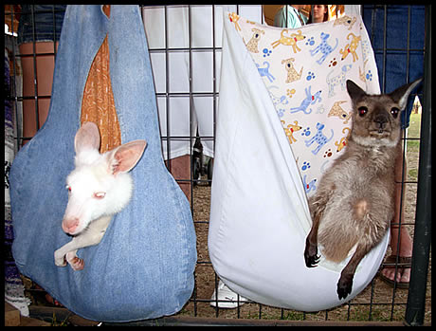
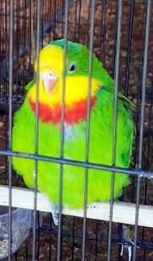
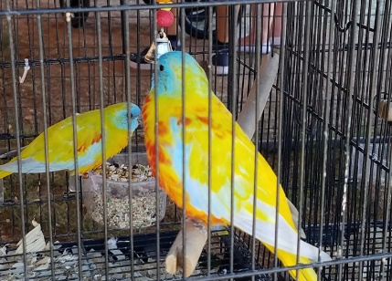
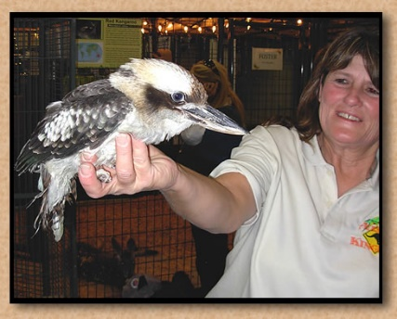
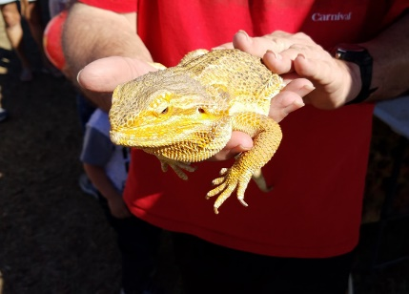
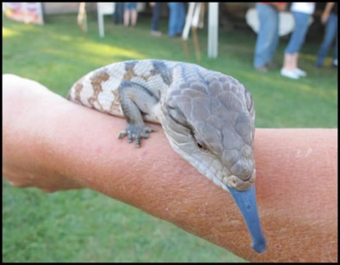
Full schedule of times will be posted at the fair office.
Aussie Kingdom
Australian Animal Show and display with Kangaroos, wallabies, walleroos, kookaburra, rainbow lorikeet, and others. Three 20-min shows per day with a display open all day.

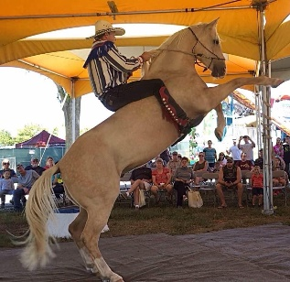
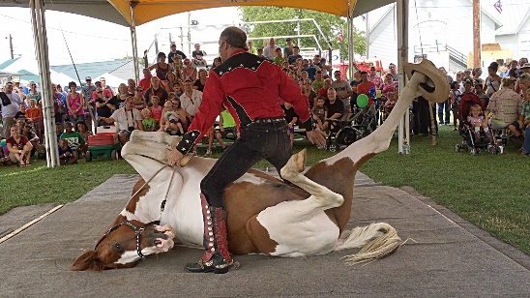
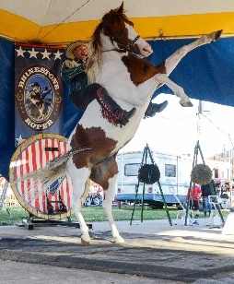
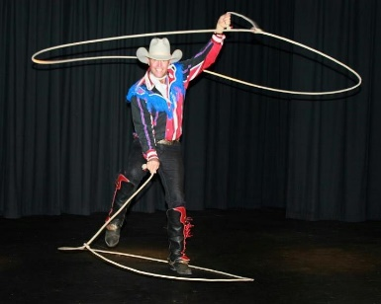
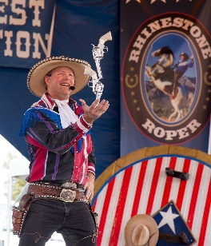
Live Entertainment
At the Lion’s Shelter
7:00 – 10:30 pm

Thursday = Jim Wolber & the Lariat Band
Friday = First Friday by Jerry Tice
Saturday = Little Man in Black by Doug Stivers
Rhinestone Roper Show
A death-defying interactive Wild West show containing humor, knowledge of the Old West, trick horses and much more.
Three 40-min shows per day.

More FREE On-Ground Entertainment
Kiddie Pedal Pull
Saturday August 5
Location: Lions Shelter
Registration 9:45 am
Pedal Pull 10:00 am

Open to all boys and girls weighing 25 – 80 pounds. Participants will be divided into 3 weight classes after registration. Trophies given to top 3 finishers based on distance.
All Carnival Rides are
FREE with paid admission.

We have rides for all ages. Children 4 and under may purchase a $5 wristband in the fair office to ride all rides.

Wednesday 8-2-23 6:00 pm – 10:00 pm
Thursday 8-3-23 5:00 pm – 10:00 pm
Friday 8-4-23 3:00 pm – 10:00 pm
Saturday 8-5-23 12:00 pm – 10:00 pm
Sunday 8-6-23 11:00 am – 4:00 pm

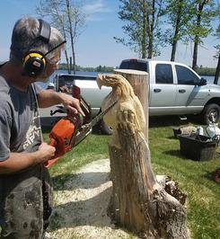
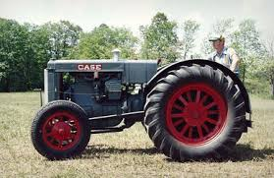
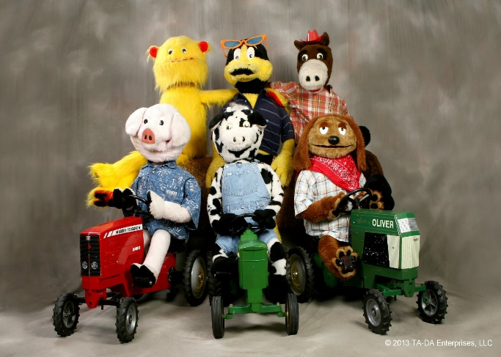
Grandstand Events
Chainsaw Artist Dave Ferrell
Several Shows Daily

Carvings will be auctioned to the public on Saturday after the animal auction in the Beef arena approximately 6:30 pm.
ANTIQUE TRACTOR SHOW & PARADE

Tractors displayed every day.

Tractor Parade every day at 5 pm.

For more information call
Remmer Schuetz 847-878-1491.
Photos with
Hawaiian Santa

Bring your own camera and take a photo with Santa.

Location: Stage near Lions Shelter
Time: Fri & Sat 2:00 – 4:00

The Magic of Brian Holt
Friday and Saturday

Friday - Walking around magic and balloon animals 4-8 pm.

Saturday – 50-min Stand-Up show at 4 pm show location TBA.
NON-DENOMINATIONAL CHURCH SERVICE

Come worship among the mooing cows and crowing chickens.

Sun. Aug. 6th at 7:30 am in the Exhibit Building
Ta-Da Robots are back. You will find them wandering around the fairgrounds.

ILLINI SATE PULLERS

Wednesday, August 3, 2023
Show Time = 6:30 pm

Thursday, August 4, 2023
Show Time = 6:30 pm

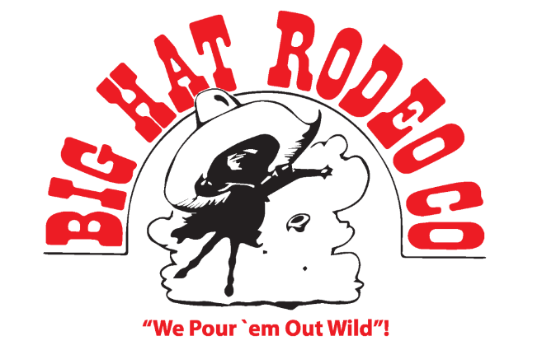
BIG HAT RODEO

2 Shows
Friday, August 4, 2023
Show Times - 2:00 & 7:00 pm

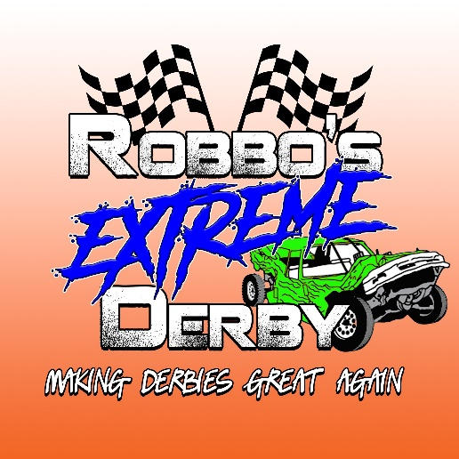
ROBBO’S EXTREME DERBY PROMOTIONS”
Harlan Holm Derby Show

Saturday, August 5, 2023
Show Time = 6:00 pm

TRI-COUNTY PULLERS INC.

Sunday, August 6, 2023
Show Time = 1:00 pm

2023 GENERAL FAIR INFORMATION FOR ALL FAIR
ATTENDEES/EXHIBITORS/VOLUNTEERS
- Alcoholic beverages and illegal drugs will be prohibited at the Ogle County Fairgrounds. If an individual is found to be in possession of alcoholic and/or illegal drugs he/she will be subject to the following:
  - An adult will be immediately escorted from the grounds.
  - A Junior exhibitor will be brought to their parents/guardians and then escorted off the grounds, they will not receive current year premium checks, and they will be prohibited from exhibiting the following year.
- No Smoking of any substances will be allowed in the livestock barns, bleachers, or grandstand areas, exhibit building, or in animal tents. Illinois Law Prevails. A designated smoking area can be found along the south fence.
- NON-COMPLIANCE WITH RULES AND REGULATIONS WILL NOT BE TOLERATED. Any affray or riotous proceedings, or resistance to the rules and regulations of the Fairgrounds will be visited by the severity of the law. The public is notified that the law gives the Fair Board “full jurisdiction and control of the Fairgrounds.” All offenders are subject to arrest and/or fine by local police.

ADA SERVICE ANIMALS:
During the Ogle County Fair, the only animals allowed on the grounds are those that align with the ADA’s Service Animal Classification for animals that are specifically trained to do work or perform tasks for people with disabilities. On-duty police dogs and trained animals appearing in a scheduled event and or competitions will be allowed.
Service animals are working animals, not pets. Dogs whose sole function is to provide comfort or emotional support do not qualify as a service animal under the ADA.
Under the ADA, service animals must be harnessed, leashed, or tethered, unless these devices interfere with the service animal’s work or the individual’s disability prevents using these devices. In that case, the individual must maintain control of the animal through voice, signal, or other effective controls.

PERSONAL PETS:
The Ogle County Fair does allow Personal Pets in the campground area. The fair board asks that all pet owners in the campgrounds keep their animal on a 4-foot leash or shorter and must pick up and dispose of all droppings left by the animal. The pets must stay in the designated camping area.

ATV/UTV/SCOOTERS/GOLF CARTS
(Exception of ADA compliant Equipment)
- ATV, UTV, Scooters and Golf Carts must be registered at the Main Fair Office for a permit number.
- Registration may be purchased in the Fair Office starting Saturday July 28th.
- Permit Time Frame: Tuesday August 1st – Monday August 7th, 2023.
- A permit fee of $20.00 will be charged (one permit per vehicle).
- Drivers must have a valid driver’s license. No unlicensed drivers will be allowed to drive these vehicles.
- Number of occupants must not exceed the registered capacity.
- Use of these vehicles will be limited to 5:00 am – 10:00 am to get food and supplies to their designated area.
- Poof of general liability insurance is to be on file in the fair office.
- Permit numbers can be revoked by Fair Board Committee. No refunds will be issued.
- Drivers must obey all road signs.
PREMIUMS OFFERED BY DEPARTMENT for 2023
Department | Fair Book Description | Offered
H01 | Junior Beef | $ 8,647.00
H03 | Junior Dairy & Dual-Purpose Cattle | $ 2,942.00
H05 | Junior Dairy Goats | $ 1,170.00
H06 | Junior Pygmy Goats | $ 531.00
H07 | Junior Meat Goats | $ 495.00
H08 | Junior Horses | $ 2,810.00
H09 | Junior Poultry | $ 2,059.00
H10 | Junior Quality Meats | $ 284.00
H11 | Junior Rabbits | $ 823.00
H12 | Junior Sheep | $ 6,697.00
H13 | Junior Swine | $ 2,436.00
K28 | Open Fruits & Vegetables | $ 180.00
L29 | Open Floriculture | $ 396.00
M30 | Open Beekeeping | $ 90.00
M31 | Open Clothing | $ 165.00
M32 | Open Craft | $ 555.00
M33 | Open Photography | $ 448.00
M34 | Open Quilting | $ 264.00
M35 | Open Painting and Drawings | $ 108.00
O36 | Open Foods | $ 414.00
P14 | Junior Clothing | $ 110.00
P15 | Junior Foods | $ 260.00
P16 | Junior Beekeeping | $ 30.00
P17 | Junior Show Visual Arts | $ 280.00
P19 | Junior Natural Resources & Environment | $ 60.00
P20 | Junior Horticultures | $ 560.00
P21 | Junior Crops & Soils | $ 40.00
P22 | Junior Electricity | $ 20.00
P23 | Junior Mechanical Sciences | $ 70.00
P24 | Junior Woodworking | $ 30.00
P25 | Junior Life Skills / Computer Science | $ 50.00
P26 | Junior Photography | $ 130.00
P27 | Junior Animal Science | $ 130.00
Q41 | Tractor Pull | $ 13,599.00
Q43 | Truck Pull | $ 7,045.00
R44 | Open Horse Show | $ 3,318.00
Z40 | Rodeo | $ 7,873.00
 | Report Total | $ 65,119.00

ALL EXHIBITOR RULES

- The Ogle County Fair, except for Jr. Quality Meats & Jr. Clothing, is to be held August 2-6, 2023, at the Ogle County Fairgrounds.
- Participants may be residents of Ogle County and Adjoining Counties.
- Exhibitors participating in the Open and/or the Junior Show, must follow all the rules and regulations listed in this fairbook. If an exhibitor does not follow the rules and regulations in the fairbook – their premium monies could be forfeited pending the decision of the OCFA executive committee.
- Parents or guardians of exhibitors under the age of 18, must follow the same rules and regulations as the exhibitors. Failure to do so by their actions or conduct (this includes offensive language) could put the exhibitor’s premium monies at risk of being forfeited pending the decision of the executive OCFA committee.
- The Ogle County Fair Board Reserves the Right To Refuse Any or All Entries.
- If there aren’t sufficient registration numbers per show, that show may be cancelled by the Fair Board Committee.
- Superintendents are permitted to remove exhibits when not suitable for showing. Superintendents reserve the right to refuse any exhibit.
- Exhibitors, except those only in Junior Horse, Quality Meats, Junior and Open General Exhibit class, may purchase an Exhibitor Pass when the Entry Form is submitted (limit 2 per exhibitor).
<NEW 2023> For the Ogle County Fair, all projects must be pre-registered online by 11:59 pm Monday July 10, 2023. No mail in registrations this year. Registration information can be found on our website: www.oglecountyfair.com. There is a $2.25 registration fee.
- If you need assistance with online registration you can go to the fair office for help on the following dates and times:
    - June 17, 2023 between 9 am – Noon
    - June 18, 2023 between Noon – 3 pm
    - July 1, 2023 between 9 am – Noon
    - July 2, 2023 between Noon – 3 pm

LATE REGISTRATIONS – To register late, starting July 11th, call the fair office phone at 815-732-6962. A late fee of $20 will be charged. No late entries will be accepted after July 28.

- NO checks will be mailed out because signatures are required. Every effort will be made to have checks available late Sunday August 6, 2023. Otherwise, check pick up will be Monday August 7, 2023, 9:00 am to 4:00 pm at the fair office.
- The Department of Agriculture shall use its best efforts to secure sufficient appropriations to fund premiums. In any year for which the General Assembly of the State of Illinois fails to make an appropriation sufficient to pay such premiums, premium amounts may not be accurately reflected in this Premium Book.
- The 4-H and Ogle County Fair shows MUST BE TWO (2) SEPARATE SHOWS. This means that the 4-H entries and the Junior Class entries shall be judged separately. For example, if a 4-H class is being judged first, all the exhibitors with their exhibits must leave the ring, before the Junior Class entries for the equivalent class can be called into the ring for judging. They all must leave the ring, even if all or some of the exhibitors and exhibits in the ring are entered in the equivalent class for the Junior Class show.

JUDGING PROTESTS
Anyone wishing to file a protest of judging results or prizes award must do the following:
- All protests require a $20.00 fee (or as stated in Department Rules) to be posted in the Fair Office and will only be returned if the protest is found in their favor.
- The alleged violation must be in writing.
- Present the written protest to the Superintendent of the division or to the Fair Office.
- The protest must be presented within 24 hours of judging.
- Interpretation of the rules and regulations is the responsibility of the Ogle County Fair Association. The Board of Directors decision will be final.

GENERAL ANIMAL SHOW RULES AND REGULATIONS
- Showmanship Ages - Competitor’s age groups are shown below unless otherwise stated in department rules. IL STATE RULE 260.95: All Junior Open classes are now open to boys/ girls who are at least 8 years of age and not yet 21 years of age on or before September 1, 2022. Ages for all divisions of Showmanship Classes are determined by their age as of September 1, 2022:
  - Junior division is for individuals ages 8 - 11.
  - Intermediate division is for individuals ages 12 - 14.
  - Senior division is for individuals ages 15 - 20.
- All livestock must be moved onto and off the grounds as stated in the "2023 Ogle County Fair Judging Schedule” or each species rules. Non-Compliance will result in forfeiture of Premiums & Awards.
- Checkout Schedule for all Animals.
  - 1:00 pm for families with last names beginning with K - Z.
  - 3:00 pm for families with last names beginning with A – J.
- Checkout for the exhibit building will be 1:00. 5:00 pm exhibit building closes.
- Each exhibitor will provide bedding, feed, water pail, and grooming equipment for their own livestock.
- Exhibitors will be required to produce health papers when called for by Veterinarians or Show Officials except dairy goats, Illinois steers, Illinois sheep, livestock in Quality Meats Carcass Show, rabbits, and horses (refer to Livestock Health Requirements for your specific species).
- All purebred breeding animals must be registered in the name of the Exhibitor by June 1st of the current year or as defined in Department Rules. No other ownership arrangement will be accepted except for horses (see Horse rules). Registration/health papers will be checked and must always be available during the fair, or premiums and awards will be forfeited.
- Only Junior exhibitors can show animals in the ring for Junior Shows. If an exhibitor must show in more than one class at the same time, that Exhibitor must arrange for the help of another Junior Exhibitor that is from Ogle County or Adjoining Counties, or someone approved by the Fair Superintendent. In the event such changes take place, the person substituting must report it to the division Superintendent.
- There is no entry fee for Champion classes or Showmanship classes.
- Do not register for Champion classes. These are determined on show date.
- Exhibitors are expected to participate in showmanship classes unless they are ineligible.
- Rules For Staying Overnight on the Ogle County Fairgrounds. All exhibitors staying overnight must be at the campsite by 10:30 pm. NO person or persons shall be permitted to be in the barns after 10:30 pm, and barns will be reopened at 6:00 am the following morning (see camping rules). Exhibitors shall be allowed to stay in the campsite area with adult supervision only.
- Each exhibitor must remove all animals and thoroughly clean his/her pens and/or stalls, and place litter in a designated area according to the individual department rules regardless of release time. Failure to do so will forfeit premiums.
- No vending type machines (dispensing animal feed or otherwise) are allowed in or near animal barns or tents. Additionally, luxuries such as microwaves and refrigerators, will not be permitted.
- Show number must be worn at the time of showing if requested by the Superintendent. Numbers will be assigned and available for pick-up the first night of the fair in the 4-H office at the south end of the fairgrounds. If you are not showing in the 4-H show, contact the Department Superintendent.
- The Ogle County Fair Association reserves the right to assign stalls & reserves the right to close entries in any Department when house facilities are exhausted, earliest dated entries will be accepted first.
- EARLY ANIMAL RELEASE - Exhibitors who need to have their animals released early MUST submit their request in writing to the Ogle County Fair Livestock superintendent before the start of the fair by 10:30 pm Wednesday August 2, 2023, in fair office. Please include the day and time you would like your animal released along with the reason for the early release and any proof you might have, such as entries to another fair.

If a veterinarian is required or requested,
the animal’s owner
is responsible for payment of the bill.

2023 ANIMAL HEALTH RULES

THE SHOW SUPERINTENDENT AND/OR FAIR VETERINARIAN WILL HAVE THE FINAL AUTHORITY OVER ALL ANIMALS AND LIVESTOCK AS TO THEIR HEALTH STATUS FOR ELIGIBILITY TO BE EXHIBITED AND/OR BE PRESENT AT ANY TIME ON THE PREMISES OF THE OGLE COUNTY FAIR AND 4-H SHOW.

HEALTH RELEASE FORM Sick animals will need a form with proper signatures before being released.

The Ogle County Fair Grounds Is A Registered Livestock Premise. Registered Premise ID Number (i.e., “00EANM9”).

These are Health Regulations Established by the Illinois Department of Agriculture and must be followed, there are no exceptions.

Illinois Department of Agriculture, Bureau of Animal Health and Welfare
State Fairgrounds P.O. Box 19281, Springfield, IL 62794-9281
Phone (217) 782-4944

2023 Exhibition Livestock Health Requirements For County Fairs

GENERAL REQUIREMENTS
These Exhibition Health Requirements apply to all livestock present at the fair including those animals that are not entered in competitive events.

- Exhibitors are required to familiarize themselves with all rules applicable to their exhibits.
All out-of-state animals shall require an entry permit. Entry permits are available online at https://entrypermit.agr.illinois.gov/Login.aspx
- All animals, except as noted, shall be accompanied by a Certificate of Veterinary Inspection (CVI) which shows that the animal meets all health requirements for the State of IL. CVI’s shall be made available to Bureau of Animal Health Personnel on request. If an official electronic CVI is utilized, the exhibitor should be able to log on and show Bureau of Animal Health Personnel the completed CVI.
CVI means a legible record made on an official form from the state of origin which has been issued, signed, & dated by an accredited veterinarian & which shows the name & address of the animal’s owner or exhibitor & the results of all required tests or vaccinations. A CVI shall list only one animal identification per line; shall be presented on the form on which it was initially issued; & shall not be corrected, changed, or altered in any manner.
- All animals shall be officially identified. The animal(s) official identification shall be recorded on the CVI.
- If animals are from tuberculosis accredited, brucellosis certified, pseudorabies qualified, or brucellosis validated herds, the identifying herd number(s) along with the date of the last herd test(s) shall appear on the CVI.
- CVI for out-of-state livestock shall be void thirty (30) days after issuance.
- CVI for IL-origin livestock shall be void ninety (90) days after issuance.
- All livestock shall be subject to examination upon entry to any IL fair or exhibition. Any animal showing evidence of infectious, contagious, or communicable diseases shall be immediately withdrawn & held in quarantine at the owner’s risk and expense until properly treated & recovered, or until the animal is released to return to the owner’s premise.
Any livestock infected with scabies, mange, active lesions of ringworm, soremouth, or multiple warts which are easily visible without close examination shall not be permitted to exhibit & are subject to quarantine or removal from the fairgrounds.
Sheep & goats with caseous lymphadenitis as evidenced by draining abscesses shall not be exhibited and are subject to immediate quarantine or removal from the fairgrounds.
- IL Dept. of Ag. personnel or designee may collect blood, tissue, milk, or urine samples from any animal being exhibited and/or raced at any IL fair to test for the presence of illegal drugs or banned substances. Examination techniques, such as ultrasound, may also be used at anytime while the animals are on the grounds of any IL fair or exhibit.
The IL Dept. of Ag. or designee may collect urine, blood, tissue, or other test samples from exhibition animals at the time of slaughter.
- All exhibitors of animals at any IL fair or exhibition shall comply with the provisions of the IL Humane Care for Animals Act. If violations are observed, the animals(s) will be excused from exhibition & ordered removed from the grounds with all awards being forfeited.
Any practice or deviation from normal, accepted care, including physical, medical or mechanical application, shall constitute a violation of show rules and may result in the animal(s) disqualification and removal from the fairgrounds.
- Any IL cattle, bison, cervidae or goats being exhibited in non-accredited free states must be isolated from the remainder of the herd/flock upon return to IL and retested for tuberculosis 60-120 days post-entry.

CATTLE
Identification
Individual identification of each animal shall be either a fully healed & legible tattoo, approved official ear tag, registration number (can only be used if the tattoo is recorded on the registration certificate or for breeds where pictures are acceptable), or individual brands, if brand is recorded on the registration certificate.

IL Cattle
Brucellosis: IL is a Bovine Brucellosis Class-Free State. Brucellosis testing is not required for IL cattle.
Tuberculosis: IL is an Accredited Tuberculosis-Free State. Tuberculin testing is not required for IL cattle.

Please Note: IL calves under 6 months of age, & IL steers are not required to have a Certificate of Veterinary Inspection.

Out-of-State-Cattle
All out-of-state cattle are to be accompanied by an entry permit. Entry permit numbers are available online at https://entrypermit.agr.illinois.gov/Login.aspx.

Brucellosis
- Female cattle six (6) months of age & older & bulls eighteen (18) months of age & older shall be negative to an official test for brucellosis within thirty (30) days prior to entry, unless exempt by one (1) of the following:
  - Originate directly from a certified brucellosis-free herd.
  - Official vaccinates of dairy breeds under twenty (20) months of age or official vaccinates of beef breeds under twenty-four (24) months of age.
  - Animal originated from a “Class Free” state (if entire state is so classified).
  - Steers and spayed heifers are not required to be tested for brucellosis.
- The negative brucellosis test shall be conducted at a state or federal laboratory within 30 days prior to exhibition.

Tuberculosis
- Accredited Tuberculosis Free States
  - No tuberculin test required. All cattle, including steers, originating from an Accredited Tuberculosis Free State, may enter IL for exhibition when accompanied by a CVI issued by an accredited veterinarian within 30 days.
- Non-Accredited Tuberculosis Free Areas or States (Not TB Free)
  - Cattle must originate from a herd where a complete herd test was conducted within the past year.
  - The individual animals entering IL must be negative to an additional tuberculin test conducted within 30 days prior to exhibition.
  - Cattle that enter IL for exhibition & remain in IL (animal does not return to the state of origin within 30 days) must be isolated & retested for TB 60-120 days from the last official TB test date.

SWINE
IL Swine
Identification
- Swine shall be identified by an official ear tag, tattoo or recognized breed ear notch.
- Ear notch identification is acceptable for all barrows, crossbred gilts & breeding swine.
(Note: Ear notch identification of crossbred swine does not satisfy USDA identification requirements for interstate movement or official testing.)
Brucellosis: Brucellosis testing is not required for IL swine.
Pseudorabies: Pseudorabies testing is not required for IL swine.

Out-of-State Swine
All out-of-state swine are to be accompanied by an entry permit. Entry permit numbers are available online at https://entrypermit.agr.illinois.gov/Login.aspx.

Identification
- Individually identified by an official ear tag, tattoo or recognized breed ear notch.
- Ear notch identification is not acceptable for crossbred animals.

Brucellosis
- Breeding swine 4 months of age and older shall be negative to an official test for brucellosis within 30 days prior to exhibition unless exempt by one (1) of the following:
  - Originate immediately & directly from a validated brucellosis-free herd.
  - Originate directly from a validated brucellosis-free state.
- Swine brucellosis tests for exhibition shall be conducted at a state or federal laboratory.

Pseudorabies
- Swine originating from a Pseudorabies Stage IV or V state are exempt from the pseudorabies testing requirement.
- Swine originating from a Pseudorabies Stage III state shall be negative to an official test for pseudorabies conducted within thirty (30) days prior to entry or originate immediately & directly from a qualified pseudorabies negative herd.
- Swine originating from a Pseudorabies Stage I or II state shall be negative to an official test for pseudorabies conducted within the 10 days prior to entry.
- Barrows and females in market classes must meet the same requirements as breeding swine.

SHEEP
Identification
Individual identification of each animal shall be by an ear tattoo or official metal or plastic tag. A microchip ID is acceptable if the owner provides the reader.
Ear tattoos may be used when a registration certificate, listing the tattoo number, accompanies the animal.
When using ear tags, the tag must indicate the premises ID and state of origin. The tag number must be assigned by a state or APHIS representative & recorded in the Scrapie Record Database.

Market Lambs
All market lambs must be slick shorn (show ring ready) before weigh-in so that show lamb fungus can be identified.

IL Sheep
- Sheep originating from a flock that has previously been classified as either an infected or source flock can be exhibited in IL upon the completion of an approved flock plan.
- For any animal born after 1/1/2002, the CVI must include the flock of birth & the flock of origin, if different.

Out-of-State Sheep
All out-of-state sheep are to be accompanied by an entry permit. Entry permit numbers are available online at https://entrypermit.agr.illinois.gov/Login.aspx.
- Sheep originating from a flock that has previously been classified as either an infected or source flock can be exhibited in IL upon the completion of an approved flock plan.
- For any animal born after 1/1/2002, the CVI must include the flock of birth & the flock of origin, if different.

GOATS
Identification
Individual identification of each animal shall be by an ear tattoo or official metal or plastic tag. A microchip ID is acceptable if the owner provides the reader.
Tattoos may be used when a registration certificate, listing the tattoo number, accompanies the animal.
When using ear tags, the tag must indicate the premises ID and state of origin. The tag number must be assigned by a state or APHIS representative & recorded in the Scrapie Record Database.
Ears should be used for tattooing when possible. If there is no space in the ear, the flank or tail fold may be used.

IL Goats
- Goats originating from a herd that has previously been classified as either an infected or source herd can be exhibited in IL upon the completion of an approved herd plan.
- For any animal born after 1/1/2002, the CVI must include the flock of birth and the flock of origin, if different.

Out-of-State Goats

All out-of-state goats are to be accompanied by an entry permit. Entry permit numbers are online at https://entrypermit.agr.illinois.gov/Login.aspx.

- Goats originating from a herd that has previously been classified as either an infected or source herd can be exhibited in IL upon the completion of an approved herd plan.
- Tuberculosis- Goats from areas or states that are not Accredited Bovine Tuberculosis Free, must be accompanied by a CVI indicating that the goats originated from a herd where a complete negative herd test has been conducted within the past twelve (12) months & the individual animals are negative to a tuberculin test conducted within thirty (30) days prior to entry. For any animal born after 1/1/2002, the CVI must include the flock of birth and the flock of origin, if different.

HORSES, PONIES, MULES AND OTHER EQUIDAE
IL Equine
- All horses & other Equidae, twelve (12) months of age & older attending an advertised equine event, shall be accompanied by a negative test for equine infectious anemia (EIA) conducted within the last twelve (12) months. A copy of this test shall accompany the animal.
- AGID (Coggins) or ELISA tests are accepted.
- An advertised equine event means a show, rodeo, sale, auction, exhibition, trail ride, or horse fair that is posted or media promoted.
- A CVI is not required for IL equine.
Out-of-State Equine
All out-of-state equines are to be accompanied by an entry permit. Entry permit numbers are available online at https://entrypermit.agr.illinois.gov/Login.aspx.
- All horses & other Equidae entering IL that are twelve (12) months of age or older, shall be accompanied by a negative test for equine infectious anemia (EIA) conducted within the last twelve (12) months. A copy of this test shall accompany the animal.
- AGID (Coggins) or ELISA tests are accepted.
- All horses & other Equidae shall be accompanied by a CVI issued within thirty (30) days prior to entry.

POULTRY
- All entries (except waterfowl, i.e., domesticated fowl that normally swim, such as ducks and geese) in a show or exhibition shall have originated from a U.S. Pullorum-Typhoid Clean or equivalent hatchery or flock OR have a negative pullorum-typhoid test within 90 days prior to exhibition. Exhibitor shall show proper information as to name & address of owner or exhibitor, name & address of the authorized testing agent, date of the testing & the number, breed, & species of those tested.

- Prior to being used to transport poultry to a show, all crates, boxes, containers & vehicles shall be thoroughly cleaned & disinfected.
- Any poultry vaccinations must be performed at least 4 weeks prior to delivery to the show.
- Upon admission to a show, all entries shall be examined by the official county fair veterinarian or qualified state personnel who shall also receive & examine all certificates necessary for admission of birds to a show. Birds not in show condition will be excused from exhibition & removed from the premises. Any fowl showing signs of illness during the fair will be removed from the exhibition grounds.
- All out-of-state turkeys must originate from flocks that are officially classified as U.S. Mycoplasma Gallisepticum Clean in accordance with the provisions of the National Poultry Improvement Plan or be negative to a test for Mycoplasma Gallisepticum within 30 days prior to entry.
- A permit is also required for out-of-state poultry. Entry permit numbers are available online at https://entrypermit.agr.illinois.gov/Login.aspx.

Please note: These poultry exhibition requirements do not apply to 4-H & FFA 1-day poultry shows where the entries are taken to the show & returned home the same day. However, a permit is required for out-of-state poultry.

CERVIDAE
(Deer, Elk, Reindeer, Caribou, Moose, Red Deer & other Related Species)
Identification
All animals shall be individually identified with an approved tag, microchip or tattoo. Elk are required to have two official/approved unique identifiers.

IL Cervidae
Chronic Wasting Disease
For Cervidae changing ownership or moving within the State, the owner must obtain a permit issued by the Department prior to movement & the cervid must originate from a herd that is enrolled in the Certified Monitored Chronic Wasting Disease (CWD) Program or the Contained Monitored Chronic Wasting Disease Program. The permit shall be obtained no more than 72 hours in advance of the movement of the cervids by providing the following information:
- Name & complete mailing address of person exhibiting the cervids.
- Certified Monitored Chronic Wasting Disease or Contained Monitored Chronic Wasting Disease Herd number.
- Name & complete mailing address of location where the animals will be exhibited.
- Number of animals & unique identification of the animals.

Tuberculosis: IL is an Accredited Tuberculosis-Free State. Tuberculin test is not required for IL Cervidae.

Out-of-State Cervidae
Chronic Wasting Disease
- All Cervidae entering IL must be in compliance with the IL Wildlife Code [520 ILCS 5]. For more information, contact the IL Dept. of Natural Resources at 217/782-6384.
- All Cervidae entering IL must be accompanied by a permit from the Department & a Certificate of Veterinary Inspection that:
  - has been issued by an accredited veterinarian of the state of origin or a veterinarian in the employ of the United States Department of Agriculture;
  - is approved by the Animal Health Official of the state of origin;
  - shows that the Cervidae are free from visible evidence of any contagious, infectious, or communicable disease or exposure thereto, do not originate from a CWD endemic area (any county & surrounding counties where CWD has been diagnosed in the past five years);
  - shows that the Cervidae are not originating from a herd under quarantine for any contagious, infectious, or communicable disease;
  - shows that the animals originate from a herd that has been monitored for at least 5 years under a state approved CWD certification program.
- A permit number can be obtained by applying online at https://www2.illinois.gov/sites/agr/Animals/AnimalHealth/Documents/permitrequestform.pdf . Applicant for permit shall furnish the following information to the Department:
- Name & post office mailing address of IL destination;
- Name & post office mailing address of the consignor and/or source herds;
- Name & post office mailing address of the herd veterinarian;
- Number & unique identification of Cervidae in shipment.

Brucellosis: Cervidae six (6) months of age & older must have a negative brucellosis card or PCFIA test within sixty (60) days prior to entry.

Tuberculosis
- Accredited Tuberculosis Free States
All Cervidae twelve (12) months of age & over shall be negative to two (2) single cervical tests for bovine TB no less than ninety (90) days apart with the second test conducted within ninety (90) days prior to entry. These animals shall be isolated from all other members of the herd during the testing period unless they originate from an accredited, qualified, or monitored herd.
  - Cervidae from an accredited herd may be moved into IL without further TB testing provided that a certificate stating that such cervids originated from an accredited herd accompanies them.
  - Cervidae originating from qualified or monitored herds may enter with a negative test within ninety (90) days prior to entry & a certificate stating that the animals originate from a monitored herd.
- Non-Accredited Tuberculosis Free Areas or States (Not TB Free)
  - All Cervidae shall originate from a herd where a complete herd test was conducted within the past year.
  - The individual animals entering IL must be negative to two (2) additional tuberculin tests conducted within 180 and 30 days prior to entry or exhibition.

RATITES
(Ostriches, Emus, Rheas, Cassowaries and Kiwis)
IL Ratites
There are no requirements governing the movement of ratites within IL.

Out-of-State Ratites
- Must be accompanied by a CVI & permit number. Entry permits are available online at https://entrypermit.agr.illinois.gov/Login.aspx .
- Individually identified by leg band or microchip.
- Negative test for Avian Influenza within 10 days prior to entry.

PIGEONS
There are no requirements governing the movements of pigeons within or into IL.

RABBITS
There are no requirements governing the movements of rabbits within or into IL.

LLAMAS
There are no requirements governing the movement of llamas within IL. A permit and health certificate are required for out-of-state llamas. Entry permit numbers are available online at https://entrypermit.agr.illinois.gov/Login.aspx

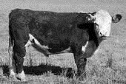
DEPARTMENT H01 (JUNIOR BEEF)
Entries Close 11:59 pm Mon. July 10, 2023

Check-in Wednesday, August 2, 12:00 pm – 3:00 pm
Weigh-in Wednesday, August 2, 5:00 pm – 8:00 pm
Judging Saturday, August 5, 9:00 am
Check-out Sunday, August 6:
1:00 pm for families with last names beginning with K - Z.
3:00 pm for families with last names beginning with A - J.

ENTRY FEE= $6.00 STALL FEE= $5.00 Exhibitor Pass Available

PREMIUMS (EXCEPT CHAMPIONS):
1st= $30.00 2nd= $25.00 3rd= $20.00 4th= $15.00 5th= $12.00 6th= $10.00

CHAMPION CLASSES: Entry Fee: 0
Premiums: 1st= $15.00 2nd= $10.00

GRAND CHAMPION CLASSES: Entry Fee= 0
Premiums: 1st= $50.00 2nd= $25.00

CLASS 187 & 188: (Entry Fee by Producer)
1st -  $100.00 | 2nd -  $90.00 | 3rd -  $80.00 | 4th -  $70.00 | 5th -  $60.00 | 6th -  $50.00 | 7th -  $40.00 | 8th -  $30.00 | 9th -  $20.00 | 10th -  10.00

JUNIOR, INTERMEDIATE & SENIOR: $17.00 cash award provided by the Ogle County Fair.
Any other Special awards shall be funded by the Department committee or sponsorships.
SPECIAL AWARD: $100 if Shorthorn Unlimited Steer wins Grand Champion overall. Classes 187, & 188 will not be paid unless funded by associations.

BEEF COMMITTEE
Rachel Safranek, Byron, Superintendent, 815-262-1856
Jake Hubbard, Chana, Assistant Superintendent, 815-762-6941
Ashley Bybee, Mt. Morris
Jason Gehrke, Byron
Bill Hanlin, Leaf River
Anna Henson, Dixon
Jeanie Yordy, Leaf River

GUIDELINES
- All General Rules and animal Department Rules apply.
- Consult the 2023 Exhibition Livestock Health Requirements for information about health papers.
- Review the 2023 Exhibition Livestock Health Requirements for information regarding the use of illegal and banned substances including seditives in the show ring and on fairgrounds. If violations are observed, the animal(s) will be excused from exhibition and all awards will be forfeited.
- No animal may be sedated in any manner to show. This is to be compliant with the state rules #8 and #9.
- All animals must be controllable. Consequences decided by beef committee. Any animal neglected during the fair will result in consequences decided by the beef committee, with support of the fair board, vet, and extension office.
- Each exhibitor may show 3 Market and/or 5 Breeding Beef (any breed or crossbred) but may only enter two (2) entries in any one class.
- All breeding animals must be registered in exhibitor's name by June 1st to show in purebred class, otherwise they will be shown in grade class. Exhibitors will be required to produce registration certificates on August 3rd during weigh-in. All breeding animals will be processed through the chute at weigh-in time.
- Bull calves will be permitted on grounds only if nursing a cow entered in cow/calf class.
- Market beef animals will be weighed and mouthed starting between 5:00 pm - 8:00 pm on August 2, 2023, and placed in their weight classes by the beef and screening committees. Registration Certificates and health papers must accompany exhibitor to chute, (only breeding beef stock and stock 6 months and under). Registration papers are required for all Purebred Breeding Beef
- The mouthing of market beef at the Fair must meet the same requirements as at the Illinois State Fair. "Each animal entered must have been dropped after January 1, 2021. Market Beef will be mouthed and must have all of their milk teeth in place and no permanent teeth showing."
- All Market Heifers must weigh at least 900 lbs. and all Steers must weigh at least 1000 lbs. to be shown.
- No fans without shields and covers!
- It is recommended that exhibitors buying purebred steers request from the seller a signed paper, stating that the calf was sired by a purebred and calved from a purebred dam.
- All animals stalled outside of the assigned barn are the responsibility of the exhibitor and not the chaperons or Superintendent.
- Classes may be divided or combined depending on number of entries.
- All animals will be stalled in the barn from 8:30 am to 6:00 pm daily, unless they are at the wash rack.
- No artificial filling before weigh-in.
- No pets in the barn.
- Chutes will be allowed on show day only, in beef barn and west end of barn.
- All Beef Exhibitors must follow the Quality Assurance and Ethics Rules (No paint or altering of the animals.)
- No feed bunks allowed at cattle barn. No feed bunks allowed between the barns.
- To show in special classes, you must enter the Junior Show & pay a stall fee.
- Each exhibitor must remove all animals and thoroughly clean his/her stalls and place litter in a designated area by 8:30 pm on Sunday August 6, 2023, regardless of release time. Failure to do so will forfeit premiums.
- Only one fan per 2 animals will be allowed unless exhibitors elect to operate additional fans from a generator.

Show Order: Will be posted the day before the show. Market beef will show first. Show Order can be changed by the Superintendent.

Ogle County Fair shall not be responsible for Payouts of class 187 & class 188.

All Entries Must Include Breed and Birth dates.
Enter Market Beef in Light Weight Classes, the committee will put in appropriate weight class.
BEEF CLASSES

Department H01 Section 001 MARKET BEEF Born January 1, 2021 to January 1, 2022
 | Angus | Hereford | Shorthorn | Other PB | Crossbred | Heifer | Dairy | Any Breed
Lt. Wt. | 100 | 103 | 106 | 109 | 112 | 117 | 119 | -
Md. Wt. | 101 | 104 | 107 | 110 | 113 | - | - | -
Hv. Wt. | 102 | 105 | 108 | 111 | 114 | 118 | 120 | -
HvHv. Wt. | - | - | - | - | 115 | - | - | -
Pair Str | - | - | - | - | - | - | - | 116

Department H01 Section 002 BREEDING BEEF
 | Angus | Hereford | Shorthorn | All Other Breeds | Crossbred | Birthdates
Calf | 122 | 130 | 138 | 146 | 155 | 9/1/22 – 6/1/23  after 1/1/21 any sex nursing cow
Late Summer | 123 | 131 | 139 | 147 | 156 | 7/1/22 - 8/31/22
Early Summer | 124 | 132 | 140 | 148 | 157 | 5/1/22 - 6/30/22
Spring Yearling | 125 | 133 | 141 | 149 | 158 | 3/1/22 - 4/30/22
Junior Yearling | 126 | 134 | 142 | 150 | 159 | 1/1/22 - 2/28/22
Senior Yearling | 127 | 135 | 143 | 151 | 160 | 9/1/21 - 12/31/21
Cow/Calf | 128 | 136 | 144 | 152 | 161 | Calf born after 1/1/23
Pair Breed Heifers | - | - | - | 153 |  | owned by a family, any breed
Pair of Steers |  |  |  | 154 |  | owned by a family, any breed

Department H01 Section 004 CHAMPION CLASSES
162 | Champion & Reserve Angus Market
163 | Champion & Reserve Hereford Market
164 | Champion & Reserve Shorthorn Market
165 | Champion & Reserve Other Breed Market
166 | Champion & Reserve Crossbred Market
167 | Champion & Reserve Market Heifer
168 | Champion & Reserve Market Dairy
169 | Champion & Reserve Angus Breeding
170 | Champion & Reserve Hereford Breeding
171 | Champion & Reserve Shorthorn Breeding
172 | Champion & Reserve All other Breed Breeding
173 | Champion & Reserve Crossbred Breeding

Department H01 Section 005
179 | Grand Champion & Reserve Market Beef
180 | Grand Champion & Reserve Breeding Beef
181 | Junior Showmanship – Youth ages 8-11 as of Sept. 1, 2022
182 | Intermediate Showmanship – Youth ages 12-14 as of Sept. 1, 2022
183 | Senior Showmanship – Youth ages 15 or older as of Sept. 1, 2022
Department H01 Section 006 NORTHERN ILLINOIS ANGUS ASSOCIATION CLASSES
Purchased from a Northern Illinois Angus Association Member & nominated by the member the day of the show. Northern Illinois Angus Association Member pays the nomination fee.
187 | Angus Steer
188 | Angus Heifer

Department H01 Section 007 SHORTHORN UNLIMITED CLASS
All steers shown in this class must have Land of Lincoln papers or registration papers and be from Shorthorn Unlimited Breeders.
189 | Shorthorn Unlimited Steer Class

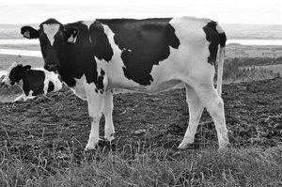
DEPARTMENT H03 (JUNIOR DAIRY & DUAL-PURPOSE CATTLE)
Entries Close 11:59 pm Mon. July 10, 2023

Check-in Wednesday, August 2, 12:00 pm – 3:00 pm
Judging Thursday, August 4, 11:00 am
Check-out Sunday, August 6:
1:00 pm for families with last names beginning with K - Z.
3:00 pm for families with last names beginning with A - J.

ENTRY FEE= $5.00 STALL FEE= $5.00 Exhibitor Pass Available

PREMIUMS (EXCEPT CHAMPION):
1st= $25.00 2nd= $20.00 3rd= $15.00 4th= $12.00 5th= $10.00 6th= $7.00

CHAMPION CLASSES: Entry Fee: 0
Premiums: 1st= $10.00 2nd= $5.00

JUNIOR, INTERMEDIATE & SENIOR: $17.00 cash award provided by the Ogle County Fair.
Any other Special awards shall be funded by the Department committee or sponsorships.

DAIRY COMMITTEE
Tom Snodgrass, Mt. Morris, Superintendent, Phone 815-291-4307
Ron Snodgrass, Oregon, Assistant Superintendent, Phone 815-973-1944
Myrna Snodgrass, Mt. Morris

GUIDELINES
- All General Rules and Animal Department Rules apply.
- Consult the 2023 Exhibition Livestock Health Requirements for information about health papers.
- An exhibitor may have 2 entries per class per Junior exhibitor.
- All breeding animals must be registered to show in purebred class, otherwise they will be shown in the grade class.
- Entries in the cow classes may or may not be in milk; however, animals in milk must show in cow classes.
- Registration papers are required for registered animals. NO EXCEPTIONS.
- Dairy must be stalled by 9:00 pm Wednesday, August 3.
- Exhibitors must clean their own stalls before leaving the Fair. The Dairy Committee will have spreaders available.
- Each exhibitor must remove all animals and thoroughly clean his/her stalls and place litter in a designated area by 8:30 pm on Sunday August 6, 2023, regardless of release time. Failure to do so will forfeit premiums.
- No pets in the barn.

Dairy Class Age Definitions:
Junior Heifer calf | Born on or after December 1, 2022
Senior Heifer calf | Born on September 1-November 30, 2022
Summer Yearling Heifer | Born on June 1-August 31, 2022
Junior Yearling Heifer | Born March 1-May 31, 2022
Winter Yearling Heifer | Born December 1, 2020 - February 28, 2022
Fall Yearling Heifer | Born September 1-November 30, 2021
2-3-Year-Old Cow | Born after September 1, 2019
Cow | Born before September 1, 2019
Dam & Daughter | Any age
Produce of Dam | Owned by one exhibitor - 2 daughters from one Dam
Best 3 Females | Owned by one exhibitor

DAIRY CLASSES
Department H03 Section 001 PUREBRED CLASS
Purebred Class | Ayrshire | Brown Swiss | Guernsey | Holstein | Jersey | Red/White Holstein
Junior Heifer Calf | 200 | 212 | 224 | 236 | 248 | 260
Senior Heifer Calf | 201 | 213 | 225 | 237 | 249 | 261
Summer Yearling Heifer. | 202 | 214 | 226 | 238 | 250 | 262
Junior Yearling Heifer. | 203 | 215 | 227 | 239 | 251 | 263
Winter Yearling Heifer | 204 | 216 | 228 | 240 | 252 | 264
Fall Yearling Heifer. | 205 | 217 | 229 | 241 | 253 | 265
Un-Fresh 2-year-old | 206 | 218 | 230 | 242 | 254 | 266
2-3-Year-Old | 207 | 219 | 231 | 243 | 255 | 267
Aged Cow | 208 | 220 | 232 | 244 | 256 | 268
Dam & Daughter | 209 | 221 | 233 | 245 | 257 | 269
Produce of Dam | 210 | 222 | 234 | 246 | 258 | 270
Best 3 Females | 211 | 223 | 235 | 247 | 259 | 271

Department H03 Section 002 GRADE CLASS
Grade Class | Ayrshire | Brown  Swiss | Guernsey | Holstein | Jersey | Red/White  Holstein
Junior Heifer Calf | 272 | 284 | 296 | 308 | 320 | 332
Senior Heifer Calf | 273 | 285 | 297 | 309 | 321 | 333
Summer Yearling Heifer. | 274 | 286 | 298 | 310 | 322 | 334
Junior Yearling Heifer. | 275 | 287 | 299 | 311 | 323 | 335
Winter Yearling Heifer. | 276 | 288 | 300 | 312 | 324 | 336
Fall Yearling Heifer. | 277 | 289 | 301 | 313 | 325 | 337
Un-Fresh 2-year-old | 278 | 290 | 302 | 314 | 326 | 338
2-3-Year-Old | 279 | 291 | 303 | 315 | 327 | 339
Aged Cow | 280 | 292 | 304 | 316 | 328 | 340
Dam & Daughter | 281 | 293 | 305 | 317 | 329 | 341
Produce of Dam | 282 | 294 | 306 | 318 | 330 | 342
Best 3 Females | 283 | 295 | 307 | 319 | 331 | 343

Department H03 Section 003 Purebred
Class 348 | Grand Champion & Reserve Purebred - Junior
Class 349 | Grand Champion & Reserve Purebred - Senior

Department H03 Section 004 Grade
Class 353 | Grand Champion & Reserve Grade- Junior
Class 354 | Grand Champion & Reserve Grade - Senior
Class 355 | Grand Champion & Reserve Grade – Over All Breeds

Department H03 Section 005 Showmanship
Class 359 | Junior Showmanship – Youth ages 8-11 as of Sept. 1, 2022
Class 360 | Intermediate Showmanship – Youth ages 12-14 as of Sept. 1, 2022
Class 361 | Senior Showmanship – Youth ages 15 or older as of Sept. 1, 2022

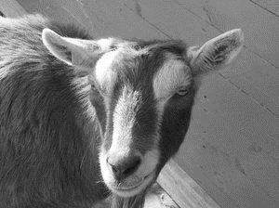
DEPARTMENT H05-H07
(JUNIOR DAIRY, MEAT, & PYGMY GOATS)
Entries Close 11:59 pm Mon. July 10, 2023

Check-in Wednesday, August 2, 12:00 pm – 3:00 pm
Weigh-in Thursday, August 3, 3:00 pm – 4:00 pm
Judging Sunday, August 7, 9:00 am as follows: Dairy, Meat, Pygmy, Pet, Showmanship
Production Milk-Out Thursday, August 3, 7:30 am & 7:30 pm
Check-out Sunday, August 6:
1:00 pm for families with last names beginning with K - Z.
3:00 pm for families with last names beginning with A - J.

ENTRY FEE= $4.00 STALL FEE= $5.00 Exhibitor Pass Available

PREMIUMS (EXCEPT CHAMPION):
1st= $10.00 2nd= $9.00 3rd= $8.00 4th= $7.00 5th= $6.00 6th= $5.00

CHAMPION CLASSES: Entry Fee: 0
Premiums: 1st= $10.00 2nd= $5.00

JUNIOR, INTERMEDIATE & SENIOR: $17.00 cash award provided by the Ogle County Fair.
Any other Special awards shall be funded by the Department committee or sponsorships.

GOAT COMMITTEE
Katrina Ring, Oregon – Superintendent Phone 779-861-0026
Annette Martin, Oregon, Asst. Superintendent Phone 815-757-4828
Cheryl Price, Mt Morris.
Julie Meridian, Dixon
Amber & Ray Kosick, Mt. Morris

GUIDELINES
- Only allowed to have 1 entry per class.
- All General Rules and Animal Department Rules apply.
- Consult the 2023 Exhibition Livestock Health Requirements for information about health papers. NO animal with draining sores or abscesses, will be allowed in the barn.
- Goats must be stalled by 3:00 pm on August 2, 2023. At this time, the committee will be available for any questions regarding the show.
- All exhibitors are advised to show in the showmanship class, according to their age level. Please sign up for the appropriate class. Pre-registration is required to receive a premium.
- For goats susceptible to jumping or crawling out of pens, pens must be reinforced with panels. No unsupervised tying allowed.
- Wethers must have been castrated by 3 months of age or by June 1, 2023.
- NO bucks will be allowed to be shown.
- Tattoo numbers, tag ID, or microchip number must be listed on the entry forms when registering for the show. If a substitution must be made because of death or serious illness of the animal, you must contact the Goat Committee prior to bringing the animal to the fair.
- Do not unload your animal until superintendent or committee member is present. Health Papers and entry forms will be verified against tattoo, tag, or chip numbers (exhibitor must provide a reader) before animals come off trailer.
- No early releases except for health reasons.
- If there are insufficient entries in a class, classes may be combined at the discretion of the Goat Committee.
- All classes, excluding wethers, showmanship, and pet goat, are entered with does only.
- All goats that are brought to the fairgrounds must be entered to be shown, except for nursing kids or nursing does with respective family.
- All Dairy Goat Entries must include tattoo numbers, tag IDs, and microchip numbers.
- Tack stalls will be assigned as available.
- Both animals shown in Dam & Daughter must have been shown in an individual class, excluding showmanship.
- On early release, all pens must be cleaned, and bedding put in manure spreader. Also see General Animal Rules #15 on page 15.
- Any assistance in showing needs to be provided by a Junior Exhibitor.
- If your animal is due the week of the fair, please contact the goat committee to make arrangements.
- Each exhibitor must remove all animals and thoroughly clean his/her pens and place litter in a designated area by 8:30 pm on Sunday August 6, 2023, regardless of release time. Failure to do so will forfeit premiums.
- No added entries at Showtime.
- No pets in the barn.
- The goat committee reserves the right to move you animal to a different class or category (dairy, meat, or pygmy) if entered in wrong one based on characteristics of the goat.
- PLEASE DO NOT SIGN UP FOR CHAMPION AND GRAND CHAMPION CLASSES.

DAIRY GOAT SHOW RULES
- No horned Purebred dairy goats allowed on the fairgrounds. Crossbreds are allowed to have horns.
- Exhibitors are encouraged to wear white pants and shirts while showing their animals.
- Dairy goat females will be broken up into purebreds and crossbreds. Registration papers are not required for purebreds. Please make sure they are strictly high percentage or purebreds. Put all other goats into the crossbred classes.
- All dairy goat wethers will be shown together no matter if purebred or crossbred.
- Dry does must have never kidded.
- All registered goats must be tattooed or microchipped (must provide a reader) according to American Dairy Goat Association (ADGA) rules. Unregistered goats must have a permanent tattoo in left ear. If you have any questions regarding ADGA rules, contact a member of the Goat Committee.
- All dairy goats should be clipped and groomed to exhibit. No exceptions.
- Milk Production Class competition – an age female (purebred or crossbred). All does will be milked out no later than 7:30 am, if a doe was milked out earlier, she must be stripped out again at 7:30 am. Does will then be milked at 7:30 pm, and the milk will be weighed. Placement of goats will be based on the amount of milk yielded at this time.
- All milkers must be milked out at 7:30 pm the night before the show.

- Purebred recognized by the ADGA: Alpine, LaMancha, Nigerian Dwarf, Nubian, Oberhasli, Saanen, Sable, and Toggenburg.
- Crossbreds can be a cross of any dairy breed including those crossed with pygmy (Nubian/Pygmy and Nigerian Dwarf/Pygmy).
- Champion purebred and crossbred will be shown against each for Grand Champion.

MEAT GOAT SHOW RULES
- Exhibitors are encouraged to wear white pants and shirts while showing their animals.
- All meat goat breeds will be shown together.
- All Registered goats must be tattooed according to American Boer Goat Association (ABGA) rules, and unregistered goats must have a permanent tattoo or tag in the left ear.
- All meat goat entries must include tattoo numbers, tag ID number, or microchip numbers. If microchipped, the exhibitor must provide a reader.
- Meat goat breeds include: Boer, Kiko, Mytonic, Savanna, Spanish, Texmaster, and Fainting. You may also show a crossbred meat goat.

PYGMY GOAT SHOW RULES
- The choice of the Goat Committee is to allow horned Pygmy goats for shows. The owner/show person is responsible for the actions of their animals. Any damage of property, or injury, shall be assumed by the owner/show person.
- Exhibitors are encouraged to dress neatly while showing their animals.
- All Pygmy goats should be shown with a collar and lead. No choke collars. It is recommended that the collar and lead are of the same color.
- All goats should be properly groomed to exhibit. No exceptions.
- All registered goats must be tattooed or tagged and match registration certificate, and unregistered goats must have a permanent tattoo or tag in the left ear.
- All Pygmy entries must include tattoo numbers, tag numbers, or microchip numbers, and premises ID on entry form. If microchipped, the exhibitor must provide a reader.

PET GOAT SHOW RULES
- Class will be judged according to care, knowledge and handling of the pet goat.
- This animal cannot be entered in any other class besides showmanship if it is the exhibitor’s only goat.
- Must be wether or female of any age.

Dairy Goat Class & Age Definitions

Department H05 Section 001 Milk Production Class
400 | Milk Production | Any age female (purebred or crossbred)

Department H05 Section 002 Purebred Dairy Dry Classes
Purebred female goats, never to have been in milk.
401 | Junior Doe Kid | Born on or after May 1, 2023
402 | Int. Doe Kid | Born April 1, 2023 to April 30, 2023
403 | Senior Doe Kid | Born January 1, 2023 through March 31, 2023
404 | Dry Yearling | Under 2 years, born after July 1, 2021 through December 31, 2022

Department H05 Section 003 Purebred Dairy Milking Classes
Purebred female goats, all animals to be in milk (except Dam & Daughter Class).
405 | Yearling Milker | Under 2 years, born after July 1, 2021
406 | Milker | 2 yrs. and under 3 yrs. – born July 1, 2020 to June 30, 2021
407 | Milker | 3 yrs. And under 5 years. – born July 1, 2018 to June 30, 2020
408 | Milker | 5 yrs. And older – born before July 1, 2018

Department H05 Section 004 Purebred Dairy Goat Other Class
409 | Dam and Daughter | Any age animal

Department H05 Section 005 Crossbred Dairy Dry Classes
Crossbred female goats, never to have been in milk.
410 | Junior Doe Kid | Born on or after May 1, 2023
411 | Int. Doe Kid | Born April 1, 2023 to April 3, 2023
412 | Senior Doe Kid | Born January 1, 2023 through March 31, 2023
413 | Dry Yearling | Under 2 years, born after July 1, 2021 through December 31, 2022
Department H05 Section 006 Crossbred Dairy Milking Classes
Cross bred female goats, all animals to be in milk (except Dam & Daughter Class).
414 | Yearling Milker | Under 2 years, born after July 1, 2021
415 | Milker | 2 yrs. and under 3 yrs. – born July 1, 2020 to June 30, 2021
416 | Milker | 3 yrs. And under 5 years. – born July 1, 2018 to June 30, 2020
417 | Milker | 5 yrs. And older – born before July 1, 2018

Department H05 Section 007 Crossbred Dairy Goat Other Class
418 | Dam and Daughter | Any age animal

Department H05 Section 008 Dairy Goat Wether Classes
419 | Wether | 1 year and under – born on or after August 1, 2022
420 | Aged Wether | Over 1 year – born before August 1, 2022

Department H05 Section 009 Dairy Goat Champion Classes
421 | Champion & Reserve Milk Producer
422 | Champion & Reserve Purebred Dry Doe
423 | Champion & Reserve Purebred Milker
424 | Champion & Reserve Purebred Dairy Dam & Daughter
425 | Champion & Reserve Crossbred Dry Doe
426 | Champion & Reserve Crossbred Milker
427 | Champion & Reserve Crossbred Dairy Dam & Daughter
428 | Grand Champion & Reserve Dry Doe
429 | Grand Champion & Reserve Milker
430 | Grand Champion & Reserve Dairy Dam & Daughter
432 | Grand Champion & Reserve Dairy Wether

Meat Goat Classes & Age Definitions

Department H06 Section 001 Meat Goat Classes
433 | Doe Kid – 0-6 months | born on or after February 1, 2023
434 | Doe Kid - 7-12 months | born after August 1, 2022 to January 31, 2023
435 | Doe Kid – 1 year and under 2 year | born August 1, 2021 to July 31, 2022
436 | Doe – 2 years and under 3 years | Born August 1, 2020 to July 31, 2021
437 | Doe – 3 years and older | Born before August 1, 2020

Department H06 Section 002 Other Class
438 | Dam & Daughter | Any aged animals

Department H06 Section 003 Wether Class
439 | Wether | born on or after January 1, 2023

Department H06 Section 004 Meat Goat Champion Classes
440 | Champion & Reserve Meat Doe Kid
441 | Champion & Reserve Meat Doe
442 | Champion & Reserve Meat Dam & Daughter
444 | Grand Champion & Reserve Meat Wether
Pygmy Goat Classes & Age Definitions

Department H07 Section 001 Pygmy Goat Kid Classes
445 | Junior Doe Kid - 0-3 months | born May 1, 2023, to July 31, 2023
446 | Intermediate Doe Kid - 3-6 months | born February 1, 2023, to April 30, 2023
447 | Sr. Doe Kid – 6-12 months | born August 1, 2022, to January 31, 2023

Department H07 Section 002 Pygmy Goat Doe Classes
448 | Junior Doe – 1-2 years | born August 1, 2021 to July 21, 2022
449 | Intermediate Doe – 2-3 years old | Born August 1, 2020 to July 31, 2021
450 | Senior Doe – over 3 years | Born before August 1, 2020

Department H07 Section 003 Pygmy Goat Other Class
451 | Dam and Daughter | any age animal

Department H07 Section 004 Pygmy Goat Wether Classes
452 | Wether – 1 year and under | Born on or after August 1, 2022
453 | Wether – over 1 year | Born before August 1, 2022

Department H07 Section 005 Pygmy Goat Champion Classes
454 | Champion & Reserve Pygmy Doe Kid
455 | Champion & Reserve Pygmy Doe
456 | Champion & Reserve Pygmy Dam & Daughter
458 | Grand Champion & Reserve Pygmy Wether

Other Goat Classes

Department H07 Section 006 Pet Goat Class
459 | Pet Goat | any age or breed of Goat. See Pet Goat rules.

Department H07 Section 007 Pet Goat Award
460 | Grand Champion & Reserve Pet Goat

Department H07 Section 008 Goat Showmanship Classes
461 | Junior Showmanship – Youth ages 8-11 as of Sept. 1, 2022
462 | Intermediate Showmanship – Youth ages 12-14 as of Sept. 1, 2022
463 | Senior Showmanship – Youth ages 15 or older as of Sept. 1, 2022

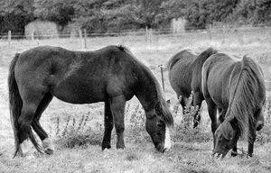
DEPARTMENT H08 (JUNIOR HORSES)
Entries Close 11:59 pm Mon. July 10, 2023

All horse on grounds and checked in - Saturday, August 5, 2023, no later than 7:30 am
Judging - Saturday, August 5, 2022, at 8:30 am.

PRE-ENTRY FEES: $5.00 No Exhibitor Pass Required
POST ENTRY FEES: $7.00

PREMIUMS (EXCEPT CHAMPION):
1st= $25.00 2nd= $20.00 3rd= $15.00 4th= $12.00 5th= $10.00 6th= $7.00

CHAMPION CLASSES: Entry Fee: 0
Premiums: 1st= $10.00 2nd= $5.00

JUNIOR, INTERMEDIATE & SENIOR: $17.00 cash award provided by the Ogle County Fair (No Entry Fee). Any other Special awards shall be funded by the Department committee or sponsorships.

HORSE COMMITTEE:
Lynne Radville, Superintendent, Phone: 815-238-7892
Ogle Co. Horse Barn Committee (aka Build-A-Barn)

GUIDELINES
- All General Rules and Animal Department Rules apply.
- Consult the 2023 Exhibition Livestock Health Requirements for information about health papers. All horses must have current negative Coggins. A copy of a negative Coggins must be on grounds and shown at check-in.
- Entries must be made on Horse entry form with attached Cover Form. All entry forms must be completed and only 2 entries per class per individual Junior.
- Ages are determined by exhibitors age as of September 1, 2022. Junior division is for ages 8-11. Intermediate division is for ages 12-14. Senior division is for ages 15-20.
- All riders must wear an approved Safety helmet when mounted anywhere on the fairgrounds. This includes all Classes, warm up, and at the gate.
- All halter classes can be shown in English, hunt seat, or western attire, but proper show attire is required for all classes.
- Horses are to be kept in the area designated by the Committee on show day.
- Special classes have been identified for Equine 56" and under (Animals may be measured before judging.)
- No stallions (except suckling’s) allowed.
- All classes, unless otherwise stated, are open to horses or ponies and mares or geldings.
- Horse rider combination in the Green Rider Walk Trot may not enter any other performance class.
- All props used in the Costume Class must be on the horse or Junior Exhibitors. Keep in mind this class is for fun and originality.
- Classes may be combined at the discretion of the committee.

- Any horse showing signs of illness will be asked to leave at the discretion of the committee.
- Speed horses will be required to enter the arena at a controlled manner, then begin their pattern. The gate will be closed and remain closed until the rider has regained control to exit the arena at a walk.
- Judge’s decision is final.
- Exhibitors are required to clean up their horse tie out area before leaving the fairgrounds.

HORSE CLASSES

Department H08 Section 001 SHOWMANSHIP CLASSES No Entry Fee or Premiums
Class 498 | Junior Showmanship – Youth ages 8-11 as of September 1, 2022
Class 499 | Intermediate Showmanship – Youth ages 12-14 as of September 1, 2022
Class 500 | Senior Showmanship – Youth ages 15 or older as of September 1, 2022

Department H08 Section 002 HALTER CLASSES
Class 501 | Junior Horse (horse ages 5 and under)
Class 502 | Registered Quarter Horse
Class 503 | Color Breed
Class 504 | Stock Type Western
Class 505 | English Type – Morgan, Arabian, Saddlebred, etc. – no stock breeds
Class 506 | Equine Under 56”

Department H08 Section 003 PERFORMANCE CLASSES
Class 507 | Equine 56” and Under
Class 508 | Junior Horse (horse ages 5 and under)
Class 509 | Green Rider Walk Trot (see Rule #11)
Class 510 | Open Walk Trot
Class 511 | Junior English Equitation
Class 512 | Senior English Equitation
Class 513 | Junior Open Pleasure
Class 514 | Senior Open Pleasure
Class 515 | Disciplined Rail
Class 516 | Color Breed Pleasure
Class 517 | Junior Western Horsemanship (ages 8-14)
Class 518 | Senior Western Horsemanship (ages 15 and older)
Class 519 | Open Bareback

Department H08 Section 004 NOVELTY CLASSES
Class 520 | Junior Egg-N-Spoon
Class 521 | Senior Egg-N-Spoon
Class 522 | Open Costume

Department H08 Section 005 SPEED CLASSES
Class 530 | Junior Poles
Class 531 | Senior Poles
Class 532 | Junior Barrels
Class 533 | Senior Barrels
Class 534 | Junior Flag
Class 535 | Senior Flag
Class 536 | Junior Plug
Class 537 | Senior Plug

DEPARTMENT H09 (JUNIOR POULTRY)
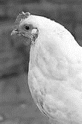
Entries Close 11:59 pm Mon. July 10, 2023

Check-in Wednesday, August 2, 12:00 pm – 3:00 pm
Judging – Sunday, August 6, 2022, 9:00 am
Check-out Sunday, August 6:
1:00 pm for families with last names beginning with K - Z.
3:00 pm for families with last names beginning with A - J.

ENTRY FEE= $2.50 PEN FEE= $1.00 Exhibitor Pass Available

PREMIUMS (EXCEPT CHAMPION):
1st= $7.50 2nd= $6.50 3rd= $5.50 4th= $4.75

CHAMPION CLASSES: Entry Fee: 0 Premiums: 1st= $10.00

SHOWMANSHIP: Entry Fee: 0 Premiums: 1st -$17.00

JUNIOR, INTERMEDIATE & SENIOR: $17.00 cash award from the Ogle County Fair.
Any other Special awards shall be funded by the Department committee or sponsorships.

POULTRY COMMITTEE
Chelsea Eden, Oregon, Superintendent, Phone 815-677-8681
Mary Beth Overmyer, Oregon, Asst. Superintendent, Phone 815-289-7236
Earl Hagemeyer, Esmond
Larry & Avolene Stengel, Mt Morris
Deb Sweeny, Monroe Center

GENERAL ENTRY GUIDELINES
- All General Rules and Animal Department Rules apply.
- Consult the 2023 Exhibition Livestock Health Requirements for information about health papers. Papers will be checked.
- Limit one entry per class. All entries are 1 bird, unless noted.
- Entries must be submitted using the Poultry Entry Form with Cover Sheet attached. Participants must provide a phone number where they can be reached during the fair.
- Poultry will be judged according to the American Poultry Association Standard of Perfection and American Bantam Association Standard.
- All entries must have their adult feathers, unless in the Hatched Pen Class.
- All Junior Exhibitors must be present during judging of their project.
- Birds hatched before to January 1, 2023, shall be entered as cock or hen; if hatched during current calendar year, then enter as cockerel or pullet. January 1 is also the break for waterfowl/turkeys whether considered old or young for the entry.
- Exhibitors must provide food, water, containers, and care for their animals. The committee takes no responsibility. The animals/pens will be checked twice daily for food, water, and cleanliness. A list of care requirements will be in the barn. After second offense, premiums will be forfeited.
- No selling or for sale signs.
- No pets in the barn.

CHECK-IN PROCEDURES
- All entries must be checked in between 5:00 pm and 8:00 pm, August 2, 2023. Late arrivals will be scratched from the show.
- Poultry must be clean, presentable, and free of pests (lice/mites) at check-in.
- Junior Exhibitors with any large bird projects such as geese, turkeys, or peacocks are required to bring their own cage.

CHECK-OUT PROCEDURES
- Entries are released at 4:00 pm, August 6, 2023. Contact a committee member if animals cannot be removed and cleaned by 5 pm.
- All Junior Exhibitors must clean up after removal of poultry and have committee member sign you out.

POULTRY CLASSES: BREED LIST
- LARGE FOWL CHICKEN CLASSES
American: Plymouth Rocks, Dominiques, Wyandottes, Javas, Rhode Island Reds, Buckeyes, Chanteclers, Jersey Giants, New Hampshires, Delawares, White Rocks, Barred Rocks, and Partridge Rock.
Asiatic: Brahmas, Cochins and Langshans
English: Dorkings, Cornish, Orpingtons, Sussex, and Australorps.
Mediterranean: Leghorns, Minorcas, Spanish, Andalusians, Sicilian Buttercups, and Catalanas.
Continental: Hamburgs, Campines, Polish, Houdans, Faverolles, Crevecoeurs, La Fleche Barnevelders, and Welsummers.
All Other Standard Breeds: Games, Sumatras, Yokohamas, Phoenix, Naked Necks, Araucanas, and Ameraucanas (Non-recognized breeds should enter here but cannot be chosen for class Champion.
- BANTAM CHICKEN CLASSES
Feather Legged Bantams: Booted, Brahmas, Cochins, Faverolles, Frizzles, Langshans, Silkies, and Sultans.
All Other Bantam Breeds: Any standard breeds without feathered legs.
- WATERFOWL CLASSES
Heavy Weight Ducks: Pekin, Aylesbury, Rouen, and Muscovy.
Medium Weight Ducks: Cayuga, Crested, Swedish, and Buff.
Light Weight Ducks: Runner, Campbell, and Magpie.
Bantam Ducks: Call, Black East Indie, and Mallard.
Heavy Weight Geese: Toulouse, Embden, and African.
Medium Weight Geese: Sebastopol, Pilgrim, American Buff, and Saddleback Pomeranian.
Light Weight Geese: Chinese, Tufted Roman, Canada, and Egyptian.
- OTHER POULTRY CLASSES
Production Pen of 3: Commercial/Hybrid eggs layers, all sex-link crosses, Cinnamon Queen, Amberlink, ISA
Meat Birds: Cornish Rocks, Red Rangers, etc. Meat birds will be weighed at check-in.
Broiler or fryer: a young chicken with live weight less than 6.7 pounds.
Roaster: a young chicken with a live weight of 6.7 pounds.
- Hatched Pen Class: Birds must not have all their adult feathers and must have been hatched using an incubator tended by the exhibitor. Incubators are available for loan through the Extension Office. Hatched Pen entries will be displayed and judged in the Rabbit/Poultry area. Exhibitors must provide heat lamps and electrical cords for chicks. Hatched pen entries include the following: 1) a pen of hatched birds; 2) a poster, display, or report detailing things learned during the incubation and embryology experience. Detailed information about chick development within the egg can be found in the Extension Office. Placing will be based on care of birds in exhibit, quality of the display, poster, or report, and the member’s general knowledge about the project on display.
- All Other Pair of Fowl: Birds not eligible in any other class may be shown in this class. Possible entries for this class include pigeons, pheasant, quail, doves, peacocks, and guineas. These birds may be housed singly or in pairs. Ratites (birds that cannot fly) are excluded due to facility limitations. Since standards may not exist for all entries, primary judging considerations will focus on handler knowledge and show condition of stock.
- Costume Class: The handler and bird must be in costume. No baby chicks.
- Egg Classes: All eggs in an entry must be of the same kind and will be judged on uniformity and quality and should be from the exhibitor’s flock. ALL Eggs Entries will be on displayed in the exhibit building.
  - Decorated Egg Classes: 3 eggs on a paper plate. Painted, crafty, anything goes. Judge will determine placing by creativity, neatness, and presentation.

POULTRY CLASSES

Department H09 Section 001 LARGE FOWL CLASSES
 | American | Asiatic | English | Mediterranean | Continental | Other Std Breed
Hen | 540 | 544 | 548 | 552 | 556 | 560
Cock | 541 | 545 | 549 | 553 | 557 | 561
Pullet | 542 | 546 | 550 | 554 | 558 | 562
Cockerel | 543 | 547 | 551 | 555 | 559 | 563

Department H09 Section 002 BANTAM CLASSES
 | All Other Bantam | Feather Legged Bantam
Hen | 564 | 566
Cock | 565 | 567
Pullet | 568 | 570
Cockerel | 569 | 571

Department H09 Section 003 EGG PRODUCTION & MEAT PEN CLASSES
Production Pen of 3 | 572 | Can be 1 male & 2 females or 3 females or 3 males
Broiler Fryer Pen of 3 | 573 | 3 females or 3 males
Roaster Market Pen of 3 | 574 | 3 females or 3 males

Department H09 Section 004 DUCK CLASSES
 | Heavy Weight | Medium Weight | Light Weight | Bantam Ducks
Old Hen | 575 | 579 | 583 | 587
Old Drake | 576 | 580 | 584 | 588
Young Hen | 577 | 581 | 585 | 589
Young Drake | 578 | 582 | 586 | 590

Department H09 Section 005 GEESE CLASSES
 | Heavy Weight | Medium Weight | Light Weight
Old Hen | 591 | 595 | 599
Old Gander | 592 | 596 | 600
Young Hen | 593 | 597 | 601
Young Gander | 594 | 598 | 602

Department H09 Section 006 TURKEY CLASSES
Old Hen | 603 | Hatched before January 1, 2023
Old Tom | 604 | Hatched before January 1, 2023
Young Hen | 605 | Hatched January 1, 2023, or after
Young Tom | 606 | Hatched January 1, 2023, or after

Department H09 Section 007 MISC OTHER CLASSES
Pair of Other Fowl | 607 | May be same sex or mixed
Hatched Pen | 608 | Very recently hatched -- 2023
Costume Class | 609 | Exhibitor and bird in costume
White Chicken Eggs | 610 | 6 eggs, in carton
Brown Chicken Eggs | 611 | 6 eggs, in carton
All Other Eggs | 612 | 6 eggs, in carton (Bantam, Waterfowl, Turkey, etc.)
Decorated Eggs (3) | 613 | Youth ages 8—11 as of Sept. 1, 2022
Decorated Eggs (3) | 614 | Youth ages 12—14 as of Sept. 1, 2022
Decorated Eggs (3) | 615 | Youth ages 15— and up as of Sept. 1, 2022

Department H09 Section 008 POULTRY CHAMPION CLASSES
Do not register for Champion Classes.
American | 620 | Grand Champion |  | Goose | 629 | Grand Champion
Asiatic | 621 | Grand Champion |  | Duck | 630 | Grand Champion
Continental | 622 | Grand Champion |  | Turkey | 631 | Grand Champion
English | 623 | Grand Champion |  | Meat Pen | 632 | Grand Champion
Mediterranean | 624 | Grand Champion |  | Production Pen | 633 | Grand Champion
All Other Std Breeds | 625 | Grand Champion |  | Decorated Eggs | 634 | Grand Champion
Feather Leg | 626 | Grand Champion |  | Eggs | 635 | Grand Champion
All Other Bantams | 627 | Grand Champion |  | Best of Show | 636 | Grand Champion
Department H09 Section 009 SHOWMANSHIP CLASSES
No Entry Fee for Showmanship
Junior Showmanship | 640 | Youth ages 8-11 as of Sept. 1, 2022
Intermediate Showmanship | 641 | Youth ages 12-14 as of Sept. 1, 2022
Senior Showmanship | 642 | Youth ages 15 or older as of Sept. 1, 2022

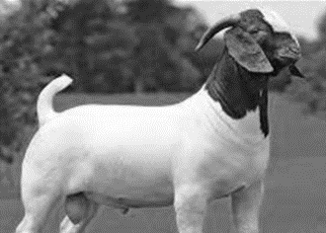
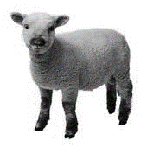
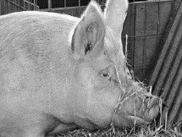
DEPARTMENT H10 (JUNIOR QUALITY MEATS)
Entries Close 11:59 pm Mon. July 10, 2023

Check-in Beef - Wednesday, July 26, 2023, 5:00 – 6:00 pm, at Nordman Feedlots, 1154 S. Blackhawk Rd., Oregon
Check-in Goats, Sheep and Swine - Thursday, July 27, 2023, 7:00 – 8:00 am, Ogle County Fairgrounds, Oregon
Judging - Monday, July 31, 2023, 8:30 am Eckman’s Locker, Seward Judges & Committee only. At 11:00 am open to exhibitors & public.

ENTRY FEE= $4.00 NO Exhibitor Pass Required

PREMIUMS (EXCEPT CHAMPION):
1st= $20.00 2nd= $17.00 3rd= $14.00 4th= $10.00 5th= $6.00 6th= $4.00

QUALITY MEATS COMMITTEE
Michael Ring, Oregon, Superintendent, Phone 815-757-3021
Mark Eden, Oregon, Assistant Superintendent, Phone 815-677-1711
Chelsea Eden, Oregon
Stan Eden, Oregon
Katrina Ring, Oregon

GUIDELINES
- All General Rules and animal Department Rules apply.
- This show is open to all Ogle County and Adjoining Counties Junior Residents with purebred, crossbred, or grade beef, sheep, goat, or swine projects. Only barrows, wethers, and steers may be shown. To qualify steers, barrows, and wethers must meet the same requirements as outlined for the regular Junior Show, plus any rules following.
- Health Certificates are not needed for carcass entries.
- Each exhibitor may enter one (1) animal in each Quality Meats Class.
- A card about 2 inches by 4 inches with project, class, owner’s name, and age must be provided by the owner at the time of the check in.
- Weight of animals:
  - Barrows 240 pounds Minimum live weight to 325 pounds Maximum live weight
  - Wethers 45 pounds minimum hot carcass weight
  - Steers 900 pounds minimum live weight
  - Animals not meeting above guidelines will not be eligible for champion or reserve.
- Official weight will be pay weight for carcasses sold at the auction.
- All animals will be taken to the Eickman's Plant at Seward for weighing, slaughtering, and cooling.

- Market Beef Animals will be delivered to Nordman Feed Lots on Wednesday, July 26, 2023, between the hours of 5:00 pm and 6:00 pm to be weighed. Sheep and Swine Market Animals will be delivered to Ogle County Fairgrounds on Thursday, July 27, 2023, between the hours of 7:00 am and 8:00 am. Entries will be weighed in at delivery time. The committee will deliver all animals to Eickman’s Locker from the fairgrounds.
- Beef, Sheep, and Swine taken to Eickman's are the responsibility of the owner.
- YOU ARE NOT ALLOWED TO SELL CARCASSES IN THE QUALITY MEATS AUCTION UNLESS YOU WERE ENROLLED IN THE OGLE COUNTY 4-H PROJECT. All carcasses not in this 4-H project should be sold privately or put in one’s own freezer.
- The animals will be judged on the rail and cut-out data collected on Monday, July 31, 2023.
- Barrow carcasses will be judged on inches of backfat, (.4" minimum) and loin-eye areas. Currently approved standards for Illinois Pork Carcass Shows will be followed. Loin muscle will be evaluated for color, marbling, and firmness.
- At the discretion of the Quality Meats Committee, any questionable or late castrated hogs will be disqualified.
- Steers will be judged on maximum yield grade of 3.99 and minimum quality grade of high select (S+). Carcass gain per day will be used in determination of rankings.
- Wethers will be judged on maximum yield grade of 3.99; have at least 0.10 inch of fat cover at the rib eye (2.6 minimum REA); have a quality grade of low choice or better (C-) a minimum leg score of 13 and meet minimum rib eye area requirements based on hot carcass weight.
- Animals entered in these classes that do not make the weight range can be shown in the market class at the Junior Show.
- All steers, wethers, and barrows must be such beyond any doubt. Judge will make final decisions. All calves must be steers (not bulls) at tattooing time.
- 2023 OWNERSHIP DEADLINES - All Quality Meats animals must be owned by the registered participant:
Beef | February 1, 2023
Goat | May 1, 2023 | purchased after Sept 1, 2022
Sheep | May 1, 2023
Swine | May 2, 2023 | Do not have to be tattooed
- All wethers must be sheared before the show.
- All Quality Meats entries must be made on Quality Meats Entry Forms.
- Steers must have been weighed and tattooed by February 18, 2023, or a date arranged and agreed upon by the Beef Committee and Extension staff.

Department H10 Section 001 QUALITY MEATS CLASSES
Class 620 | Swine
Class 621 | Sheep
Class 622 | Beef
Class 623 | Goat

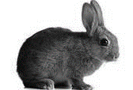
DEPARTMENT H11 (JUNIOR RABBIT)
Entries Close 11:59 pm Mon. July 10, 2023

Check-in Wednesday, August 2, 12:00 pm – 3:00 pm
Judging – Saturday August 5, 2022, 9:00 am.
Check-out Sunday, August 6:
1:00 pm for families with last names beginning with K - Z.
3:00 pm for families with last names beginning with A - J.

ENTRY FEE= $2.50 PEN FEE= $1.00 Exhibitor Pass Available

PREMIUMS (EXCEPT CHAMPION):
1st= $6.00 2nd= $5.00 3rd= $4.00 4th= $3.50 5th= $3.00 6th= $2.75

CHAMPION CLASSES: Entry Fee: 0 Premiums: 1st= $10.00 2nd= $5.00

JUNIOR, INTERMEDIATE & SENIOR: $17.00 cash award provided by the Ogle County Fair.
Any other Special awards shall be funded by the Department committee or sponsorships.
RABBIT COMMITTEE
Lydia Zabran, Byron, Superintendent, Phone 815-985-3907
Kristine Griffin, Polo, Assistant Superintendent, Phone 815-677-1107
Mary Beth Overmyer, Oregon
Chelsea Eden, Oregon
Earl Hagemeyer, Esmond
Larry & Avolene Stengel, Mt. Morris
Travis Zabran, Byron

GUIDELINES
- All General Rules and animal Department Rules apply.
- Consult the 2023 Exhibition Livestock Health Requirements about information about health papers.
- All rabbits will be inspected by a Rabbit Committee member prior to placing them in the cages. The Rabbit Committee reserves the right to reject any entry. Rabbits with colds, ear mites or open sore hocks will not be accepted.
- All rabbits must have either temporary or permanent ear I.D. markings.
- All exhibits must be brought in from 12:00 pm to 3:00 pm, August 2 and will not be released until 1:00 pm, August 6. Animals penned before check-in or taken out before release time will forfeit awards unless agreements have been made in advance with the Rabbit Superintendent or Assistant.
- <NEW 2023> Only two entries per class.
- Exhibitors must be present during judging.
- Rabbits must be entered on the Rabbit entry form with Cover form attached.
- Single fryers should weigh minimum of 3.5 lbs. and maximum of 5.5 lbs. per rabbit and may not be over 70 days old.
- Cages will be furnished on a first come, first served basis, after that each Junior Exhibitors must furnish their own cages. Only Exhibitors who help set up can reserve cages. Exhibitors must provide their own dishes & heavy crocks or water bottles. The cages (pens) will be checked twice daily for adequate food and water and cleanliness. A list of requirements will be listed in the barn. After second offence premium will be forfeited.
- Each exhibitor is responsible to feed & water their rabbits each day they are kept at the Fair. The committee DOES NOT assume this responsibility.
- PEN MEAT RABBITS includes 3 rabbits--each weighing a minimum of 3.5 lbs. and maximum of 5.5 lbs. per rabbit and may not be over 70 days old. Rabbits will be weighed.
- All Junior Exhibitors must clean up after removal of the rabbits. Exhibitors will not be released until their cage areas have been checked.
- Rabbits will be judged according to ARBA Guidelines.
- Each exhibitor must remove all animals and thoroughly clean his/her pens; place litter in a designated area by 6:00 pm on Sunday August 7, 2022, and checkout with a committee member. Failure to do so will forfeit premiums.
- No selling of animals during fair. “For sale” signs to be approved by committee.
- No pets in the barn.
- Class 636 Butcher Carcass – Entries for this class should be brought to the fairgrounds dressed. Dress with heart and liver intact. The committee will not be responsible for dressing. Exhibitors should plan to bring their own appropriate storage containers (coolers). Live weight of dressed animals should be 3 ½ - 5 lbs. Carcasses will be released after judging concludes.
- Production Class: Mother & Offspring. “3 babies required, not less than 4 weeks old, not more than 3 months old.”

RABBIT CLASSES

Department H11 Section 001 MEAT RABBITS
629 | Market Pen – All Other Breeds
630 | Single Fryer – Any Breed
632 | Junior Doe Meat Breed
633 | Junior Buck Meat Breed
634 | Senior Doe Meat Breed
635 | Senior Buck Meat Breed
636 | Butcher Carcass – must be Iced in cooler

Department H11 Section 002 FANCY RABBIT
 | Mini-Rex, Rex | All other breeds | (Lop)
Junior Doe | 637 | 641 | 645
Junior Buck | 638 | 642 | 646
Senior Doe | 639 | 643 | 647
Senior Buck | 640 | 644 | 648

Department H11 Section 003 CROSSBRED RABBIT
649 | Junior Doe Crossbred
650 | Junior Buck Crossbred
651 | Senior Doe Crossbred
652 | Senior Buck Crossbred

Department H11 Section 004 PRODUCTION
 | Meat | Fancy | Crossbred
Mother & 3 Offspring | 670 | 671 | 672

Department H11 Section 005 Junior, Intermediate, & Senior Showmanship
(No entry fee for classes below)
654 | Grand Champion & Reserve Production Mother & 3 Offspring
657 | Champion & Reserve Market Pen - All Other Breeds
658 | Champion & Reserve Single Fryer
659 | Grand Champion & Reserve Meat Pen
660 | Champion & Reserve MiniRex & Rex
661 | Champion & Reserve Lop
662 | Champion & Reserve All Other Breeds
663 | Best of Show & Best Reserved AFL Show
664 | Grand Champion & Reserve Fancy Rabbit
665 | Grand Champion & Reserve Crossbred Rabbit
667 | Junior Showmanship – Youth ages 8-11 as of Sept. 1, 2022
668 | Intermediate Showmanship – Youth ages 12-14 as of Sept. 1, 2022
669 | Senior Showmanship – Youth ages 15 or older as of Sept. 1, 2022

NOTES:
Meat Classes Consist of the Following Breeds:
Californian Flemish Giant New Zealand Palomino Satin

Fancy Classes Consist of the Following Breeds:
Angora Dutch Havana Jersey Wooly Lop – Holland
Mini Polish Rex Mini Rex Silver Martin Lion Head

DEPARTMENT H12 (JUNIOR SHEEP)
Entries Close 11:59 pm Mon. July 10, 2023

Check-in Wednesday, August 2, 12:00 pm – 3:00 pm
Weigh-in - Thursday, August 2, 2022, 3:00 – 4:00 pm
Judging – Saturday, August 6, 2022, 8:30 am
Check-out Sunday, August 6:
1:00 pm for families with last names beginning with K - Z.
3:00 pm for families with last names beginning with A - J.

ENTRY FEE= $4.00 STALL FEE= $5.00 Exhibitor Pass Available

PREMIUMS (EXCEPT CHAMPION):
1st= $15.00 2nd= $13.00 3rd= $11.00 4th= $9.00 5th= $7.00 6th= $6.00

CHAMPION CLASSES: Entry Fee: 0 Premiums: 1st= $10.00 2nd= $5.00

JUNIOR, INTERMEDIATE & SENIOR: $17.00 cash award provided by the Ogle County Fair.
Any other Special awards shall be funded by the Department committee or sponsorships.

Forreston Sheep Association is offering $25.00 cash award or $25.00 credit to be used toward the purchase of a sheep. Youth will have to make the choice about which award they choose immediately upon winning an award.

SHEEP COMMITTEE
Amy Ewald, Byron, Superintendent, Phone 815-378-8895
Matt Swanson, Stillman Valley, Assistant Superintendent, Phone 815-742-0930
Sarah Hackbarth, Lindenwood
Michele Swanson, Stillman Valley
Garrett Hackbarth,

GUIDELINES
- All General Rules and Animal Department Rules apply.
- Consult the 2023 Exhibition Livestock Health Requirements for information about health papers.
- All sheep must have Scrapies ID ear tag and endorsement on health papers stating that the sheep are not showing clinical signs of Scrapies to be allowed on the fairgrounds.
- All sheep exhibited must be ear tagged or tattooed for identification and will be checked into the entry book with these numbers. Purebred papers will be checked. Times for check-in will be posted in the barn. Scrapies Ear Tag also.
- All sheep to be stalled by 3:00 pm, August 2, 2023.
- All lambs must be less than one year old and have lambs’ teeth (all small teeth) Yearling ewes must be one year old and under two based on September 1 cut-off date. Mouth characteristics of a yearling are no more than two large permanent incisors. All sheep will be mouthed by the judge and over-aged sheep will be disqualified.
- Two entries and two premiums per exhibitor are allowed per class, except Group classes.
- Senior and Junior lamb classes split as follows: For Cheviots, Oxford, Shropshires, and Southdowns – September 1 - February 15 for Seniors; February 16 and after for Juniors. For all other breeds: September 1 - December 31 for Seniors; January 1 and after for Juniors.
- Commercial Classes are for entries of grade or crossbred sheep and must be slick shorn in the previous 30 days. A separate award for Champion commercial ewe is given and therefore these ewes are not eligible for other overall awards.
- Pair of Lambs Class can be either or both sexes.
- Market lamb classes: Market lambs may be either ewes or wethers, however, these same ewe lambs may not be shown in the breeding classes. Wether lambs must be castrated or pinched prior to June 1. Market Lambs must be 80 pounds minimum weight. A total of 3 market lambs are allowed per exhibitor (not more than 2 per class) and 1 pair of market lambs. Market lambs must be slick shorn within 5 days of show. All market lambs must have ear tags.
- Market lambs will be weighed Thursday August 3, 2023, at 3:00-4:00 pm. Classes may be combined at the discretion of the Sheep Superintendent.
- Registration papers will not be required for market lambs, but animals must carry breed characteristics. The Sheep Superintendent will make final decision.
- All Junior exhibitors must show their own sheep and when two entries in a class, they must find the assistance of another Junior exhibitor.
- Each exhibitor must remove all animals and thoroughly clean his/her pens and place litter in a designated area by 8:30 pm on Sunday August 6, 2023, regardless of release time. Failure to do so will forfeit premiums.
- No pets in the barn.
- Show order is at the discretion of the superintendent.

SHEEP CLASSES

Department H12 Section 001 MARKET LAMBS CLASSES
(Enter as Light Weight, and they will be put in appropriate weight class)
Breed | Light Weight | Medium Weight | Heavy Weight
Columbia | 667 | 668 | 669
Southdown | 670 | 671 | 672
Dorset | 673 | 674 | 675
Suffolk | 676 | 677 | 678
Hampshire | 679 | 700 | 701
Corriedale | 702 | 703 | 704
Montadale | 705 | 706 | 707
Oxford | 708 | 709 | 710
Any other Purebred | 711 | 712 | 713
Crossbred & Grade | 714 | 715 | 716
Pair Whiteface Market Lambs | 717 | 718 | 719
Pair Blackface Market Lambs | 720 | 721 | 722

Department H12 Section 002 BREEDING SHEEP
Breed | Senior Ewe Lamb | Junior Ewe Lamb | Yearling Ewe | Ram Lamb | Young Flock | Pair of Lambs | Pair of Yearling Ewes
Southdown | 730 | 731 | 732 | 733 | 734 | 735 | 736
Suffolk | 737 | 738 | 739 | 740 | 741 | 742 | 743
Columbia | 744 | 745 | 746 | 747 | 748 | 749 | 750
Oxford | 751 | 751 | 753 | 754 | 755 | 756 | 757
Hampshire | 758 | 759 | 760 | 761 | 762 | 763 | 764
Montadale | 765 | 766 | 767 | 768 | 769 | 770 | 771
Corriedale | 772 | 773 | 774 | 775 | 776 | 777 | 778
Other Purebred Wool | 779 | 780 | 781 | 782 | 783 | 784 | 785
Other Purebred Meat | 786 | 787 | 788 | 789 | 790 | 791 | 792
Commercial | 793 | 794 | 795 |  |  | 796

Department H12 Section 003 SHOWMANSHIP-MARKET & PUREBRED
800 | Junior Showmanship – Youth ages 8-11 as of Sept. 1, 2022
801 | Intermediate Showmanship – Youth ages 12-14 as of Sept. 1, 2022
802 | Senior Showmanship – Youth ages 15 or older as of Sept. 1, 2022

Department H12 Section 004 SPECIALTY CLASS & BREEDING CHAMPIONS
807 | Grand Champion & Reserve Market Lamb
808 | Grand Champion and Reserve Flock
809 | Grand Champion and Reserve Purebred Ewe Lamb
810 | Grand Champion and Reserve Purebred Yearling Ewe
811 | Grand Champion and Reserve Purebred Ram Lamb
812 | Grand Champion and Reserve Purebred Pair of Lambs
813 | Grand Champion and Reserve Purebred Pair Yearling Ewes
814 | Grand Champion and Reserve Commercial Ewe
815 | Grand Champion and Reserve Overall Female
816 | Champion Black face market
817 | Champion White face market
818 | Grand pair of market lambs

DEPARTMENT H13 (JUNIOR SWINE)
Entries Close 11:59 pm Mon. July 10, 2023

Check-in Wednesday, August 2, 12:00 pm – 3:00 pm
Weigh-in Wednesday, August 2, 3:00 pm – 6:00 pm
Judging – Friday, August 4, 2022, 8:00 am.
Check-out Sunday, August 6:
1:00 pm for families with last names beginning with K - Z.
3:00 pm for families with last names beginning with A - J.

ENTRY FEE= $4.00 STALL FEE= $5.00 Exhibitor Pass Available

PREMIUMS (EXCEPT CHAMPION):
1st= $14.00 2nd= $13.00 3rd= $12.00 4th= $11.00 5th= $10.00 6th= $9.00

CHAMPION CLASSES: Entry Fee: 0 Premiums: 1st= $10.00 2nd= $5.00

JUNIOR, INTERMEDIATE & SENIOR: $17.00 cash award provided by the Ogle County Fair.
Any other Special awards shall be funded by the Department committee or sponsorships.

SWINE COMMITTEE
Joe Eden, Byron, Superintendent, Phone 815- 721-4921
Mark Eden, Oregon, Assistant Superintendent, Phone 815-677-1711
Alan Alderks, Monroe Center
Michaela Eden, Oregon
Adrianne Hall, Monroe Center
Brian & Janet Hall, Monroe Center
Todd Seaworth, Lindenwood
Kolton Myrvold, Oregon
Cassidy Myrvold, Oregon

GUIDELINES:

Before the Fair:
- All General Rules and Animal Department Rules apply.
- Consult the 2023 Exhibition Livestock Health Requirements for information about health papers. Secure health papers within 90 days of the fair.
- Exhibitors should strive to have their hogs weighing between 220 and 325 pounds by fair time.
- Secure breed papers showing ownership prior to fair for exhibitors showing purebreds in the breeding gilt classes or the purebred barrow classes.
- Must have ownership of all swine on or before May 1, 2023.

Weigh In/Check In:
- All swine must be weighed and penned by 6:00 pm on August 2, 2023. Weighing will start at 3:00 pm and conclude when all pigs are weighed.
- Veterinary papers must be provided to swine committee prior to unloading of animals.
- Provide breed papers showing ownership to swine committee during check in.
- Early arrivals must be approved by phoning superintendent or assistant and provide a copy of health papers before arrival.

During the Fair:
- Exhibitors are responsible for the proper care of their animals until the conclusion of the Fair.
- Pens must be kept dry and clean! All swine are to be bedded with wood shavings, no straw or paper will be allowed.
- Pigs will be penned two per pen. An exhibitor showing six pigs will have a maximum of three pens. Exhibitors should be prepared to pen two pigs up in each of their pens. Any tack pens or extra pens will be assigned fairly at the discretion of the swine committee.

Check out:
- Exhibitor must remove all animals and thoroughly clean his/her pens and place litter in a designated area by 5:30 pm on Sunday, August 6, 2023. Failure to do so will result in forfeiture of premiums.

Swine Show Regulations/Information:
- All hogs must be born on or after December 15, 2022.
- Any pig under 220 pounds cannot show. Any pig over 325 cannot show for Grand Champion. There are no upper weight restrictions for breeding gilts. All crossbreds and purebred barrows are limited to 325 pounds.
- Each exhibitor will be allowed to show up to six hogs. An exhibitor may show any combination of hogs, gilts and barrows, all gilts, or all barrows, as long as the number shown does not exceed six. An individual hog may only participate in one individual class- gilt- purebred breeding, crossbred breeding, or market class, barrow- purebred or market class.
- An exhibitor may show a total of two pair; he/she may show either two gilt pairs or two barrow pairs or one pair of each barrows and/or gilts. A pair must consist of two barrows and/or two gilts. A purebred barrow and a market barrow may show as a pair. A breeding gilt and a market gilt may show as a pair.
- Breed papers showing ownership will be required for all swine entered in purebred classes.
- Breeding Gilts: All Purebred Breeding Gilts will be divided based on their breed. Purebred gilt classes will be as follows: Duroc, Hampshire, Yorkshire, White AOB (Chester White and Landrace breeds), and Dark AOB (Berkshire, Poland China, Spotted Poland’s, and Hereford breeds). If numbers permit within any breed, there will be two weight classes. Breeds will be joined/split based on numbers of each breed. Champion and Reserve Champion of each class will be awarded. All crossbred breeding gilt classes will be divided by their weight. The winners of each crossbred breeding class will compete for Champion Crossbred Breeding Gilt. 2nd place class winners should be ready to enter champion drive. Breed Class Grand Champions and the Grand Champion Crossbred Breeding Gilt will compete for the TOP 5 Breeding Gilt Honors. Reserve Champion 2nd Place Purebred Gilts and Reserve Champion Crossbred Breeding Gilt should be on deck to enter the ring when necessary.
- Market Animals: All Market Gilts will show in classes based on weight. All class winners will compete for Champion Market Gilt. 2nd place class winners should be ready to enter champion drive if necessary. All Purebred Barrows will show by their weight. Purebred barrow classes will be as follows: Duroc, Hampshire, Yorkshire, White AOB (Chester White and Landrace breeds), and Dark AOB (Berkshire, Poland China, Spotted Poland’s, and Herford breeds). If numbers permit within any breed, there will be two weight classes. Breeds will be joined/split based on numbers of each breed. All Market Barrows will show in classes based on weight. All class winners will compete for Champion Market Barrow. 2nd place class winners should be ready to enter champion drive if necessary. Champion Market Gilt, Purebred Class Grand Champions, and the Grand Champion Market Barrow will compete for the TOP 5 Market Honors. The Reserve Champion Market Gilt, Reserve Champion 2nd Place Purebred Barrows, and Reserve Champion Market Barrow should be on deck to enter the ring when necessary.
- PAIRS: Exhibitor may choose to show a total of two pairs; he/she may show either two gilt pairs or two barrow pairs or one pair of each barrows and/or gilts. Purebred barrows will be allowed to be shown as part of the pair of barrows class. Also, a breeding gilt and a market gilt may be shown as a pair of gilts. Pairs will be divided by combined weight. Gilt Pair Class Winners will show for Champion Gilt Pair, 2nd Place Class Winners should be ready to enter champion drive. Barrow Pairs Class Winners will show for Champion Barrow Pair, 2nd Place Winners should be ready to enter champion drive.
- Crossbred breeding gilts and purebred breeding gilts will be judged as gilts suitable for breeding stock. Market Gilts, Market Barrows, and Purebred Barrows will be judged as premium market swine.
- At the discretion of the fair veterinarian and the swine committee, any questionable or late castrated swine will not be allowed to show.
- This is not a terminal show.
- No pets in the barn.

SWINE CLASSES

Enter ALL Swine in the LIGHT Class!
Swine will be put in appropriate class based on weigh-in weight.

Department H13 Section 001 MARKET CLASS
 | Light-Light | Light | Light-Medium | Light-Heavy | Medium | Heavy-Light | Heavy-Medium
Market Gilt |  | 800 | 801 | 802 | 803 | 804 | 805
Market Barrow | 806 | 807 | 808 | 809 | 810 | 811 | 812

Department H13 Section 002 PUREBRED BARROW
Barrow Purebred Duroc | 815
Purebred Hampshire Barrow | 816
Purebred Yorkshire Barrow | 817
Purebred White All Other Breeds | 818
Purebred Dark All Other Breeds | 819

Department H13 Section 003 BREEDING GILT
Purebred
Purebred Duroc Breeding. Gilt | 822
Purebred Hampshire Breeding Gilt | 823
Purebred Yorkshire Breeding Gilt | 824
Purebred White Breeding Gilt | 825
Purebred Dark Breeding Gilt | 826
Crossbred
Crossbred Light Breeding Gilt | 827
Crossbred Light Heavy Breeding Gilt | 828
Crossbred Medium Breeding Gilt | 829
Crossbred Heavy Light Breeding Gilt | 830
Crossbred Heavy Medium Breeding Gilt | 831

Department H13 Section 004 PAIR OF GILTS
 | Light | Light-Medium | Light-Heavy | Medium | Heavy-Light | Heavy-Medium
Pair of Gilts | 834 | 835 | 836 | 837 | 838 | 839

Department H13 Section 005 PAIR OF BARROWS
 | Light-Light | Light | Light-Medium | Light-Heavy | Medium | Heavy-Light
Pair of Barrows | 842 | 843 | 844 | 845 | 846 | 847

Department H13 Section 006 CHAMPION CLASS
850 | Grand Champion and Reserve Purebred Breeding Gilt
851 | Grand Champion & Reserve Crossbred Breeding Guilt
852 | Grand Champion and Reserve Market Gilt
853 | Grand Champion and Reserve Market Barrow
854 | Grand Champion and Reserve Purebred Barrow
855 | Grand Champion and Reserve Pair of Gilts
856 | Grand Champion and Reserve Pair of Barrows
857 | Junior Showmanship – Youth ages 8-11 as of Sept. 1, 2022
858 | Intermediate Showmanship – Youth ages 12-14 as of Sept. 1, 2022
859 | Senior Showmanship – Youth ages 15 or older as of Sept. 1, 2022

Top 5 Breeding Gilt awards and Top 5 Market Swine awards will be funded by the swine committee and local business sponsorships.

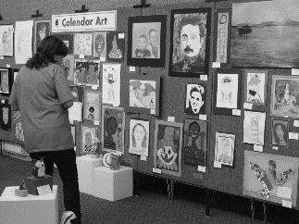
Junior Show
Exhibit Building
Department P

Entries Close 11:59 pm Mon. July 10, 2023

Check-in for all General Exhibits (excluding Junior Foods, Horticulture, Crops & Soils) – Sunday, July 30, 2023, 1:00 - 5:00 pm.

Check-in for Junior Foods, Horticulture, Crops & Soils – Tuesday, August 1, 2023, 3:30 - 5:30 pm.

Judging – Tuesday, August 1, 2023 – 6:00 pm.

Check-out Sunday, August 6, 1:00 pm

Absolutely no early checkouts unless released by Junior Show Exhibit Superintendents. Any projects left after 4 pm are not the responsibility of Ogle County Fair Committee.

ENTRY FEE= $1.00 per entry NO Exhibitor Pass Required

PREMIUMS (EXCEPT CHAMPION):
1st= $4.00 2nd= $3.50 3rd= $2.50
There will be NO checks mailed out, but every effort will be made to have checks available late Sunday August 6, 2023. Otherwise, check pick up will be Monday August 7, 2023, 9:00 am to 4:00 pm at the fair office.

EXHIBIT COMMITTEE
Chris Carter, Stillman Valley, Superintendent Phone 815 985-5621
Sarah Berkowski, Stillman Valley Assistant Superintendent 815-721-6281

JR. SHOW EXHIBITION RULES AND GUIDELINES
- Junior classes are open to boys/ girls who are at least 8 years of age and not yet 21 years of age on or before September 1, 2022. This is for all classes unless a class specifically states otherwise.
- Exhibitors under 8 years of age as of September 1, 2022, should enter classes specifically designed for their age group. Please read age and experience requirements for each department and class.
- Exhibitors under 8 years of age as of September 1, 2022, may enroll in the following classes.
  - The following class is for ages 8 and under only
    - Visual Arts: Beginning Artwork (1020 1036)), original and non-original
  - The following classes are for all ages including 8 and under.
    - Mechanical Science: Tractor Science (1153)
    - Mechanical Science: Kite (1155)
    - Life Skills: I Design (1175)
    - Life Skills: I Make Theater (1176)
    - Computer Generated Art (1179)
    - Animal Science: classes 1231 – 1239, 1243 (under 8 may NOT enroll in classes 1240-1242)
- All exhibits must be checked in by the designated time frame. NO exhibits will be accepted after check-in.
- Projects must have tags attached; picking up tags does not qualify as having your project checked in. Exhibits must be physically there and entered by a Superintendent.
- Projects entered as a 4-H project cannot be entered as a Junior Show project in the same year. Separate exhibits are required for 4-H projects and for Junior Show exhibits. Previous 4-H projects can be entered as a Junior Show project.
- No previously premium-awarded Junior Show project may be entered again.
- Every project entered in Junior Show requires an entry tag with age and years of experience in project area. Entry tags are distributed at time of check-in.
- Projects must be whole and complete with all elements and parts intact at time of check-in. Missing parts or elements cannot be brought in after check-in.
- All Junior Exhibitors may enter 1 project in each class.
- Please, follow all directions specific to your exhibit class carefully. Projects failing to follow guidelines may be rejected. Make sure your poster, display area, container, art, etc. meets requirements.
- NO SIZE LIMITS unless specified under class description - please contact supervisor ahead of entry day for any extra-large projects to prepare space.
- Displays are defined as 3 dimensional exhibits that sit on the floor or table.
- Posters / exhibits to be hung require hanging device firmly attached that can support the weight of the exhibit. Items not secured as directed, risk lower grade of award.
- Please, keep track of check-in, checkout, and premium pick-up times as listed in the schedules.
- No equipment will be provided for any exhibits. This includes extension cords, computers, projectors, or laptops.
- Exhibits illustrating inappropriate subject matter and/or graphics that are not acceptable for general public viewing or deemed inappropriate for audiences of youth will not be displayed.

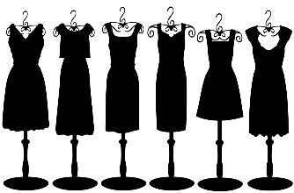
DEPARTMENT P14 (JUNIOR CLOTHING)
Entries Close 11:59 pm Mon. July 10, 2023

Check-in – Sunday, July 30, 2023, 1:00 - 5:00 pm.
Judging – Tuesday, August 1, 2023 – 6:00 pm.
Check-out Sunday, August 6, 1:00 pm

ENTRY FEE= $1.00 per entry NO Exhibitor Pass Required

PREMIUMS: 1st= $4.00 2nd= $3.50 3rd= $2.50

GUIDELINES
- All exhibits must conform to Jr. Show Exhibition Rules and Guidelines.
- Exhibitor is required to supply appropriately sized clear plastic bag to protect their exhibit.
- Junior Exhibits in Clothing and Knitting cannot be the same exhibit for 4-H. Separate exhibits must be made for Junior and 4-H Show.
- All garments must have been constructed during the current year, unless it was shown in the 4-H Show the previous year.
- All garments must be fresh, clean and in good condition worthy of being judged and must be the work of the exhibitor.
- Clothing will be judged on garment construction.
- Wool Garments will be released early if the exhibitor plans to wear those garments in the Sheep Lead Class Competition at the Fairgrounds.
- Theme Costume must be 75% fabric. Judging will be on best use of theme and assembly techniques.

DEPARTMENT P14 Section 001 CLOTHING
900 | Blouse | Exhibit 1 blouse
901 | Knit Top | Exhibit 1 knit top
902 | Skirt | Exhibit 1 skirt
903 | Casual Dress | Exhibit 1 Casual dress
904 | Formal Dress | Exhibit 1 formal dress. (Ex: prom, bridesmaid, etc.)
905 | Theme Costume | Exhibit 1 costume that displays one clear theme. (Ex: Theater Play costume for a character, movie character or clothing that reflects a decade style)
906 | Holiday Costume | Exhibit 1 costume that best displays a holiday theme. (Ex: Christmas Elf, Halloween, etc. as long as appropriate for general public)
907 | Pants | Exhibit 1 pants
908 | Shorts | Exhibit 1 pair shorts
909 | Knitting | Exhibit 1 hand or machine knitted wearable item (Ex: scarf)
910 | Crocheting | Exhibit 1 hand crocheted wearable garment (Ex: scarf)

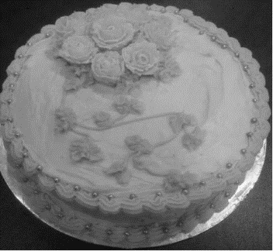
DEPARTMENT P15 (JUNIOR FOODS)
Entries Close 11:59 pm Mon. July 10, 2023

Check-in – Tuesday, August 1, 2023, 3:30 - 5:30 pm.
Judging – Tuesday, August 1, 2023 – 6:00 pm.
Check-out Sunday, August 6, 1:00 pm

ENTRY FEE= $1.00 per entry NO Exhibitor Pass Required

PREMIUMS: 1st= $4.00 2nd= $3.50 3rd= $2.50

FOODS COMMITTEE
Vickie Smith, Forreston, Superintendent Phone 815-938-2711 or 815-541-6924
Anna Henson, Dixon, Assist. Superintendent, Phone 815-757-4828

GUIDELINES
- All exhibits must conform to Jr. Show Exhibition Rules and Guidelines.
- Canned Fruits & Vegetables and Jellies; Preserves must be in regulation canning jar, half pint or pint. Fruits and Vegetables must be in pint or quart regulation canning fruit jars with a 2-piece lid and labeled with non-decorative labels. All canned items may be opened if judge desires. Paraffin sealed jars will not be judged.
- All baked goods must be made from scratch – no mixes are permitted.
- All baked goods except bread must be on white 7-inch plate sized disposable and must be covered with clear plastic bags (preferably zip-lock).
- If food products become decomposed or moldy, they will be disposed of.
- Junior Exhibits in foods cannot be the same item as 4-H Foods item. Separate products must be made for Junior and 4-H Show.
- Fancy cakes (Wedding Cakes, etc.) may be decorated on Styrofoam, cake pans, cardboard, etc. They are judged strictly on decoration.
- Wedding cakes are not to exceed 16" in diameter. All other decorated cakes have no size limit.
- Cakes are to have appropriate frame to support structure and be able to withstand display for fair. Frame is to be completely covered.

Department P15 Section 001 BAKING & CANDY CLASSES
(Place items in clear plastic bag if applicable)
 | 930 | Favorite Cookie | 3 Per Plate
 | 931 | Favorite Cake | Whole Cake 9x9 Round
 | 932 | Favorite Yeast Bread | Whole (in plastic bag only)
 | 933 | Favorite Quick Bread | Whole-(must include recipe)
 | 934 | Favorite Pie | Must have 2 crusts
 | 935 | Favorite Candy | Must include 4 pieces
 | 936 | Decorated Cake | May use forms for center. No size limit.
 | 937 | Best & Most attractive plate of Holiday Cookies | Exhibit 3 cookies. Decorate as desired. Recipe to be include.
 | 938 | Best & Most attractive plate of decorated cupcakes | Exhibit 3 decorated cupcakes suitable for a child's birthday party.
 | 939 | Best & Most attractive Edible Centerpiece | Use your creativity, kitchen tools (paring knives, peelers, etc.), fruit and/or vegetables, table centerpiece. Should be displayed on a large paper plate. Covering not necessary.
 | 940 | Exploring Our Food Heritage | Exhibit 3 cookies from an ethnic recipe. Include recipe. Identify ethnic group.

Department P15 Section 002 CANNED FRUITS & VEGETABLE CLASSES
941 | Applesauce
942 | Beets
943 | Beans
944 | Blueberries
945 | Blackberries
946 | Cherries
947 | Pickles
948 | Raspberries (red or black)
949 | Relish
950 | Salsa
951 | Any Other Canned Fruit
952 | Any Other Canned Vegetable

Department P15 Section 003 JAMS, JELLIES, PRESERVES CLASSES
953 | Favorite Marmalade
954 | Favorite Jam or Preserve
955 | Favorite Jelly

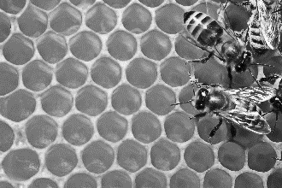
DEPARTMENT P16 (JUNIOR BEEKEEPING)
Entries Close 11:59 pm Mon. July 10, 2023

Check-in – Sunday, July 30, 2023, 1:00 - 5:00 pm.
Judging – Tuesday, August 1, 2023 – 6:00 pm.
Check-out Sunday, August 6, 1:00 pm

ENTRY FEE= $1.00 per entry NO Exhibitor Pass Required

PREMIUMS: 1st= $4.00 2nd= $3.50 3rd= $2.50

GUIDELINES
- All exhibits must conform to Jr. Show Exhibition Rules and Guidelines.
- No size limit.

Department P16 Section 001 BEEKEEPING
1000 | Use of Beeswax | Display 1 or more items showing the use of Beeswax – Molded or Sculpted or in homemade product. Ex: hand cream, lip gloss, wax candle (include recipe).
1001 | Hive Products | A basket or box of hive products. Display in a basket or appropriate container. Products containing honey or beeswax or produce from a beehive.
1002 | Beekeeping informational display. | Entries must consist of an item depicting Beekeeping in an informational manner.

DEPARTMENT P17 (JUNIOR VISUAL ARTS)
Entries Close 11:59 pm Mon. July 10, 2023

Check-in – Sunday, July 30, 2023, 1:00 - 5:00 pm.
Judging – Tuesday, August 1, 2023 – 6:00 pm.
Check-out Sunday, August 6, 1:00 pm

ENTRY FEE= $1.00 per entry NO Exhibitor Pass Required
PREMIUMS: 1st= $4.00 2nd= $3.50 3rd= $2.50

GUIDELINES
- All exhibits must conform to Jr. Show Exhibition Rules and Guidelines.
- All art entered must have been made by exhibitor.
- Exhibits entered cannot be the same as 4-H exhibits. Previous 4-H projects may be entered into current Junior Show. Previous premium-awarded Junior Show projects may not be entered again.
- Exhibitors may enter one project per class.
- Request to have date when made. Please list on source card.
- It is strongly recommended that any flat visual art project (i.e., painting, pen & ink, etc.) be matted and framed. Oil and acrylic projects do not require mats. All other projects (i.e., watercolor, chalk, etc.) must be matted.
- No size limits unless stated within a specific class.
- All projects should either be prepared to hang or displayed with secure hanging device.
- Original classes refer to works of art that have been created solely by the exhibitor. It is a product of the creator’s imagination, research, and/or work, resulting in a piece entirely of the creator.
- Non-original classes refer to a product not of the creator’s own imagination, research, and/or work. It is art made using kits, molds, pre-formed models, and trademarks or copyright patterns. Projects made from article patterns or pictures from websites or magazines can be used as a starting point that result in original designs. Dramatic changes must be made to the original design. Team or school logos are not original.
- The following classes are open to only ages 8 and under:
  - Class 1020 Beginning Artwork – Original
  - Class 1036 Beginning Artwork – Non-Original
- All projects may include a source card on a 3x5 or 4x6 note card; one source card per project. Recommended source cards should be attached to project & in a viewable, accessible area. Source cards are to be attached to project(s) at time of check-in.
- Source cards should include only the following information: the exhibitor’s name, date of birth, town of residence, project class number, class name, techniques used, where the idea came from, date project was made and what was done special.
Exhibitor Name
Date of Birth and Town of Residence
Class Number-Class Name

Technique: Cross-hatching

Date made: June 12, 2023

I got the idea for this exhibit from: school project where we had to create our own car.

What I did special for this exhibit: used several colors of pen to create the color and shading.

EXAMPLE SOURCE CARD:

Visual Arts Classes

Department P17 Section 001 VISUAL ARTS ORIGINAL ARTWORK
1010 | Paper-Original | Exhibit an original paper
1011 | Fiber-Original | Exhibit an original fiber
1012 | Clay-Original | Exhibit an original clay
1013 | Wood-Original | Exhibit an original wood
1014 | Pen/Ink/Pencil-Original | Exhibit an original pen/ink/pencil
1015 | Crayon/Marker-Original | Exhibit an original crayon/marker
1016 | Oil/Acrylic/Watercolor Painting-Original | Exhibit an original oil/acrylic/watercolor
1017 | Glass/Plastic-Original | Exhibit an original glass/plastic
1018 | Metal-Original | Exhibit an original metal
1019 | Leather-Original | Exhibit an original leather
1020 | Beginning Artwork-Original | Exhibit an original beginning artwork; only for 8 yrs. or under
1021 | Chalk/Pastel-Original | Exhibit an original chalk/pastel

Department P17 Section 002 VISUAL ARTS NON-ORIGINAL ARTWORK
1022 | Paper-Non-Original | Exhibit a non-original paper
1023 | Fiber-Non-Original | Exhibit a non-original fiber
1024 | Clay-Non-Original | Exhibit a non-original clay
1025 | Wood-Non-Original | Exhibit a non-original wood
1030 | Pen/Ink/Pencil- Non-Original | Exhibit a non-original pen/ink/pencil
1031 | Crayon/Marker- Non-Original | Exhibit a non-original crayon/marker
1032 | Oil/Acrylic/Watercolor Painting-  Non-Original | Exhibit a non-original oil/acrylic/watercolor
1033 | Glass/Plastic-Non-Original | Exhibit a non-original glass/plastic
1034 | Metal-Non-Original | Exhibit a non-original metal
1035 | Leather-Non-Original | Exhibit a non-original leather
1036 | Beginning Artwork-Non-Original | Exhibit a non-original beginning artwork; only for 8 yrs. or under
1037 | Chalk/Pastel-Non-Original | Exhibit a non-original chalk/pastel

Department P17 Section 003 VISUAL ARTS OTHER
1038 | Heritage Arts and Crafts | Exhibit a product based/created from traditional methods or created with a historical purpose
1039 | Scrapbook Memory Chapter | Exhibit sheets in protective covering or scrapbook memory chapter that displays one theme that reflects one story, memory or event.
1040 | 3-D Sculpture | Exhibit a piece that is made from single medium, such as clay, paper, wood carving, etc.
1041 | Mixed Media Painting | Exhibit a piece that can be seen from 3 sides and from at least 3 different materials. Piece is designed to be hung as a painting.

DEPARTMENT P19 (JUNIOR NATURAL RESOURCES & ENVIRONMENT)
Entries Close 11:59 pm Mon. July 10, 2023

Check-in – Sunday, July 30, 2023, 1:00 - 5:00 pm.
Judging – Tuesday, August 1, 2023 – 6:00 pm.
Check-out Sunday, August 6, 1:00 pm

ENTRY FEE= $1.00 per entry NO Exhibitor Pass Required

PREMIUMS: 1st= $4.00 2nd= $3.50 3rd= $2.50

GUIDELINES
- All exhibits must conform to Jr. Show Exhibition Rules and Guidelines.

Department P19 Section 001 NATURAL RESOURCES & ENVIRONMENT
1050 | Entomology | Display an accurately labeled collection of at least 15 species representing at least 4 orders.
1051 | Forestry | Make a display of at least 10 or more of leaves, samples of wood, or bark samples. Include correct identification of items, place found, and purpose for use (if applicable).
1052 | Geology | Display at least 10 rock/mineral specimens with accurate labels, where found, and any purpose for use (if applicable).
1053 | Soil and Water Conservation | Exhibit a poster showing soil or water conservation practices
1054 | Wildlife Conservation | Exhibit a poster or display of wildlife ecology or backyard wildlife. DO NOT include live animals as an exhibit part.
1055 | Natural Resources & Environment, other | Display any information relating to natural resources and/or the environment that does not fit in any of the above classes.

It is highly suggested that projects enrolled in Entomology, Forestry, and Geology include a small poster displaying experiences or information directly relating to project area; and an informational sheet describing the project due to the wide levels of experience. Posters should not exceed the outer boundaries of a project.

DEPARTMENT P20 (JUNIOR HORTICULTURE)
Entries Close 11:59 pm Mon. July 10, 2023

Check-in – Tuesday, August 1, 2023, 3:30 - 5:30 pm.
Judging – Tuesday, August 1, 2023 – 6:00 pm.
Check-out Sunday, August 6, 1:00 pm

ENTRY FEE= $1.00 per entry NO Exhibitor Pass Required

PREMIUMS: 1st= $4.00 2nd= $3.50 3rd= $2.50

GUIDELINES FOR FLORAL ARRANGEMENTS AND CUTS
- All exhibits must conform to Jr. Show Exhibition Rules and Guidelines.
- All exhibits must have been grown by exhibitor. The minimum possession of plants must be 90 days prior to exhibition unless Roadside Flowers. Foliage is judged as well as bloom. No leaf shine may be used on exhibited plants.
- Cut flowers should be cut 3-4 hours prior to show. Condition plants by placing in cool water out of drafts to maintain floral quality.
- Tag flowers with common name in a viewable location
- DO NOT use wiring, artificial color, florist green, or filler in specimen classes. Artificial color, florist green, and filler are allowed in Miniature Floral Arrangement class and in Natural Material.
- Exhibits are limited to Exhibit Building Rules. Unless made as a single large standing unit, all Floral Arrangement and Cuts projects are considered either a tabletop or other display.
- All flower specimens must have foliage. Gladioli and Daylilies are exempt from having foliage and are the only class to which this applies.
- Exhibits are to be set up and maintained solely by exhibitor. Junior Show committee members and the Ogle County Fair Association are not responsible for the care and maintenance of exhibits. Please plan accordingly for exhibit care. Failure to care properly for exhibit may result in premium and/or ribbon loss and exhibit to be taken off display.
- Previous premium and/or ribbon awarded plants may not be entered. Plants should be the product of the current year, including foliage and bloom. Perennial plants may be entered again, regardless if it has been previously premium and/or ribbon awarded.

Department P20 Section 001 GENERAL HORTICULTURE CLASSES
1070 | Miniature Floral Arrangement | Any small floral arrangement with a total dimension of 8” x 8” with container. Can be silk or real flowers but at least 50% must be made of real plant material such as foliage, flowers, twigs, etc.

Department P20 Section 002 GARDEN CUT FLOWERS CLASSES
1071 | Vase of Daylilies | Exhibit a minimum of 3 – 4 Stems
1072 | Vase of White Flowers | Exhibit a minimum of 3 – 4 Stems
1073 | Vase of Cut Roadside Flowers | Excludes dry material
1074 | Vase of Lavender Flowers | Exhibit 3-4 stems
1075 | Vase of Yellow Flowers | Exhibit 3-4 stems
1076 | Vase of Red Flowers | Exhibit 3-4 stems
1077 | Vase of Blue Flowers | Exhibit 3-4 stems
1078 | Vase of Pink Flowers | Exhibit 3-4 stems
1079 | Vase of Roses | Exhibit 3-4 stems
1080 | Vase of Marigolds | Exhibit 3-4 stems

GUIDELINES FOR VEGETABLES AND FRUITS
- All exhibits must conform to Jr. Show Exhibition Rules and Guidelines.
- All vegetables and fruits must have been grown by the exhibitor.
- Vegetables exhibits should be prepared according to VC-24-83-Horticulture Facts: Exhibiting Vegetables. Copies are available through Cooperative Extension Service Office.
- DO NOT use waxes and oils on vegetables.
- ALL exhibitors are expected to set up their own vegetable or fruit exhibits. Use appropriately sized containers or plates for exhibiting vegetables.
- Exhibits are limited to Exhibit Building Rules and Guidelines.
- Projects larger than allowed display area may be rejected. Unless otherwise stated, projects are considered either a tabletop or other display.
- NOTE: 1082 Fruit Basket & 1083 Vegetable basket category size is to NOT exceed 2’ x 2.5’.

Department P20 Section 003 VEGETABLES & FRUITS
1082 | Fruit Basket | - Include 4 and no more than 8 different fruits. There may not be more than 2 different varieties of any fruit.  - Number and type of fruits used must conform to the Vegetable & Fruit Plate Classes  - Display must be labeled with the name and variety of fruits.  - Exhibit must not exceed 2’ x 2.5’ display area
1083 | Vegetable Basket | - Must be 6 and not more than 12 different vegetables. There may not be more than 2 different varieties of any vegetables.  - Number and type of vegetables use must conform to the Vegetable & Fruit Plate Classes.  - Display must be labeled with the name and variety of vegetables.  - Exhibit must not exceed 2’ x 2.5’ display area.
1124 | Experimental or Educational Exhibit | Any vegetable/fruit gardening exhibit (experimental or educational) that does not fit into a class below. May be poster or display. Include explanation for public understanding.
1125 | Most Unusual or Odd Shaped Home-Grown Vegetable | Exhibit ONE not so perfect specimen from the individual vegetable plate class. Oddity must be result of natural growing.
1126 | Decorative Vegetable | Create a unique piece using vegetables only. Toothpicks and glue are allowed but no trims such as paper, markers, etc.

Department P20 Section 003 VEGETABLES & FRUITS
Vegetable and Fruit Plate (Classes 1084-1123 see below)
- May exhibit up to three different vegetable plates and three different fruit plates.
- Only one variety per plate.
- Vegetables or fruits of different varieties may not be shown as separate plates (i.e., red and yellow onions)
1084 | Apples | 5 apples |  | 1102 | Lettuce | 1 head or plant
1085 | Asparagus | 5 spears |  | 1103 | Muskmelon | 1 melon
1086 | Beans, Lima | 12 pods |  | 1104 | Okra | 12 okras
1087 | Beans, Snap, Golden Wax | 12 pods |  | 1105 | Onions, large dry | 5 onions
1088 | Beans, Snap, Green Pod | 12 pods |  | 1106 | Onions, green or set | 12 onions
1089 | Beets | 5 beets |  | 1107 | Parsnips | 5 parsnips
1090 | Blackberries | 1 pint |  | 1108 | Peaches | 5 peaches
1091 | Broccoli | 1 head |  | 1109 | Pears | 5 pears
1092 | Cabbage | 1 head |  | 1110 | Peas | 12 pods
1093 | Cauliflower | 1 head |  | 1111 | Peppers, large  fruited | 5  (bell/banana)
1094 | Carrots | 5 carrots |  | 1112 | Peppers, small  fruited | 12  (chili/cherry)
1095 | Cucumber, pickling | 5 cucumbers |  | 1113 | Plums | 5 plums
1096 | Cucumbers, slicing | 5 cucumbers |  | 1114 | Potato | 5 potatoes
1097 | Eggplant | 1 eggplant |  | 1115 | Pumpkin | 1 pie variety
1098 | *Greens | 1 plant (see below) |  | 1116 | Raspberry | 1 pint
1099 | Grapes | 3 clusters |  | 1117 | Squash, winter | 1 squash
1100 | Kohlrabi | 5 kohlrabi |  | 1118 | Squash, summer | 1 squash
1101 | Horseradish | 1 root |  | 1119 | Strawberries | 1 pint

*A green is considered one of the following: collard, endive, escarole, kale, mustard, or Swiss chard.
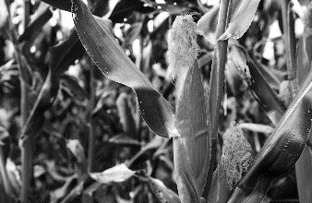
DEPARTMENT P21 (JUNIOR CROPS AND SOILS)
Entries Close 11:59 pm Mon. July 10, 2023

Check-in – Tuesday, August 1, 2023, 3:30 - 5:30 pm.
Judging – Tuesday, August 1, 2023 – 6:00 pm.
Check-out Sunday, August 6, 1:00 pm

ENTRY FEE= $1.00 per entry NO Exhibitor Pass Required

PREMIUMS: 1st= $4.00 2nd= $3.50 3rd= $2.50

GUIDELINES
- All exhibits must conform to Jr. Show Exhibition Rules and Guidelines.
- All crops and soils should be properly prepared. Soil should be washed off corn and soybean roots and should be displayed in a bucket of water or clear plastic bag so judges can see the full root system.
- Crops should be properly dug to show root systems. Corn plants should be dug one foot out from the corn stalk and 1.5 feet deep to get the best display of roots.
- Small grains include oat, wheat, rye, and barley.

Department P21 Section 001 GENERAL CROP & SOIL
1130 | Corn | Display 2 fresh corn plants to be representative of the field.
1131 | Soybean | Display 5 fresh soybean plants to be representative of the field.
1132 | Small Grain | Exhibit 1 gallon of small grain of the current year’s crop.
1133 | Hay | Exhibit 1 bale of hay.

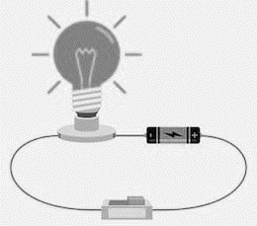
DEPARTMENT P22 (JUNIOR ELECTRICITY)
Entries Close 11:59 pm Mon. July 10, 2023

Check-in – Sunday, July 30, 2023, 1:00 - 5:00 pm.
Judging – Tuesday, August 1, 2023 – 6:00 pm.
Check-out Sunday, August 6, 1:00 pm

ENTRY FEE= $1.00 per entry NO Exhibitor Pass Required

PREMIUMS: 1st= $4.00 2nd= $3.50 3rd= $2.50

GUIDELINES
- All exhibits must conform to Jr. Show Exhibition Rules and Guidelines.

Department P22 Section 001 GENERAL ELECTRICITY
1141 | Electricity | Display one of the following items:  - Exhibit a circuit board that demonstrates current-battery wiring and components. Include a diagram of display with explanation of process. Ex: a switch to a bulb, rocket launcher, and burglar alarms, etc.  - Exhibit two electrical household circuits using 120V materials to comply with the National Electrical Code. Include one appliance with a simple on/off switch and one using a 3-way switch. Ex: light bulb with one switch, light bulb with two switches
1142 | Electricity/Safety | Exhibit a display or poster relating to safety around electricity; include examples and practices used when running electrical appliances, working with electrical machines, and when wiring

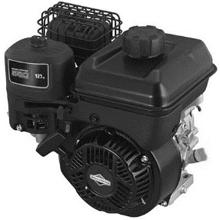
DEPARTMENT P23 (JUNIOR MECHANICAL SCIENCES)
Entries Close 11:59 pm Mon. July 10, 2023

Check-in – Sunday, July 30, 2023, 1:00 - 5:00 pm.
Judging – Tuesday, August 1, 2023 – 6:00 pm.
Check-out Sunday, August 6, 1:00 pm

ENTRY FEE= $1.00 per entry NO Exhibitor Pass Required
PREMIUMS: 1st= $4.00 2nd= $3.50 3rd= $2.50

GUIDELINES
- All exhibits must conform to Jr. Show Exhibition Rules and Guidelines.
- Small engine exhibits should be 20 horsepower or smaller.
- Airplane and Kites classes are exempt from any size limit.
- All Mechanical Science display will be static. They will not be flown, launched, or ran. Please plan appropriately.
- No Size Limit. Contact Superintendent if your display is a large project to plan for space.
- The following classes are open for all ages including ages 8 and under:
  - Class 1153 Tractor Science
  - Class 1155 Kite

Department P23 Section 001 GENERAL MECHANICAL SCIENCE
1150 | Small Engines I | Exhibit a display of one of the following items:  - Identify different engine or lawn and garden equipment parts.  - Show the function of various engine parts or lawn and garden equipment parts.  - Identify and explain tools needed for small engine work
1151 | Small Engines II | Exhibit a display of an over-hauled or rebuilt operable engine or piece of lawn and garden equipment. Include a maintenance schedule and a brief description of steps used in over- hauling or rebuilding.
1152 | Operating Safety | Exhibit a poster or display of safety practices used around and/or rebuilding engines or lawn and garden equipment
1153 | Tractor Science | Exhibit a poster or display of tractor care, maintenance, and/or safety care. All ages allowed.
1154 | Rocketry | Exhibit one model assembled by exhibitor. Model rocket should be in good flying condition. DO NOT include rocket engine with exhibit since rocket will not be launched. Include printed directions for construction of the rocket.
1155 | Kite | Exhibit one hand-made kite in good flying condition. All ages allowed.
1156 | Airplane | Exhibit one model airplane assembled by exhibitor that is in good flying condition. Include printed directions of airplane construction. Plane will not be launched.

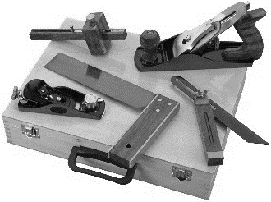
DEPARTMENT P24 (JUNIOR WOODWORKING)
Entries Close 11:59 pm Mon. July 10, 2023

Check-in – Sunday, July 30, 2023, 1:00 - 5:00 pm.
Judging – Tuesday, August 1, 2023 – 6:00 pm.
Check-out Sunday, August 6, 1:00 pm

ENTRY FEE= $1.00 per entry NO Exhibitor Pass Required

PREMIUMS: 1st= $4.00 2nd= $3.50 3rd= $2.50

GUIDELINES
- All exhibits must conform to Jr. Show Exhibition Rules and Guidelines.
- Woodworking projects are exempt from size limitations.
- Use best judgment when entering projects into a class. Well-done and elaborate projects may qualify under a higher level of woodworking.
- Exhibit Building personnel are not responsible for damage occurred at fair. If a project is delicate, easily damaged, or has safety concerns, bring appropriate precautionary measures to protect project to be placed after judging. These can include corner protectors, clear see-through cover (project must be able to be seen for viewing), and soft mats to be set onto. These items will not be furnished by the fair and is the responsibility of exhibitor to bring.

Department P24 Section 001 GENERAL WOODWORKING
1160 | Woodworking - Beginning | Display any wood item constructed or refinished by exhibitor; suggested 1-2 years of experience
1161 | Woodworking - Intermediate | Display any wood item constructed or refinished by exhibitor; suggested 2-4 years of experience
1162 | Woodworking - Advanced | Display any wood item constructed or refinished by exhibitor; suggested 4 or more years of experience

DEPARTMENT P25 (JUNIOR LIFESKILLS/COMPUTER SCIENCE)
Entries Close 11:59 pm Mon. July 10, 2023

Check-in – Sunday, July 30, 2023, 1:00 - 5:00 pm.
Judging – Tuesday, August 1, 2023 – 6:00 pm.
Check-out Sunday, August 6, 1:00 pm

ENTRY FEE= $1.00 per entry NO Exhibitor Pass Required

PREMIUMS: 1st= $4.00 2nd= $3.50 3rd= $2.50

GUIDELINES
- All exhibits must conform to Jr. Show Exhibition Rules and Guidelines.
- All work must be original. Copyrighted or trademark sources may be used as a beginning but must be put into exhibitor’s own words.
- Plan accordingly for items needed to run exhibits, and safety precautions. No computers will be furnished. Projects needing a power source should plan in advance for the items needed. Drop cords, etc. will not be furnished. Delicate projects should be properly protected by clear plastic or glass so long as the exhibit can be seen. For example, a miniature puppet can be placed under a glass dome with a stand.
- The following classes are open for all ages including ages 8 and under:
- 1175 I Design
- 1176 I Make Theater
- 1179 Computer Generated Art

Department P25 Section 001 GENERAL LIFESKILLS
1175 | I Design | Exhibit project on a poster/display by exhibitor relating to designing and/or decorating. Can be painting a room, fabric choices, and/or re-designing a bedroom or family room. Architecture designs, garden designs/planning, and other landscaping or building plans can be submitted in this category so long as they are detailed and well made. All ages allowed.
1176 | I Make Theater | Exhibit project on a poster or display relating to theater. This can be displaying original skits or plays made by exhibitor, miniature stage, theater sets, or clothing for actors and singers. Puppets qualify under this class. All ages allowed.
1177 | Computer Science -Beginning | For ages 10 or under as of January 1, 2021, OR for those with 2 years or less of experience. Exhibit a poster or display relating to computers, using computers, programming, running programs, etc.
1178 | Computer Science -Advance | For ages 11 or older as of January 1, 2021, OR for those with 3 years or more of experience. Exhibit a poster or display relating to computers, using computers, programming, running programs, etc.
1179 | Computer Generated Art | Create a piece of art in any software program. Can NOT be scanned work, clip art, downloaded images from any source, imported images from any source, or photographs. Pixels must be original. Photo mosaics are not allowed. Art can be colored or black and white. All ages allowed.

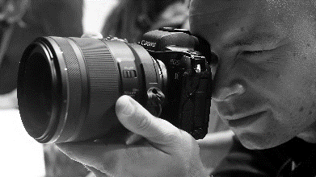
DEPARTMENT P26 (JUNIOR PHOTOGRAPHY)
Entries Close 11:59 pm Mon. July 10, 2023

Check-in – Sunday, July 30, 2023, 1:00 - 5:00 pm.
Judging – Tuesday, August 1, 2023 – 6:00 pm.
Check-out Sunday, August 6, 1:00 pm

ENTRY FEE= $1.00 per entry NO Exhibitor Pass Required

PREMIUMS: 1st= $4.00 2nd= $3.50 3rd= $2.50

GUIDELINES
- All exhibits must conform to Jr. Show Exhibition Rules and Guidelines.
- Each picture must follow appropriate guidelines. Photographs failing to comply may be rejected. Image size Minimum 5 x 7, Maximum 8 x 10; TOTAL MAX SIZE including frame for entries is 18” x 20”. Photos may be edge mounted. Appropriate titles may be included with the photograph so long as they do not cover the photograph. Titles may be attached to the bottom back of the mat, preferably so it is on the right side when looking on.
- Exhibit Building is not responsible for lost or damaged parts of photographs. If mat or title separate from the picture, it may be disqualified and taken off display.
- Secure photographs to mats using appropriate methods.
- Photos cannot be photo-shopped or computer enhancement. Black and White digital photos will be allowed to use program for dismissing color (Sepia or black and white will be accepted).
- One entry allowed per class. Duplication of photographs is not allowed (i.e., color and B&W of same photo entered into different classes). Duplicate photos may be disqualified and/or taken off display. Photographs must have been taken by exhibitor only. Exhibitors cannot claim other’s work or that of professionals.
- Digital photography is to have no computer enhancing or any digital program to enhance photo will be allowed except black and white and class #1202.
- Classes are defined as the following:
- Landscape/Cityscape: essentially scenery. A wide view normally of such things as mountains, pastures, rivers, waterfalls, rocks, or other natural formations or that of a broad view of a city. Person(s) is not the main focus of the picture.
- Animal/People: (a) Individual—the physical likeness of a single person or animal; (b) Group—the physical likeness of two or more persons or animals. Animals interacting with one or more person the photograph is considered a portrait rather than an animal photograph and should be placed in the respective class (i.e., a child interacting with a hamster).
- Architecture: the likeness of a building, monument, or other man-made edifice. Normally a single building or similar that is isolated from its environment, rather than including many such structures which could be confused with Cityscape.
- Sports: photographs of sporting events as they happen. Normally these are action photos; can be photos of fishing, hunting, baseball card trading chess, checkers, classic car shows, rodeo, lumberjack competitions, tug of war, etc.
- Still Life: photographs of non-living things. These may be “found” arrangements of items that create a pleasing line or view, such as a row of pumpkins on a farmer’s porch or a series of flowerpots making a pleasing design, etc. The photographer may intentionally create a setup, such as a tabletop centerpiece or arrangement.
- Photos may be taken with camera, electronic tablet, or cellphone.

Department P26 Section 001 GENERAL PHOTOGRAPHY
1190 | Funniest Picture at Ogle County Fair | Any funny picture taken at Ogle Co. Fair-Color or B&W
1191 | Black & White Landscape/Scenic | Any B&W landscape picture or natural scene
1192 | Black & White Still Life | Any B&W still life picture
1193 | Black & White Photo of People | Any B&W picture depicting people
1194 | Black & White Animal life | Any B&W picture subject is an animal
1195 | Black & White Creative Techniques | B&W using any visual techniques not enhanced with computer program to create photo, creativity counts
1196 | Color or Black & White Patriotic Picture | Any subject to best display sense of patriotism
1197 | Color Landscape/Scene | Any color landscape picture or natural scene
1198 | Color Still Life | Any color still life picture
1199 | Color People | Any color picture depicting people
1200 | Animal Life | Any color picture Subject is an animal
1201 | Color Technique Creative | Using any visual techniques not enhanced with computer program to create photo, creativity counts
1202 | Digital Photo Special Effects | Open to any process for best use of digital photography

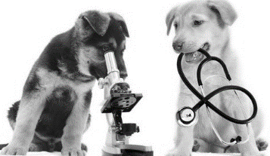
DEPARTMENT P27 (JUNIOR ANIMAL SCIENCE)
Entries Close 11:59 pm Mon. July 10, 2023

Check-in – Sunday, July 30, 2023, 1:00 - 5:00 pm.
Judging – Tuesday, August 1, 2023 – 6:00 pm.
Check-out Sunday, August 6, 1:00 pm

ENTRY FEE= $1.00 per entry NO Exhibitor Pass Required

PREMIUMS: 1st= $4.00 2nd= $3.50 3rd= $2.50

GUIDELINES
    - All exhibits must conform to Jr. Show Exhibition Rules and Guidelines.
    - All posters and displays are limited to Exhibition Rules and Guidelines.
    - Junior Animal Science Classes allow ages under 8 (classes 1231 – 1239, 1243), EXCEPT for Veterinary Science (1240) and both Animal Education (1241-1242).
    - Projects must be able to be handled. Sharp objects such as syringes and needles are not allowed. No live animals. Plants may be used so long as they are properly covered, and viewers protected. Dangerous and poisonous plants are not allowed. Tools and other such items must be properly stored in order to be exhibited.
    - Focus on each science can be included, but are not limited to animal anatomy, nutritional effects and proper feeding, handling, caring for animals, diseases that affect an animal with treatment and clinical signs, training of animals, breeding, etc.
    - The following classes are open for all ages including ages 8 and under:
      - 1231 Cat Science
      - 1232 Dog Science
      - 1233 Rabbit Science
      - 1234 Poultry Science
      - 1235 Horse Science
      - 1236 Cattle Science
      - 1237 Goat Science
      - 1238 Sheep Science
      - 1239 My Non-Traditional Pet Science
      - 1243 Animals that Effect Our World

Department P27 Section 001 GENERAL ANIMAL SCIENCE
1231 | Cat Science | Exhibit a poster/display focusing on feline science.
1232 | Dog Science | Exhibit a poster/display focusing on canine science.
1233 | Rabbit Science | Exhibit a poster/display focusing on rabbit science.
1234 | Poultry Science | Exhibit a poster/display focusing on poultry science.
1235 | Horse Science | Exhibit a poster/display focusing on equestrian science.
1236 | Cattle Science | Exhibit a poster/display focusing on cattle science, beef, dairy, etc.
1237 | Goat Science | Exhibit a poster/display focusing on goat science.
1238 | Sheep Science | Exhibit a poster/display focusing on sheep science.
1239 | My Non-traditional Pet Science | Exhibit a poster or display that focuses on non-traditional pet animals that are not listed in above. Can be reptiles, exotic birds, llamas, insects, etc. Fish qualify under this class.
1240 | Veterinary Science | Exhibit a poster or display that focuses on veterinary science. Can be vet care techniques, how to run a vet clinic, medicine for animals and/or in the vet field, agricultural influences, etc. For ages 8 and older as of January 1, 2022. Project should focus on things above and beyond everyday care and information.
1241 | Animal Education-Small Animal | Exhibit a display relating to others about small animals. Small animals include cats, dogs, rabbits, poultry, etc. For ages 8 and older as of January 1, 2022.
1242 | Animal Education-Large Animal | Exhibit a display relating to others about large animals. Large animals include horses, sheep, goats, cattle, etc. For ages 8 and older as of January 1, 2022.
1243 | Animals that Effect Our World | Exhibit a poster or display that does not fit into any above categories and is relating to animals. Can be fish hatchery, ocean life, wildlife, tropical animal life, rainforest animals, whales, etc.

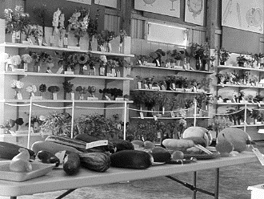
Open Show Exhibit Building
Departments K, L, M, O

Entries Close 11:59 pm Mon. July 10, 2023

Check-in for Open Beekeeping, Clothing, Craft, Photography, Quilting, & Painting/Drawing – Sunday, July 30, 2023, 1:00 - 5:00 pm.

Check-in for Open Fruits/Vegetables, Floriculture, & Foods – Tuesday, August 1, 2023, 3:30 - 5:30 pm.

Judging – Tuesday, August 1, 2023 – 6:00 pm.
Check-out Sunday, August 6, 1:00 pm

Absolutely no early checkouts unless released by Junior/Open Show Exhibit Superintendents. Any projects left after 4 pm is not the responsibility of Ogle County Fair Committee.

ENTRY FEE= vary by department—please see individual department information
NO Exhibitor Pass Required

PREMIUMS: vary by department—please see department information.
There will be NO checks mailed out, but every effort will be made to have checks available late Sunday August 6, 2023. Otherwise, check pick up will be Monday August 7, 2023, 9:00 am to 4:00 pm at the fair office.

EXHIBIT COMMITTEE – OPEN SHOW
Chris Carter, Stillman Valley, Superintendent Phone 815-985-5621
Email: Chriscarter.4life@gmail.com

OPEN SHOW EXHIBITION RULES AND GUIDELINES
- Open Show is for all ages. Juniors planning to show in the Open Show must have a separate exhibit that is not entered in the Junior show or 4-H show.
- All exhibits must be checked in by the designated time frame. No exhibits will be accepted after end of check-in. Projects must have tags attached; picking up tags do not qualify as having your exhibit checked in. Exhibits must be physically there and entered by a Superintendent.
- Exhibits must be picked up at Check-Out times. Ogle County Fair Association and Committee Members are not responsible for exhibits not picked up after check-out times.
- Exhibitor names will not be disclosed until departments are judged, and awards are finalized. This is to ensure fair and anonymous judging for all who enter. Winner names are posted after judging, and ribbons placed.
- All open show exhibit entries are limited to one per individual per class. More than one exhibit per individual per class will not be accepted.
- All exhibit work must have been made within one current year of showing at the Ogle County Fair and come whole and complete. One current year is from August 2022 through July 2023. All exhibits must be checked-in with all parts/pieces. Pieces of exhibit(s) not brought at time of check-in will not be accepted as part of the exhibit. Please make sure that if an exhibit has more than one part to it, that all pieces are brought and checked in simultaneously.
- Open Show exhibits cannot be dual-enrolled as a 4-H and Junior Show exhibit. Previous projects and exhibits from Junior Show and 4-H may be entered into the Open Show area only if the exhibitor meets the rules and guidelines for Open Show.
- Some Open Show classes have specialized size limitations due to the nature of the class. Please see each Department and Class Description for appropriate size limitations.
- Previously premium awarded Open Show exhibits may not be re-entered.
- Previously premium awarded Junior Show exhibits may be entered and awarded a premium for Open Show.
- Awards and rosettes (special awards) are presented at judge(s)’ discretion. Awards are based upon the judge(s)’ grading of an exhibit. Judge(s) reserve the right to not award an exhibit placing for reasons including, but not limited to:
  - an exhibit does not meet the standards for a certain placing.
  - an exhibit is without competition for proper placing.
- No professional work is allowed. A professional is defined as one whom:
  - maintains a business.
  - advertises for a business.
  - derives more than 50% of their income from the business.
- Open Show Committee and the Fair Association are not responsible for any damage, and/or missing or misplaced pieces. Protection of exhibit(s) is the sole responsibility of the exhibitor. Please come prepared as no materials will be offered and/or available for use upon arrival. This may include covers and casing, corner protection, padded legs of tables/other, etc. that ensures the maintenance of quality for an exhibit. If covers and/or cases are included with an exhibit, the overall size limitation includes the cover/casing. Covers and/or casings must be clear, and the exhibit viewable.
- PROJECTS MUST BE REMOVED FROM EXHIBIT BUILDING ACCORDING TO RULES.

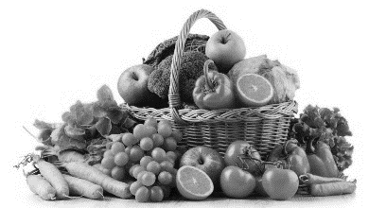
DEPARTMENT K28 (OPEN FRUITS & VEGETABLES)
Entries Close 11:59 pm Mon. July 10, 2023

Check-in – Tuesday, August 1, 2023, 3:30 - 5:30 pm.
Judging – Tuesday, August 1, 2023 – 6:00 pm.
Check-out Sunday, August 6, 1:00 pm

ENTRY FEE= $1.00 per entry NO Exhibitor Pass Required

PREMIUMS: 1st= $3.50 2nd= $2.50 3rd= $1.50

GUIDELINES
- All exhibits must conform to Open Show Exhibition Rules and Guidelines.
- Produce must have been grown during the current year by the exhibitor.
- Exhibits larger than allowed display area may be rejected. Unless otherwise stated, exhibits are considered either a tabletop or other display.
- Label all produce with appropriate name of variety.
- All produce must be in their natural state. Waxes and oils are not permitted for use on ANY exhibit.
- All produce must be properly displayed on white paper plates.

Department K28 Section 001 OPEN FRUITS AND VEGETABLES
1246 | Broccoli | Exhibit 1 head |  | 1258 | Sweet Corn | Exhibit 5 ears
1247 | Cabbage | Exhibit 1 head |  | 1259 | Zucchini | Exhibit 3 zucchini
1248 | Carrot | Exhibit 5 carrots |  | 1260 | Kohlrabi | Exhibit 1 kohlrabi
1249 | Cucumber | Exhibit either:  3 large or 5 small |  | 1261 | Grape | Exhibit 3 clusters
1250 | Bean | Exhibit 12 pods |  | 1262 | Squash | Exhibit 1 eatable squash
1251 | Tomato | Exhibit either:  3 large or 5 small |  | 1263 | Berry | Exhibit 1 pint of either: Raspberry or strawberry or blackberry or blueberry
1252 | Lettuce | Exhibit 1 head |  | 1264 | Pea | Exhibit 12 pods
1253 | Melon | Exhibit 1 melon |  | 1265 | Pumpkin | Exhibit 1 pie variety
1254 | Onion | Exhibit either:  5 large or 12 small |  | 1266 | Greens | Exhibit 1 green (collard, endive, escarole, kale, mustard, or Swiss chard)
1255 | Pepper | Exhibit either:  5 bell/banana  12 chili/cherry |  | 1267 | Pitted Fruit | Exhibit 5 of either: Peaches or plums
1256 | Potato | Exhibit 5 potatoes |  | 1268 | Pears | Exhibit 5 pears
1257 | Radish | Exhibit 5 radish |  | 1269 | Eggplant | Exhibit 1 eggplant

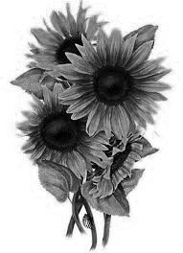
DEPARTMENT L29 (OPEN FLORICULTURE)
Entries Close 11:59 pm Mon. July 10, 2023

Check-in – Tuesday, August 1, 2023, 3:30 - 5:30 pm.
Judging – Tuesday, August 1, 2023 – 6:00 pm.
Check-out Sunday, August 6, 1:00 pm

ENTRY FEE= $1.00 per entry NO Exhibitor Pass Required

PREMIUMS: 1st= $4.00 2nd= $3.00 3rd= $3.50 4th= $1.50

GUIDELINES
- All exhibits must conform to Open Show Exhibition Rules and Guidelines.
- All exhibits must have been grown by exhibitor unless otherwise stated.
- Exhibits larger than allowed display area may be rejected. Unless otherwise stated, all Floriculture is considered either a tabletop or other display.
- The minimum possession of plants must be 90 days prior to exhibition unless in Roadside class. Foliage is judged as well as bloom. No leaf shine may be used on exhibited plants.
- Cut flowers should be cut same day of show. Condition plants by placing in cool water out of drafts to maintain floral quality.
- Tag flowers with common name in a viewable location.
- DO NOT use wiring, artificial color, florist green, or filler in any class unless otherwise stated.
- All flower specimens must have foliage. Gladioli & Daylilies are exempt from having foliage and are the only class to which this applies.
- Exhibits are to be set up and maintained solely by exhibitor. Junior/Open Show committee members and the Ogle County Fair Association are not responsible for the care and maintenance of exhibits. Please plan accordingly for exhibit care. Failure to care properly for exhibit may result in premium and/or ribbon loss and exhibit to be taken off display.
- Previous premium and/or ribbon awarded plants may not be entered. Plants should be the product of the current year, including foliage and bloom. Perennial plants may be entered again, regardless if it has been previously premium and/or ribbon awarded.
- Fairy Garden arrangements are not to exceed 8” high and 8”x 8” base, using only live flowers.
- There are no size limitations except for the Fairy Garden class.
- Themes floral arrangements may include non-floral accents to enhance the overall arrangement.

Department L29 Section 001 Garden Cut Flowers
1270 | Cut Roadside Weeds | No dried material. Exhibit weeds in a vase or basket
1271 | Mixed Perennials | Exhibit a mixed perennial in a vase or basket
1272 | Mixed Annuals | Exhibit a mixed annual in a vase or basket
1273 | Single Variety | Exhibit one variety of flowers in a vase or basket
1274 | Lavender Flowers | Exhibit 3-4 specimen stems in a vase
1275 | Yellow Flowers | Exhibit 3-4 specimen stems in a vase
1276 | Red Flowers | Exhibit 3-4 specimen stems in a vase
1277 | Blue Flowers | Exhibit 3-4 specimen stems in a vase
1278 | Pink Flowers | Exhibit 3-4 specimen stems in a vase
1279 | Roses | Exhibit 3-4 specimen stems in a vase
1280 | Gladiolus | Exhibit 3-4 specimen stems in a vase
1282 | Zinnias | Exhibit 3-4 specimen stems in a vase
1283 | Largest Sunflower | Exhibit a pair of exceedingly tall sunflowers; bloom size and height count in a vase
1284 | White Flowers | Exhibit 3-4 specimen stems in a vase
1285 | Daylilies | Exhibit 3-4 specimen stems in a vase

Department L29 Section 002 Floral Arrangements
1288 | Wedding Themed | Exhibit a floral arrangement for a Wedding
1289 | Dinner Themed | Exhibit a silk floral arrangement
1290 | Dried/Preserved | Exhibit a floral arrangement with dried flowers
1291 | Fairy Garden | Exhibit a fairy garden
1292 | Theme | Exhibit a holiday-themed floral arrangement

Department L29 Section 003 Flowering Plants
1293 | Violet | Exhibit one flowering violet plant
1295 | Impatiens | Exhibit one flowering impatiens plant
1296 | Geranium | Exhibit one flowering geranium plant
1297 | Begonia | Exhibit one flowering begonia plant
1298 | Gloxinia | Exhibit one flowering gloxinia plant
1299 | Fuchsia | Exhibit one flowering fuchsia plant
1300 | Succulent | Exhibit 1-3 succulents in a pot

Department L29 Section 004 Foliage Plants
1301 | Spider Plant | Exhibit one spider plant
1303 | Fern | Exhibit one fern plant
1304 | Ivy | Exhibit one ivy plant
1305 | Philodendron | Exhibit one philodendron plant
1306 | Sedum | Exhibit one sedum plant
1307 | Wandering Jew | Exhibit one wandering Jew plant
1308 | Hosta | Exhibit one Hosta plant
1309 | Other Foliage | Exhibit one any foliage plant not fitting into other classes

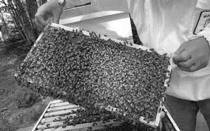
DEPARTMENT M30 (OPEN BEEKEEPING)
Entries Close 11:59 pm Mon. July 10, 2023

Check-in – Sunday, July 30, 2023, 1:00 - 5:00 pm.
Judging – Tuesday, August 1, 2023 – 6:00 pm.
Check-out Sunday, August 6, 1:00 pm

ENTRY FEE= $1.00 per entry NO Exhibitor Pass Required

PREMIUMS: 1st= $7.00 2nd= $6.00 3rd= $5.00

GUIDELINES:
- All exhibits must conform to Open Show Exhibition Rules and Guidelines.
- Exhibits are to be set up and maintained solely by exhibitor.
- NO LIVE EXHIBITS WILL BE EXCEPTED.
- Junior/Open Show committee members and the Ogle County Fair Association are not responsible for the care and maintenance of exhibits. Please plan accordingly for exhibit care. Failure to care properly for exhibit may result in premium and/or ribbon loss and exhibit to be taken off display.
- No size restrictions.

Department M30 Section 001 Open Beekeeping
1313 | Extracted Honey | In clear viewable container, display 2-4 jars of one of the following color of honey:  Extra Light Extracted Honey  Light Extracted Honey  Light Amber Extracted Honey  Amber Extract Honey  Dark Extracted Honey
1314 | Crème & Chunk Comb Honey | In clear viewable container, display 4 items of either:  Creamed Honey  Chunk Comb Honey
1315 | Cut Comb Honey | In clear viewable container, display 4 items of cut comb honey. Section comb honey consisting of:  4 wood sections packaged in cardboard cellophane window cartons.  4 round sections with clear covers and labels  4 half-combed cassettes
1316 | Beekeeping Photography Display | One or more photos depicting an aspect of beekeeping. Mounted photos in a display that is cohesive. (Ex: poster or tri-fold stand)
1317 | Art Design in Beeswax (molded item) | 2 items containing beeswax as an ingredient (supply weights of ingredients listed heaviest to lightest). Molded Art design, Soap bars, or Lotion Bars or Candles.

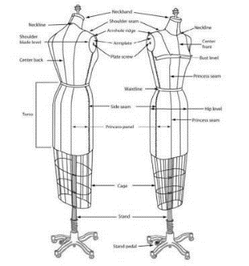
DEPARTMENT M31 (OPEN CLOTHING)
Entries Close 11:59 pm Mon. July 10, 2023

Check-in – Sunday, July 30, 2023, 1:00 - 5:00 pm.
Judging – Tuesday, August 1, 2023 – 6:00 pm.
Check-out Sunday, August 6, 1:00 pm

ENTRY FEE= $1.00 per entry NO Exhibitor Pass Required

PREMIUMS: 1st= $6.00 2nd= $5.50 3rd= $5.00

GUIDELINES:
- All exhibits must conform to Open Show Exhibition Rules and Guidelines.
- Exhibits are to be set up and maintained solely by exhibitor. Junior/Open Show committee members and the Ogle County Fair Association are not responsible for the care and maintenance of exhibits. Please plan accordingly for exhibit care. Failure to care properly for exhibit may result in premium and/or ribbon loss and exhibit to be taken off display.
- All exhibits are to be the work of the current year and previous premium-awarded exhibits may not be entered again.
- The current year is from August 2020 to July 2021. See Open Show Exhibition Rules and Guidelines in regarding work not from the current year.
- All exhibits should be fresh, clean, in good condition, and made by the exhibitor.

Department M31 Section 001 Open Clothing
1319 | Blouse | Exhibit 1 blouse
1320 | Knit Top | Exhibit 1 knit top
1321 | Skirt | Exhibit 1 skirt
1322 | Children’s clothing | Exhibit 1 item under size 12
1323 | Dress | Exhibit 1 dress
1324 | Theme Costume | Exhibit 1 costume that displays one clear theme. (Ex: Theater play costume for a character, movie character, or clothing that reflects a decade style.)
1325 | Holiday Costume | Exhibit 1 costume that best displays a holiday theme. (Ex: Christmas Elf, Halloween, etc. as long as appropriate for general public)
1326 | Pants | Exhibit 1 pair of pants
1327 | Shorts | Exhibit 1 pair of shorts
1328 | Vintage themed Clothing | Exhibit 1 vintage clothing that best represents a historical perspective or decade.

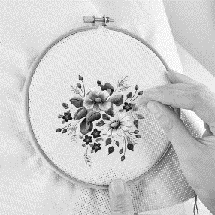
DEPARTMENT M32 (OPEN CRAFT)
Entries Close 11:59 pm Mon. July 10, 2023

Check-in – Sunday, July 30, 2023, 1:00 - 5:00 pm.
Judging – Tuesday, August 1, 2023 – 6:00 pm.
Check-out Sunday, August 6, 1:00 pm

ENTRY FEE= $1.00 per entry NO Exhibitor Pass Required

PREMIUMS: 1st= $6.00 2nd= $5.00 3rd= $4.00

GUIDELINES
- All exhibits must conform to Open Show Exhibition Rules and Guidelines.
- All exhibits must be clean and in good condition. Unsuitable exhibits may be disqualified and may result in removal of exhibit and/or loss of premiums. No exhibits showing wear or soil will be accepted.
- All exhibits are to be the work of the current year and previous premium-awarded exhibits may not be entered again. The current year is from August 2022 to July 2023. See Open Show Exhibition Rules and Guidelines in regarding work not from the current year.
- Exhibits made from kits or are prefabricated are eligible in all craft classes.
- All framed exhibits must be able to be hanged. This may be by wire or saw tooth attached to the back top of the exhibit. It is highly suggested that all flat works be framed or protected by a clear covering.
- Exhibits are to be set up and maintained solely by exhibitor. Junior/Open Show committee members and the Ogle County Fair Association are not responsible for the care and maintenance of exhibits. Please plan accordingly for exhibit care. Failure to care properly for exhibit may result in premium and/or ribbon loss and exhibit to be taken off display.

Department M32 Section 001 Needlecraft
1330 | Crocheted Article | Exhibit 1 article crocheted with fiber
1331 | Knitted Blanket/Throw | Exhibit a knitted article that is a throw, lap blanket, baby blanket or similar function.
1332 | Knitted Article, Other | Exhibit any form of knitted article (Ex: scarf, hat, toy, etc.)
1333 | Hand Embroidery, Article | Exhibit any hand embroidered article
1334 | Machine Embroidery Blanket/Throw | Exhibit embroidery article that is a throw, lap blanket, baby blanket or similar function.
1335 | Machine Embroidery Article, Wearable | Exhibit embroidery article that is applied to wearable clothing. (Ex: hat, shirt, creative wearable art, etc.)
1336 | Crewel Embroidery, Article | Exhibit any crewel embroidered article
1337 | Cross Stitch Item | Exhibit any cross-stitched item
1338 | Holiday needlecraft | Exhibit any needle craft for any season or holiday.
1339 | Needle Felting | Exhibit any item that is needle felted that displays a form.
1340 | Natural Fiber Felting | Exhibit any item that demonstrates natural fiber felting technique. (Ex: wool fiber felted on silk scarf, fiber art, etc.)
1341 | Needlepoint | Exhibit 1 needlepoint item.
1342 | Diamond Art | Exhibit 1 diamond art craft.
1343 | Heritage Craft | Exhibit any item that demonstrates a heritage craft. Note card with 1 paragraph description of historical significance to be included.
1344 | Cloth/Fiber Doll | Exhibit any cloth or fiber doll. No size limit
1345 | Non-Cloth/Fiber Doll | Exhibit any Doll made from any material other than fiber / cloth. No size limit.
1346 | Crocheted Rug | Exhibit a crocheted rug; exempt from size limit
1347 | Recycled Rug | Exhibit 1 rug made from recycled material, fabric, or fibers. No size Limit.
1348 | Hand Appliquéd Article | Exhibit a hand appliquéd article
1349 | Needlecraft, other | Exhibit a needlecraft item that does not fit into the other categories

Department M32 Section 002 Handcraft
1350 | Candle making | Exhibit no more than 2 items of similar technique
1351 | 3-D Sculpture | Exhibit a 3-D Sculpture from one material. (Ex: clay, paper, wood, stone, etc.)
1352 | Basket Weaving | Exhibit a weaved basket
1353 | Yard Art/ Sculpture | Exhibit any item hand crafted that may be displayed in a garden
1354 | Leatherwork | Exhibit a leather article or item
1355 | Metalwork | Exhibit a metalwork item
1356 | Egg Decorating | Exhibit a Fabergé Egg
1357 | Wood Carving /Wood Burned design original | Exhibit a wood carving or burned wood piece
1358 | Jewelry | Exhibit a piece or set of jewelry
1359 | Beaded Art piece /not jewelry | Exhibit piece created from beads, not a piece of jewelry
1360 | Recycled Art | Exhibit one piece that is made with at least 80% recycled material and is in 3D form. Recycled material must be safely secured and safe for public viewing.
1361 | Ceramic/Pottery/Clay | Exhibit an item that is ceramic, pottery, or clay
1362 | Recycled Yard Display | Exhibit 1 piece that is with at least 80% recycled material and is created to be displayed in the yard.
1363 | Memory Page Scrapbooking | Exhibit a 12” x 12” memory page that is protected in a clear viewable sleeve.
1364 | Memory Scrapbook Chapter | Exhibit 2 or more pages that reflects an event, memory, or personal story. Pages are to be protected in clear viewable sleeve. Display may show several pages.
1365 | Holiday Craft | Exhibit a holiday-based craft
1366 | Glass Painted item | Exhibit any item made of glass that is painted Ex: sun catcher, wine glasses

DEPARTMENT M33 (OPEN PHOTOGRAPHY)
Entries Close 11:59 pm Mon. July 10, 2023

Check-in – Sunday, July 30, 2023, 1:00 - 5:00 pm.
Judging – Tuesday, August 1, 2023 – 6:00 pm.
Check-out Sunday, August 6, 1:00 pm

ENTRY FEE= $1.00 per entry NO Exhibitor Pass Required
PREMIUMS: 1st= $5.00 2nd= $4.00 3rd= $3.00 4th= $2.00

GUIDELINES
- All exhibits must conform to Open Show Exhibition Rules and Guidelines.
- Each photo to be mounted and displayed individually with white color mat surrounding photo. Mat can be any material.
- Exhibits are limited to the following:
  - Image Size Minimum 5 x 7, MAX 8” x 10”.
  - Overall, MAX size including frame 18” x 20”.
- All pictures are to have been taken after June 1, 2022.
- Exhibit Building is not responsible for lost or damaged parts of photographs. If mat or title separate from the picture, it may be disqualified and taken off display.
- Black and White digital photo will be allowed to use program for dismissing color. Sepia or black and white will be accepted.
- Classes are defined as the following:
  - Landscape/Cityscape: essentially scenery. A wide view normally of such things as mountains, pastures, rivers, waterfalls, rocks, or other natural formations or that of a broad view of a city. Person(s) is not the main focus.
  - Animal/People: (a) Individual—the physical likeness of a single person or animal; (b) Group—the physical likeness of two or more persons or animals. Animals interacting with one or more person the photograph is considered a portrait rather than an animal photograph and should be placed in the respective class (i.e., a child interacting with a hamster).
  - Architecture: the likeness of a building, monument, or other man-made edifice. Normally a single building or similar that is isolated from its environment, rather than including many such structures which could be confused with Cityscape.
  - Sports: photographs of sporting events as they happen. Normally these are action photos; can be photos of fishing, hunting, baseball card trading, chess, checkers, classic car shows, rodeo, lumberjack competitions, tug of war, etc.
  - Still Life: photographs of non-living things. These may be “found” arrangements of items that create a pleasing line or view, such as a row of pumpkins on a farmer’s porch or a series of flowerpots making a pleasing design, etc. The photographer may intentionally create a setup, such as a tabletop centerpiece or arrangement.
- One entry allowed per class. Duplication of photographs is not allowed (i.e., color and B&W of same photo entered into different classes). Duplicate photos may be disqualified and/or taken off display. If more than 1 photo enrolled in a class by exhibitor, there is a risk of loss for premiums. This is at the discretion of the superintendent.
- Photographs must have been taken by exhibitor only. Exhibitors cannot claim other’s work or that of professionals.
- Photos may be taken with camera, tablet, or cellphone.
Department M33 Section 001 B&W OR COLOR PRINT OF OGLE COUNTY
1380 | Historical Picture | Exhibit one photo with an Ogle Co. historical focus
1381 | Best of the Fair | Exhibit one photo showing the Ogle Co. Fair at its best
1382 | Fair Funnies | Exhibit one photo showing a funny moment at the Ogle Co. Fair
1383 | Best of Ogle Co. | Exhibit 1 photo that Best represents OGLE COUNTY

Department M33 Section 002 BLACK & WHITE
1390 | Cityscape | Exhibit one cityscape photo
1391 | Landscape | Exhibit one landscape photo
1392 | Seascape | Exhibit one seascape photo
1393 | Architecture, Any | Exhibit one photo of any architecture
1394 | Floral | Exhibit one floral-based photo
1395 | Still Life | Exhibit one still life photo
1396 | People, Individual | Exhibit one subject photo of a person
1397 | People, Group | Exhibit one subject photo of 2 or more people
1398 | Pets | Exhibit one subject of a dog or cat or another pet
1399 | Weather | Exhibit one definition of a weather event: Ex: Clouds/Rain/ Sunshine
1400 | Animal, Other | Exhibit one animal subject-based photo
1401 | Sports | Exhibit one sports subject-based photo

Department M33 Section 003 COLOR PRINT
1412 | Cityscape | Exhibit one cityscape photo
1413 | Landscape | Exhibit one landscape photo
1414 | Seascape | Exhibit one seascape photo
1415 | Architecture, Any | Exhibit one photo of any architecture
1416 | Floral | Exhibit one floral-based photo
1417 | Still Life | Exhibit one still life photo
1418 | People, Individual | Exhibit one subject photo of a person
1419 | People, Group | Exhibit one subject photo of 2 or more people
1420 | Pets | Exhibit one subject of a dog or cat or another pet
1421 | Weather | Exhibit one definition of a weather event: Ex: Clouds/rain/sunset
1422 | Animal, Farm | Exhibit a color photo of a farm animal such as: bovine, hog, goat, sheep, poultry, rabbit, or horse.
1423 | Sports | Exhibit 1 sports subject-based photo, non action based.
1424 | Event Group Celebration | Photo of 2 or more people in a single celebration event.
1425 | Family | Exhibit 1 photo of 2 or more people that best shows a family (any kind of family).
1426 | Macro Photo | Extreme close-up photo of small subject(s).
1427 | Digital Photo Enhanced | Exhibit 1 enhanced digital photo using any method, Camera phone image accepted.
1428 | Farm Building/Barn | Exhibit 1 photo that focuses on a farm building(s) or barn(s).
1429 | Forest/Wildlife Animals | Exhibit 1 photo of a forest animal(s) or local wildlife.
1430 | Sea Life/Creature | Exhibit 1 of a photo of sea life or sea creature(s).
1431 | Action Sports | Exhibit 1 photo of action sports event. Can be either a person or team in action/motion.
1432 | Bird | Exhibit 1 photo of any bird(s) in nature.
1433 | Water | Exhibit 1 photo of water, can have other items in the photo but water is the focus (frozen, mist, liquid, fog, etc.).

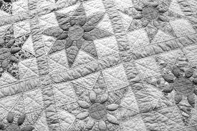
Department M34 (Open Quilting)
Entries Close 11:59 pm Mon. July 10, 2023

Check-in – Sunday, July 30, 2023, 1:00 - 5:00 pm.
Judging – Tuesday, August 1, 2023 – 6:00 pm.
Check-out Sunday, August 6, 1:00 pm

ENTRY FEE= $3.00 per entry NO Exhibitor Pass Required

PREMIUMS: 1st= $12.00 2nd= $11.00 3rd= $10.00

GUIDELINES
- All exhibits must conform to Open Show Exhibition Rules and Guidelines.
- All exhibits should be clean and in good condition.
- All exhibits must have been finished or made since the previous Ogle County Fair. Please see the Open Show Exhibition Rules and Guidelines in regarding previous 4-H and/or Junior Show work.
- Kits may be used / Project made from kit MUST be identified on tag.
- All wall hangings must be wired for hanging; saw tooth are acceptable.
- All Open Show Quilting is exempt from size limitations EXCLUDING appliquéd pillows.
- Failure to follow rules and guidelines may result in disqualification.
- Quilts will be covered in plastic and prepared for public viewing with all considerations for preservation.
- Quilts may have an explanation card to display, this is optional. Explanation may reflect meaning of pattern, family history, or memory. Explanation card will not be used in judging but for the public to learn more about the value of quilting.

Department M34 Section 001 Open Quilting
1440 | Quilt, Appliquéd | Exhibit 1 appliquéd quilt
1441 | Quilt, Hand Quilted Crib-Sized | Exhibit 1 quilt that is crib-sized that is hand-quilted
1442 | Quilt, Hand Tied, Pieced or Machined Appliquéd, Machine Quilted | Exhibit 1 quilt that is hand tied, pieced or machine appliquéd, and machine quilted
1443 | Quilt, Pieced Hand Quilted | Exhibit 1 quilt that is pieced and hand quilted
1444 | Quilt, Pieced Machine Quilted | Exhibit 1 quilt that is pieced, and machine quilted
1445 | Quilt, Novelty | Exhibit 1 novelty quilt (preprinted, embroidered, etc.)
1446 | Quilted Pillow | Exhibit 1 quilted pillow. Can be pieced, appliquéd, etc.
1447 | Quilted Item, Other | Exhibit 1 quilted item. Can be wall hangings, table runners, etc.

DEPARTMENT M35 (OPEN PAINTING AND DRAWING)
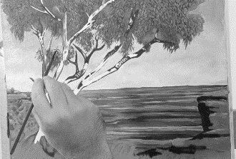
Entries Close 11:59 pm Mon. July 10, 2023

Check-in – Sunday, July 30, 2023, 1:00 - 5:00 pm.
Judging – Tuesday, August 1, 2023 – 6:00 pm.
Check-out Sunday, August 6, 1:00 pm

ENTRY FEE= $1.50 per entry NO Exhibitor Pass Required

PREMIUMS: 1st= $7.00 2nd= $6.00 3rd= $5.00

GUIDELINES
- All exhibits must conform to Open Show Exhibition Rules and Guidelines.
- All styles and genres welcomed (i.e., traditional, stylized, contemporary, etc.).
- All exhibits must be original. Kits, number paintings, or other such work that is not from the creator’s own imagination, interpretation, or research is not allowed.
- All exhibits must be frame, excluding sculptures. Glass is desirable over delicate works, such as transparent watercolor and charcoal, but is not required. A mat is not considered a frame.
- All exhibits must be wired for hanging, excluding standing sculptures. Hooks, tape, string, saw tooth, or other such material used for hanging is not acceptable. Failure to include proper hanging wire will result in disqualification. Wall-based sculptures must abide by this rule.
- All exhibits must be the work of the exhibitor.

Department M35 Section 001 Open Painting and Drawing
1450 | Oil | Exhibit one original oil painting or work
1451 | Acrylic | Exhibit one original acrylic painting or work
1452 | Watercolor | Exhibit one original watercolor painting or work
1454 | Cartooning | Exhibit one original cartooning work
1455 | Pen/Ink/Pencil | Exhibit one original pen, ink, or pencil work
1456 | Mixed Media | Exhibit one original 3 or more painting mediums

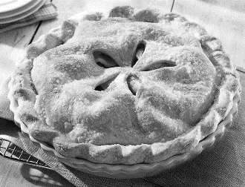
DEPARTMENT O36 (OPEN FOODS)
Entries Close 11:59 pm Mon. July 10, 2023

Check-in – Tuesday, August 1, 2023, 3:30 - 5:30 pm.
Judging – Tuesday, August 1, 2023 – 6:00 pm.
Check-out Sunday, August 6, 1:00 pm

ENTRY FEE= $1.50 per entry NO Exhibitor Pass Required

PREMIUMS:
Sections | 1st place | 2nd place | 3rd place | 4th place
001 Baking,  004 Canned Fruits & Vegetables,  005 Canned Meats,  006 Jams, Jellies, & Preserves | $6.00 | $4.00 | $3.00 | $2.00
002 Pies | $6.00 | $5.00 | $4.00 | $3.00
003 Decorated Cakes & Candies | $10.00 | $6.00 | $4.00 | $2.00

GUIDELINES
- All exhibits must conform to Open Show Exhibition Rules and Guidelines.
- Food exhibits are not to be picked up at the closing of Fair due to health risks. All other foods other than unopened canned foods will be disposed of.
- Perishable goods will be disposed of before the close of Fair if spoilage occurs.
- Canned Fruits, Vegetables, Meats, Jams, Jellies, and Preserves:
  - Must be in clear ½ pint, pint, or quart sized jars, etc. with a 2-piece lid and labeled with non-decorative labels.
  - All canned items may be opened if judge feels it is necessary. Paraffin sealed jars will not be judged.
- Canned items can be from end of previous Fair to current year’s Fair (August 2020 - July 2021).
- All baked goods must be from scratch; mixes are not allowed.
- No bread machine loaves will be allowed, except in specified class 1503.
- Fancy cakes (wedding, etc.) may be decorated on Styrofoam, cake pans, cardboard, etc. and are judged strictly on decoration.
- Wedding cakes are not to exceed 16” in diameter; other cakes not to exceed 14” in diameter or 10” high.
- All baked goods must be on white paper plates or heavy cardboard squares (not to exceed ½” larger than item) and must be covered with clear plastic bags.

Department O36 Section 001 BAKING
1500 | Favorite Cookie | 4 per plate; attach recipe on 3x5 card
1501 | Favorite Cake | Whole cake (9 x 9 round)
1502 | Favorite Yeast Bread | Whole
1503 | Favorite Bread | Machine Bread; whole
1504 | Favorite Quick Bread | Whole; attach recipe on 3x5 card

Department O36 Section 002 PIES
1505 | Favorite Pie | Must have 2 crusts

Department O36 Section 003 DECORATED CAKES AND CANDIES
1506 | Favorite Candy | Must include 4 pieces
1507 | Decorated Wedding Cake | Limited to above rules
1508 | Other Decorated Cake | Limited to above rules

Department O36 Section 004 CANNED FRUITS AND VEGETABLES
1509 | Applesauce |  | 1515 | Pickles
1510 | Beets |  | 1516 | Raspberries (red or black)
1511 | Beans |  | 1517 | Relish
1512 | Blueberries |  | 1518 | Salsa
1513 | Blackberries |  | 1519 | Any Other Canned Fruit
1514 | Cherries |  | 1520 | Any Other Canned Vegetable

Department O36 Section 005 CANNED MEATS
1521 | Beef
1522 | Poultry

Department O36 Section 006 JAMS, JELLIES, & PRESERVES
1523 | Favorite Marmalade
1524 | Favorite Jam or Preserve
1525 | Favorite Jelly

Special Events
Departments Q, Z & Demo
DEPARTMENT Q41 & Q43
Wed. TRACTOR & STOCK PULLS

Check-in – Wednesday, August 2, 2023, 3:30-5:30 pm
Weigh-in – starts at 4:30 pm
Driver Meeting – 6:15 pm
Show – Wednesday August 2, 2023, 6:30 pm

ENTRY FEE = $10.00 each person
INSURANCE FEE = $10

ILLINI STATE PULLERS RULES APPLY, CHECK THEIR WEBSITE:
- All tractors must weigh on the fairground scale. Weighing starts at 4:30 pm.
- All drivers are to attend the drivers meeting at 6:15.
- All Illini State Pullers Rules will be followed.
- NO cut tires -- NO water or alcohol injection
- 2800 RPM Max -- 20.8 X 38 max tire size
- No sanctioned tractors
- See the Illini Pullers Website for more information: www.IlliniStatePullers.com.
- For information, contact: Mike Sauter at 815-617-9375 for Illini State Pullers or Tom Simpson 815-298-6591.

Department Q41 Section 003 Stock Classes
CLASS | CLASS DESCRIPTION | 1st | 2nd | 3rd
1721 | 6,000 NA Farm Stock | $150 | $100 | $50
1723 | 10,000 NA Farm Stock | $150 | $100 | $50
1724 | 6,800 Stock Class | $150 | $100 | $50

Department Q41 Section 003 Tractor Classes
CLASS | CLASS DESCRIPTION | 1st | 2nd | 3rd | 4th | 5th | 6th | 7th | 8th | 9th | 10th
1726 | 6,000 NA Tractors | $220 | $190 | $155 | $125 | $100 | $80 | $70 | $60
1727 | 1,050 SS Garden Tractor | $200 | $160 | $130 | $115 | $90 | $75 | $65 | $60 | $55 | $50

DEPARTMENT Q41 & Q43
Thur. TRACTOR, TRUCK & STOCK PULLS

Check-in – Thursday, August 3, 2023, 3:30-5:30 pm
Weigh-in – starts at 4:30 pm
Driver Meeting – 6:15 pm
Show – Thursday August 3, 2023, 6:30 pm

ENTRY FEE = $10.00 each person
INSURANCE FEE = $10

ILLINI STATE PULLERS RULES APPLY, CHECK THEIR WEBSITE:
- All tractors must weigh on the fairground scale. Weighing starts at 4:30 pm.
- All drivers are to attend the drivers meeting at 6:15.
- All Illini State Pullers Rules will be followed.
- NO cut tires -- NO water or alcohol injection
- 2800 RPM Max -- 20.8 X 38 max tire size
- No sanctioned tractors
- See the Illini Pullers Website for more information: www.IlliniStatePullers.com
- For information, contact: Mike Sauter at 815-617-9375 for Illini State Pullers or Tom Simpson 815-298-6591.

Department Q41 Section 004 TRACTOR Classes
CLASS | CLASS NAMES | 1st | 2nd | 3rd | 4th | 5th | 6th | 7th | 8th | 9th | 10th | 11th | 12th
1733 | 5,000 NA S/S Pro Field | $380 | $320 | $275 | $220 | $160 | $145
1734 | 7,000 NA S/S Pro Field | $360 | $290 | $235 | $205 | $160 | $135 | $115 | $110 | $100 | $90
1735 | 6,000 Light Super Stock | $480 | $385 | $310 | $280 | $215 | $180 | $155 | $145 | $130 | $120
1737 | 11,000 Too Hot to Farm | $375 | $295 | $240 | $185 | $160 | $145 | $135 | $120 | $105 | $95 | $80 | $65
1738 | 6,500 Open | $375 | $295 | $240 | $185 | $160 | $145 | $135 | $120 | $105 | $95 | $80 | $65

Department Q43 Section 002 Truck Classes
CLASS | CLASS NAMES | 1st | 2nd | 3rd | 4th | 5th | 6th | 7th | 8th | 9th | 10th
1750 | 6,200 Super Stock Trucks | $400 | $320 | $260 | $230 | $180 | $150 | $130 | $120 | $110 | $100
1751 | 6,300 Altered Trucks | $265 | $225 | $185 | $150 | $120 | $100 | $85 | $70
1752 | 6,500 Light Pro Stock Diesel Trucks | $440 | $375 | $315 | $250 | $200 | $160 | $135 | $125
1753 | 8,000 Hot Street Diesel Trucks | $300 | $250 | $210 | $180 | $135 | $125
1754 | 8,000 Street Diesel Trucks | $100 | $80 | $50 | $40 | $30
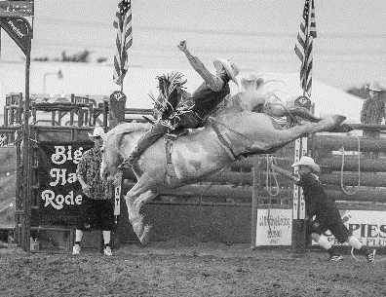
DEPARTMENT Z40 (BIG HAT RODEO COMPANY)

Friday, August 4, 2023, 2:00 pm & 7:00 pm

The Ogle County Fair Ground, 1440 North Limekiln Road, Oregon, IL.
Tom Simpson, Superintendent 815-298-6591
Rodeo Produced by: Big Hat Rodeo Company

ENTRY FEES: $50.00 per person, per event

Other fees total $30.00 plus $30.00 contestant insurance for All non-IPRA member entries. Insurance is purchased from rodeo secretary on day of rodeo. You must pay All fees in cash two hours before the performance.

PREMIUMS: Added Money: $300.00 per event or $2,100.00 total
Purse for each class split:
1st - 40% | 2nd - 30% | 3rd - 20% | 4th - 10%

DISCLAIMER: Purse for classes
If only three places are paid, rates would be 50%, 30%, 20%
If only two places are paid, rates would be 60%, 40%
If only one place is paid, rate would be 100%

SHOW RULES
- The Rodeo is sanctioned by the IPRA, and IPRA rules apply.
- Call 1-337-427-6336 in advance to confirm entry times.
- Internet Entries www.rodeosportsnetwork.com open Sunday, July 31, 2022, staring at Noon and close Monday August 1, 2022, at Noon.
- Phone entries (1-337-427-8336) open Monday August 1, 2022, at 8 am, and close Monday August 1, 2022, at 5 PM.
- When you call, you will be asked your name, address, social security number, event entering & phone number. You will be placed on a waiting list and told when to call back to verify your entry.
- If you do not call back, You WILL NOT be entered.
- Any contestant under the age of 18 must have a NOTARIZED parental release form on file with Big Hat Rodeo Co prior to entering rodeo. Call or text Lenora with rodeo questions at 815-823-3245.

QUESTIONS CALL:
Call or text Lenora at Big Hat Rodeo Company with all rodeo related questions at 815-823-3245 or email at lenora@bighatrodeo.com. For fair related question contact Tom Simpson at 815-298-6591.

RODEO CLASSES: Friday 2:00 pm
Department Z40 Section 001 GENERAL RODEO
Class 1650 | Bareback Riding
Class 1651 | Tie Down Roping
Class 1652 | Saddle Bronc Riding
Class 1653 | Steer Wrestling
Class 1654 | Cowgirls Barrel Racing
Class 1655 | Bull Riding
Class 1656 | Team Roping-Header
Class 1657 | Team Roping-Heeler
High Points | Participation
Class 1658 | Champion Bareback Bns.
Class 1659 | Champion Saddle Bronc Bns.
Class 1660 | Champion Bull Riding Bns.
Class 1661 | High Point Earned Award
Class 1662 | Girls Breakaway Roping

Department Z40 Section 002 GENERAL RODEO NOVICE
Class 1671 | Bareback Riding
Class 1672 | Saddle Bronc Riding
Class 1673 | Bull Riding

RODEO CLASSES: Friday 7:00 pm
Department Z40 Section 001 GENERAL RODEO
Class 1680 | Bareback Riding
Class 1681 | Tie Down Roping
Class 1682 | Saddle Bronc Riding
Class 1683 | Steer Wrestling
Class 1684 | Cowgirls Barrel Racing
Class 1685 | Bull Riding
Class 1686 | Team Roping-Header
Class 1687 | Team Roping-Heeler
High Points | Participation
Class 1688 | Champion Bareback Bns.
Class 1689 | Champion Saddle Bronc Bns.
Class 1690 | Champion Bull Riding Bns.
Class 1691 | High Point Earned Award
Class 1692 | Girls Breakaway Roping

Department Z40 Section 002 GENERAL RODEO NOVICE
Class 1695 | Bareback Riding
Class 1696 | Saddle Bronc Riding
Class 1697 | Bull Riding
DEPARTMENT X00 (DEMOLITION DERBY)
“ROBBO’S EXTREME DERBY PROMOTIONS”

Harlan Holm Derby Show
Saturday, August 5, 2023
Show Time = 6:00 pm

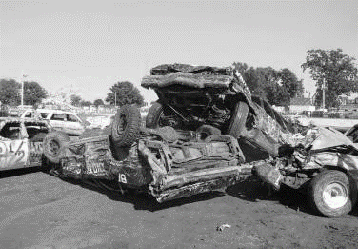
The Ogle County Fair Ground, 1440 North Limekiln Road, Oregon, IL.
Tom Simpson, Superintendent 815-298-6591

Registration will take place the day of the show and will close one hour before the show starts.

Pit Pass only included and free car entry.
Extra Pit passes purchased = $20.00.

Premiums Paid: Will be based on number of entries per class at registration time. The Ogle County Fair Association reserves the right to set payout per class on the day of the show.

Guaranteed Purse = $12,000
Trophies for 1st – 5th place in all classes.

CLASSES
Open Wire Full Size
Open Wire Mini Vans
Young Gun Full Size
TBA

Kids Power Wheel Derby at the beginning of the derby.
Open to youth up to 10 years of age. Parent must sign a release.
No fee to enter. Participation awards and a 1st place trophy will be given.
12-volt maximum size
no open leg type power machines
Bike helmet must be worn.

All class entries are controlled by the promoter of these events and are subject to change.

Read All Rules!
Rules can be found on Robbo’s Extreme DERBY Promotions Facebook page. https://www.facebook.com/Robbos-Extreme-DERBY-Promotions-1871017613138283

Any and all questions or concerns will only be answered by Rob.
Call or text him at 309-285-4710.

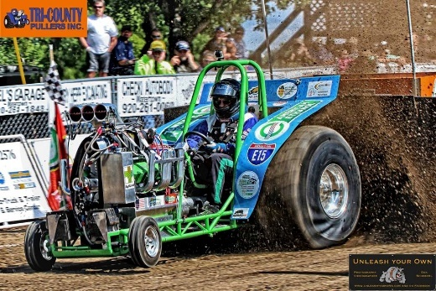
New Grandstand Event
Tri-County Pullers Inc.
Sunday August 6, 2023 at 1:00 pm

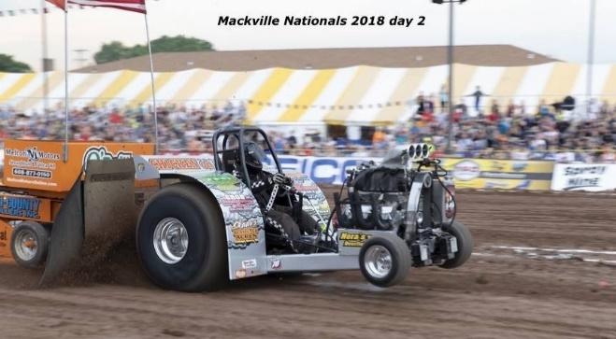
They bring some of the loudest and fastest paced mini-rod tractor pulling in Southern Wisconsin and Northern Illinois. They have been creating exciting entertainment for all ages for over 30 years.

The Purse payout for Mini Rod Tractor Pulling is based on registration fees paid. 100% of the registration fee is paid out. For each class split, the percentages could change.

Disclaimer:
If only four places are paid, rates would be 40%, 30%, 20%, 10%.
If only three places are paid, rates would be 50%, 30%, 20%.
If only two places are paid, rates would be 60%, 40%.
If only one place is paid, rate would be 100%.

DEPARTMENT Q41 Section 005 TRACTOR classes

EXAMPLES: if purse is $500.00
Limited Mini | 1st – 50% | 2nd – 30% | 3rd – 20%
#1760 | $250 | $150 | $100
EconoMod Mini | 1st – 40% | 2nd – 30% | 3rd – 20% | 4th – 10%
#1761 | $200 | $150 | $100 | $50
Open Mini | 1st – 50% | 2nd – 30% | 3rd – 20%
#1762 | $250 | $150 | $100

For more information visit their website: http://www.tricountypullersinc.com/

Or see their facebook page: https://www.facebook.com/tricountypullersinc

Ogle County Fairgrounds
1440 North Limekiln Road
Oregon, IL 61061
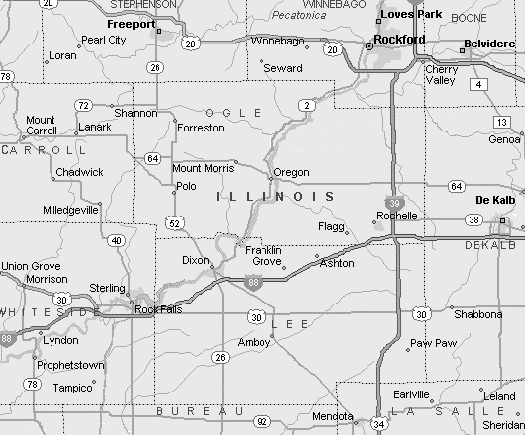

From the Chicago
Travel West on I-88, take exit 79 to I-39 North, take exit 104 (IL-64) and turn left (West) toward Oregon. Watch for signs approximately a mile West of Oregon, turn right on Limekiln Rd.
From Rockford
- Travel South on IL-2, to Oregon, in Oregon turn right (West) onto IL-64. Watch for signs approximately a mile West of Oregon, turn right on Limekiln Rd.
- Alternate routes are South on IL 251 or IL-39 to IL 64, then West onto IL-64. Follow it through Oregon. Watch for signs approximately a mile West of Oregon, turn right on Limekiln Rd.
From Rochelle
Travel North on IL-251 to IL-64, turn left (West) onto IL-64. Watch for signs approximately a mile West of Oregon, turn right on Limekiln Rd.
From Dixon
Travel North on IL-2, to Oregon, in Oregon turn left (West) onto IL-64. Watch for signs approximately a mile West of Oregon, turn right on Limekiln Rd.
From Freeport
Travel South on IL-26 to IL-64, turn left (East) onto IL-64, go through Mt. Morris, and watch for signs after 4 miles, turn left on Limekiln Rd.
From Mt Carroll
Travel East on IL-64, go through Mt Morris and watch for signs after 4 miles, turn left on Limekiln Rd.
OGLE COUNTY FAIR CAMPING REQUEST
Space is Limited; Spaces are filled on a request “first” received bases. Please make sure paper work is completely filled when submitting.
=======================================================
Mail entries with checks payable to: Ogle County Fair Association
PO Box 142
Oregon, Illinois 6l06l

Please Print Date
DRIVER’S LICENSE NUMBER (REQUIRED)
NAME
ADDRESS
CITY _____________________________ STATE ____________ ZIP
County of Residence
TELEPHONE (______) _________________ CELL PHONE (______)

Date of arrival _____________________ (Not permitted before Saturday, July 29, 2023)
Departure date _____________________
Camper License plate number ________________ Number of People in your party
Length of camper ______________________

Tent sites will be $10/day.
Campers on the grounds Saturday-Tuesday before the fair will be charged:
$10/day if not plugged into our electric
$20/day if they are plugged into our electric

Campers on the grounds for the fair week (Wednesday Aug 2 – Sunday Aug 6) will follow the fee schedule below.
CAMPING FEES BASED ON FOOTAGE 30’ – 39’ = $ 140 for fair week
40’ – 49’ = $ 180 for fair week
*** Porches and ramps must be included in overall footage ***
50’ and over = $ 220 for fair week

 | Number of days | Price per day | Total
Pre-Fair
During Fair
 |  | Combined Total =

Submission of this request form indicates acceptance of the Rules and Regulations of the Ogle County Fair Association
- There are shower facilities available on fairgrounds.
- Pets are allowed in the camping area only, and must be on leashes and have current health papers.
- In case of injury, theft, storm, act of nature, or fire, it is the responsibility of the person making request and not the sponsors, fair board, or fair volunteers.
- No Smoking will be allowed in the livestock barns, grandstand, or in animal tents. Illinois Law Prevails.
- Submission of this request form indicates acceptance of Ogle County Fair Association Rules and Regulations.
____________________________________________________________________________________________________________________________________

For Fair use only Amount paid $ _____________ Check # __________
Paid in full (circle one) yes no

Map of Fairgrounds
1440 North Limekiln Road
Oregon, IL 61061
Fair Office
Building B

Stage
Commercial Exhibits

Food Court
Grandstands
Exhibit Bldg.
Carnival Area
Commercial Tent
Antique Tractors
General Parking
Entrance Gate
Restroom
Lion’s Shelter
Horse Arena
Building A

Building C

Building D
Pit Area
Camping Area
Entrance Gate
4-H Office
Admin Office
DePuy Drive
Public Parking Entrance
Smoking Area

E
W
N
S

Building A = Swine
Building B = Poultry & Rabbit
Building C = Beef
Building D = Goat & Sheep
Exhibit Building = 4-H, Jr. & Open Exhibits

Ogle County Fair
August 2 – 6, 2023
1440 N. Limekiln Road, Oregon, IL 61061
Purchase Reduced Price Preseason Tickets at any Casey’s in Ogle County (until 11:59 pm Aug 2nd) or online at https://www.eventsprout.com/event/23-ogle-county-fair

Regular price (starting Aug 3rd) tickets may be purchased online or at the gates.

Regular TICKET PRICES at the Gates
One Entrance Pass (includes ground entrance & carnival rides) | $10.00
Age 4 and under (Entrance Only) | Free
Age 4 and under Carnival Ride wristband | $5.00
5-Day Entrance Pass (5-days of ground entrance with Carnival Rides) | $40.00
One Day Grandstand Pass (after ground entrance) | $10.00
5-Day Grandstand Pass (includes all 5 grandstand events only) | $40.00
One Day Pit Pass (available Wed., Thur., Sat., & Sun. allows you into the pit area only) | $20.00

Barns will be closed during animal show judging.
2023 Office Hours:
Friday | July 28 | 10 am – 4 pm
Saturday | July 29 | 10 am – 6 pm
Sunday | July 30 | Noon – 4 pm
Monday | July 31 | 10 am – 8 pm
Tuesday | August 1 | 8 am – 8 pm
Wednesday | August 2 | 7 am – 11 pm
Thursday | August 3 | 7 am – 11 pm
Friday | August 4 | 7 am – 11 pm
Saturday | August 5 | 7 am – 11 pm
Sunday | August 6 | 7 am = 7 pm
Monday | August 7 | 9 am – 4 pm
For more information on this year’s Ogle County Fair, Check these sources:

Website: www.oglecountyfair.com
Facebook:
Ogle County Fair
Phone: 815-732-6962

2023 OGLE COUNTY FAIR

FULL EVENT SCHEDULE
Day | Event | Location | Time
Daily | Rhinestone Roper Show |  | Various Times TBA
 | Aussie Kingdom Show |  | Various Times TBA
 | Ta-Da-Robotics | Strolling around | Various Times
 | Chainsaw Artis Carving |  | Various Times TBA
Wed 8-2-23 | 4-H & Jr. Animals Check In | All Barns | 12:00 pm – 3:00 pm
 | 4-H Cloverbud Judging, Party & Graduation | Exhibit Building | 2:00 pm
 | Swine Weigh-In | Swine Barn | 3:00 pm – 6:00 pm
 | Commercial Tent Open |  | 3:00 pm – 10:00 pm
 | Gate Entrance Open |  | 4:00 pm – 10:00 pm
 | Exhibit Building Open | Exhibit Building | 4:00 pm – 9:00 pm
 | Antique Tractor Parade | Perimeter of Grounds | 5:00 pm
 | 4-H Bucket Calf Clinic | Building C (beef barn) | 5:00 pm
 | Beef Weigh-In | TBA | 5:00 pm – 8:00 pm
 | 4-H Children’s Farm |  | 5:00 pm – 9:00 pm
 | Queen Contests | Stage near Lions Shelter | 5:30 pm
 | Carnival Rides Open | Midway | 6:00 pm – 10:00 pm
 | Stock Truck & Tractor Pull (pit pass available) | Grandstand | 6:30 pm
Thur 8-5-23 | Gate Entrance Open |  | 7:00 am – 10:00 pm
 | 4-H & Jr. Dairy Goat Milk Production Milk-Out | Building D (sheep barn) | 7:30 am
 | 4-H Swine Show | Building A (swine barn) | 8:00 am
 | Exhibit Building Open | Exhibit Building | 9:00 am – 9:00 pm
 | 4-H Rabbit Show | Building B (rabbit barn) | 10:00 am
 | 4-H & Jr. Dairy Show | Building C (beef barn) | 11:00 am
 | Goat & Sheep Weigh-In |  | 3:00 pm– 4:00 pm
 | 4-H Children’s Farm |  | 3:00 pm – 9:00 pm
 | Commercial Tent Open |  | 3:00 pm – 10:00 pm
 | 4-H Sheep Show | Building D (sheep barn) | 5:00 pm
 | 4-H Beef Show | Building C (beef barn) | 5:00 pm
 | Antique Tractor Parade | Perimeter of Grounds | 5:00 pm
 | Carnival Rides Open | Midway | 5:00 pm – 10:00 pm
 | 4-H Bucket Calf Check-In |  | 5:30 pm – 6:00 pm
 | 4-H State Fair Orientation | Exhibit Building | 6:00 pm
 | 4-H Bucket Calf Judging | Building C (beef barn) | 6:30 pm approx..
 | Illini Tractor Pull (pit pass available) | Grandstand | 6:30 pm
 | Jim Wolber & the Lariat Band | Lions Shelter | 7:00 pm – 10:30 pm
 | 4-H & Jr. Dairy Goat Milk-Out Production Contest | Building D (goat barn) | 7:30 pm
Fri 8-4-23 | Gate Entrance Open |  | 7:00 am – 10:00 pm
 | Jr Swine Show | Building A (swine barn) | 8:00 am
 | 4-H Goat Show | Building D (goat barn) | 9:00 am
 | Exhibit Building Open | Exhibit Building | 9:00 am – 9:00 pm
 | 4-H Poultry show | Building B (poultry barn) | 12:30 pm
 | Big Hat Rodeo | Grandstand | 2:00 pm
 | Hawaiian Santa Photos | Stage Near Lions Shelter | 2:00 pm – 4:00 pm
 | Commercial Tent Open |  | 2:00 pm – 10:00 pm
 | 4-H Children’s Farm |  | 3:00 pm – 9:00 pm
 | Carnival Rides Open | Midway | 3:00 pm – 10:00 pm
 | Magic of Brian Holt | Walking around grounds | 4:00 pm – 8:00 pm
 | Antique Tractor Parade | Perimeter of Grounds | 5:00 pm
 | Big Hat Rodeo | Grandstand | 7:00 pm
 | First Friday by Jerry Tice | Lions Shelter | 7:00 pm – 10:30 pm
Sat 8-5-23 | Gate Entrance Open |  | 7:00 am – 10:00 pm
 | Jr. Show Horses on Grounds | Horse Arena | 7:30 am
 | Jr. Horse Show | Horse Arena | 8:30 am
 | Jr. Sheep Show | Building D (sheep barn) | 8:30 am
 | Jr. Beef Show | Building C (beef barn) | 9:00 am
 | Jr. Rabbit Show | Building B (rabbit barn) | 9:00 am
 | Exhibit Building Open | Exhibit Building | 9:00 am – 9:00 pm
 | 4-H Children’s Farm |  | 9:00 am – 9:00 pm
 | Kiddie Pedal Pull | Lions Shelter | 10:00 am
 | Hawaiian Santa Photos | Stage Near Lions Shelter | 2:00 pm – 4:00 pm
 | Commercial Tent Open |  | 2:00 pm – 10:00 pm
 | 4-H Blue Ribbon Livestock Auction | Beef Barn | 3:00 pm
 | Carnival Rides Open | Midway | 12:00pm – 10:00pm
 | Magic of Brian Holt Show | TBA | 4:00 pm
 | Antique Tractor Parade | Perimeter of Grounds | 5:00 pm
 | Pork Chop Dinner | Food Court Area | 5:00 pm – 7:00 pm
 | Chainsaw Carving Auction | Beef Arena | 6:30 pm tentative
 | Demolition Derby (pit pass available) | Grandstand | 6:30 pm
 | 4-H Master Showmanship Contest | Building C, D, A (swine, sheep, & beef barn) | 7:00 pm
 | Little Man in Black by Doug Stivers | Lions Shelter | 7:00 pm – 10:30 pm
Sun 8-6-23 | Gate Entrance Open |  | 7:00 am – 4:00 pm
 | Church Service | Exhibit Building | 7:30 am
 | Jr. Goat Show | Building D (goat barn) | 9:00 am
 | Jr. Poultry Show | Building B (poultry barn) | 9:00 am
 | Benefit Open Horse Show | Horse Arena | 9:30 am
 | Carnival Rides Open | Midway | 11:00 am – 4:00 pm
 | Exhibit Building Open | Exhibit Building | 10:00 am – 1:00 pm
 | 4-H Children’s Farm |  | 12:00 pm – 4:00 pm
 | Commercial Tent Open |  | 12:00 pm – 4:00 pm
 | Tri-County Pullers (pit pass available) | Grandstand | 1:00 pm
 | Exhibit Building & Animal Check Out | Families last name begins K-Z | 1:00 pm
 | Exhibit Building & Animal Check Out | Families last name begins A-J | 3:00 pm
 | Exhibit Building closed | Exhibit Building | 5:00 pm

Thank You for Supporting the Ogle Co. Fair.

We look forward to seeing you again in 2024 July 31 - August 4.

